APPLICATION INFORMATION

Project Lead Contact Information

Name: Morgan Johnston
E-mail: mbjohnst@illinois.edu
Phone: 217-333-2668
Address: 1501 S. Oak, Champaign, IL 61820

Title: TDM Coordinator
Organization/Department: F&S / Transportation Demand Management (TDM)

Secondary Contact Information
Name: John Marlin
E-mail: jmarlin@istc.illinois.edu

Phone: 217-333-8956
Address: One East Hazelwood Drive, Champaign, IL 61820

Title: Interim Director
Organization/Department: Illinois Sustainable Technology Center

Unit Financial Officer Contact Information:
Name: Morgan Johnston
E-mail: mbjohnst@illinois.edu

Phone: 217-333-2668
Address: 1501 S. Oak, Champaign, IL 61820

Title: TDM Coordinator
Organization/Department: F&S / TDM

I. Detailed Project Description:
We are pleased to request funding for minor site improvements to a convenient and peaceful connector for bicycle commuters along Hazelwood Drive. The Hazelwood Path is perfectly located to bring University students and employees from south Urbana to the Research Park, in a direct and comfortable route. This will allow cyclists to forego the dangers of St. Mary’s Road, and it provides ample opportunities to head north to campus proper at Lincoln Avenue, Wright Street Extended, Fourth Street, First Street, or Oak Street.

Please include:
- Project goals.
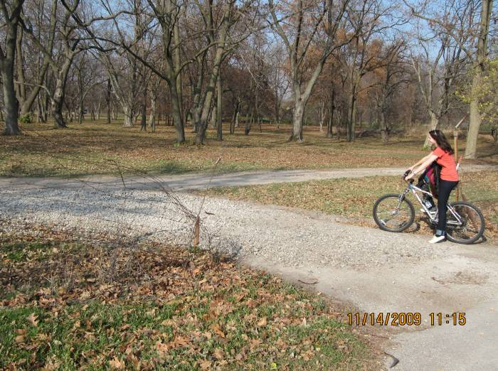
The immediate goal of this project is to upgrade and formalize the off-road bicycle trail along the line of Hazelwood Drive, connecting southern Urbana with the UI Research Park in Champaign. There are four squeeze points at gates along the path, that make some bicyclists believe it is not an acceptable route. This project will eliminate the major obstacles on the path, while still keeping motor vehicles from using it as a throughway from Race Street in Urbana to First Street in Champaign.

1. Gate between Orchard Downs and Arboretum. The existing gate is shown in the picture to the right, with large gravel which is difficult to ride over. This project will create a cut through at the gate that is aligned with Hazelwood, and add road pack to reduce mud impacts.

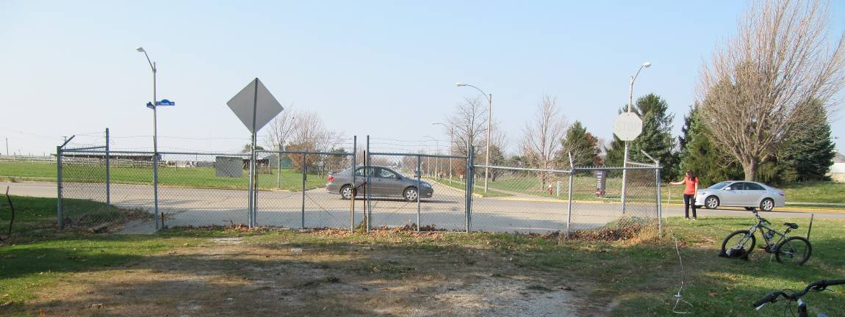
2. Gate at Lincoln Avenue (right). The existing gate at this location needs to have one pole added in the center, to allow for a five foot passage for cyclists, in line with the existing ramp and the appropriate alignment for further travel on the far side of Lincoln.

During discussions about this project with the Campus Transportation Committee, it was agreed that a bicycle crossing sign will be needed on Lincoln at this crossing. Thus, in addition to the gate modifications, a bike crossing will need to be marked on Lincoln Avenue. This will include the appropriate bicycle warning signs and painted street markings, as recommended by the University District Crosswalk Guidelines.

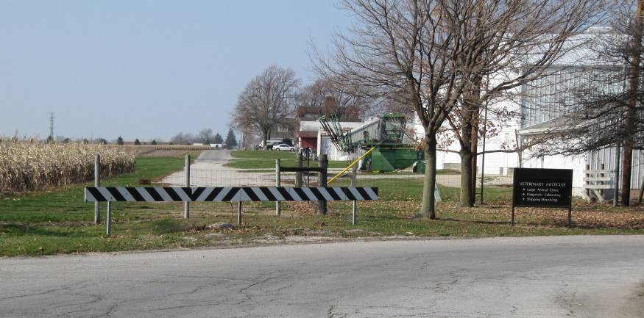
3. Vet Med Gate and Barricade (left). This end of street warning barricade will be removed, separated into two pieces, and replaced with a five foot opening for bicyclists to pass through. The fence in the background will need to have a section opened up as well, and road pack will be laid to reduce the impacts of mud.
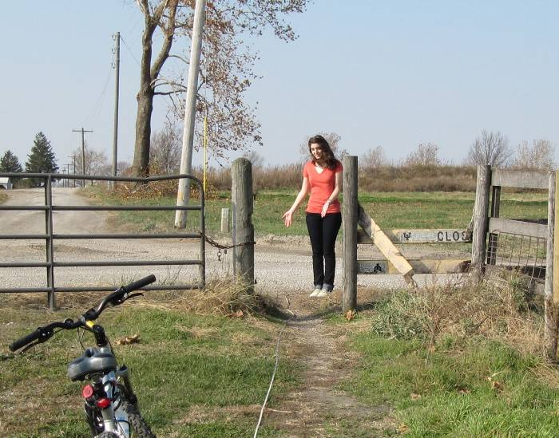
4. Fourth Street Gate (right). This gate simply needs to be opened a bit more. There are three slats and a post which will be removed here.

The result of these improvements will be a continuous connection from Urbana to Champaign, without the use of arterial streets. When this idea was discussed by the Champaign County Bikes listserv in early 2008, they noted “what the community really wants and needs is a route that will go all the way from Orchard Downs (Race Street) to First Street. This is what will really give good cross town access.”

- Definition of sustainability and the relationship of the project to this definition.
Sustainability is a complex term which aims to minimize the negative effects of present behaviors on the world of tomorrow. Bicycle riding has essentially no negative impacts on the future. There are no greenhouse gas emissions from bike riding, and no fossil fuels are consumed to power a bicycle. In fact, bike riding is actually more sustainable than walking, because the calories needed to power a bicycle for a mile are lower than the calories needed to power a human walk for a mile.
- Feasibility evaluation.
This is a simple project that will be completed by the Facilities & Services shops. They have already been on site and we have created the specific to do list in cooperation. The F&S Planning Division is also aware of this bike trail project, and they accept it. There will be a step needed that brings this change in the campus site through the campus Architecture Review Committee for final approval. Formal approval cannot be requested until funding is secured. Additionally, the location of this path is acceptable to the cities of Champaign and Urbana, the various campus departments in the vicinity of the path, Transportation Demand Management, and the Urbana campus Master Plan.
- Longevity and/or permanence of project results on campus.
The barriers being removed by this path will stay removed for a considerable length of time. If the new federal transportation authorization bill would provide funding, then the path would be formalized with a full length asphalt shared use trail. Until then, the changes planned by this project will continue to exist and provide the great connection for cyclists for many years to come. Additionally, there is a project planned to extend Fourth Street, from St. Mary’s Road to Windsor Road. With that construction, the block of Hazelwood from Fourth Street to First Street will be improved to a freshly paved road with curb and gutter. It will accommodate the cyclists using this Hazelwood Path, and it will not end the usefulness of this project’s work.
- A summary of communications with relevant campus administrative entities and Facilities & Services personnel.
This project is led by the TDM department, which is the responsible unit at F&S for transportation systems, including bicycle routing. The decision to encourage cyclists to use the Hazelwood path, began a few years ago. Since that time, the campus departments that are aligned with the path have agreed that this is a good path to enhance. The cities of Urbana and Champaign have participated in some initial planning conversations. The Arboretum participated in previous planning sessions, and they are happy to have this facility upgraded through their segment of the path, at George Huff Drive and at Lincoln Avenue. Vet Med and ACES have also agreed it would be beneficial to enhance the path along their section, at Goodwin Avenue Extended and at Fourth Street.
- Location, including any concerns that may arise from the chosen site; applicants are encouraged to consult with Facilities & Services prior to submitting their proposal to ensure selection of appropriate sites.
The location, as shown in this tiny map, is on the south side of campus. It is aligned with the Hazelwood Drive road segments, and it is one block south of St. Mary’s Road on campus. There are no concerns with this chosen site.

II. Budget & Fundraising:
1. Detailed budget
- Provide a detailed budget for the full project costs, including initial costs and life-cycle operation and maintenance costs. Include an analysis of the project’s rate of return.
The cost of this project will include labor and materials for the four gateway modifications, the cost of the bike crossing installation at Lincoln Avenue, and the cost of plaques to acknowledge the SSC’s funding contribution. There will be no upkeep costs for this project, as the path will not have associated snow removal or path sweeping needs.

While not easily quantifiable for this bicycle projects, the rate of return could be measured by the number of people that choose to use the bike path for their journey to work. The savings will include reduced need to add parking pavement, reduced use of gasoline, and increased health.
- Detail both the specific budget items and the total funding amount being requested.
- $4,550.00 – labor and materials for the four gateway modifications, including placement of road pack, per verbal quote from F&S labor shop foreman on 3/10/10
- $1,400.00 – bike crossing installation at Lincoln Avenue
- $50.00 – creation and placement of SSC acknowledgment plaque
- Total Cost = $6,000.00
We have identified a funding source for $1,000.00 towards this project. Thus, we are requesting $5,000 from the SSC. We recognize that this is 3% higher than your standard 80% match program.
- If the Student Clean Energy Committee does not fund the full requested amount, will the project be able to move forward?
If you are only able to provide us with $4,800, we will continue to seek funding to cover the remaining $200.00. We will continue with the project. Thank you for considering the slightly increased request.

2. Fundraising
- List any grants or other sources of funding that have been obtained or applied for, and please attach letters of support.
- The TDM department is able to contribute $1,000.00 toward this project.
- If necessary, we will seek additional funding from other impacted departments and entities in the area of the path.

III. Timeline
Provide a detailed project timeline.
This project is very straight forward, so the timeline will only be dependent on the weather and the scheduling of the F&S labor shop. It is expected that the full project will be completed in one month, precluding major rain interruptions. The labor shop can being a couple of weeks after the funding is available. The final end date goal is to have this project completed before the start of the Fall 2010 term. If funding is approved quickly enough, we will strive to have this route open before May 4th, 2010, which is the first community wide C-U Bike to Work Day.

IV. Energy, Environmental, Social and Economic Impact
A. Renewable Energy Projects
Not applicable
B. Energy Efficiency Projects
This project does not directly impact the UI energy usage. However, it is part of an overall campus TDM program that encourages the use of active modes of transportation, rather than automobiles. A recent survey of Illinois students shows that nine percent use a bicycle as their primary mode of transportation, and nearly half of the students surveyed own a bicycle. By making this improvement to the campus bicycle paths, the University will increase the use of the most energy efficient transportation mode: bicycling.

C. All Projects

Environmental Impact: Effect on greenhouse gases
This is one part of the overall transportation goal to double the number of people using bicycles as a primary mode of transportation. The long range reduction in overall greenhouse gas emissions can be estimated as follows: assuming 2,500 new cyclists and a very minimal impact of one gallon of gasoline savings per new cyclist per month, that is a reduction of 48,500 pounds of CO2 per month, based on 19.4 pounds of CO2 per gallon of gasoline.

Social Impact

Bike riding is an important part of human culture. In focus groups about the benefits of bike riding, participants always recall a feeling of joy and freedom from early bike riding memories. The health benefits of bike riding are similar to any regular exercise, i.e., reduced weight, decreased depression, increased personal energy, et cetera. Additionally, bicycles have a positive socioeconomic impact, because they cut across race, class, and economic barriers. For example, some cyclists ride because they can not afford a motor vehicle, while others ride because they have time and money to spare.

Economic Impact

This project provides a safe and comfortable bicycle connection from Urbana to Champaign through the University campus. This will increase the bicycle traffic between the two cities. Bicycling is not an expensive mode of travel, and within Champaign-Urbana area the travel time is not significantly dependent on modal choice. Within the city, the commute ‘cost’ as a function of time is not much higher for a bicycle than for a motor vehicle. One example of the economic impact of this connection was described in a letter of support for the project. The author said “news that a Hazelwood path was a definite plan might actually tip the scale toward convincing me to purchase a home in Urbana just east of Race.” By providing a bicycle path, we are encouraging people to live close to their place of employment, which has far reaching environmental and economic benefits.

V. Outreach and Education
The Student Sustainability Committee strives to fund projects that will be highly visible and have a positive impact the lives of the UIUC students that pay the fee. Selected projects will be required to publicize their project in press releases and/or presentations and mention the support of the ILLINOIS Student Sustainability Committee. It is also expected that they will prepare a poster for display at the annual Environmental Horizons conference. With that focus, please address the following:
- visibility of the project to students
The Campus Bike Plan will be going through a public input process this year, and it will include this route as an existing path (after the project is complete). TDM will have a website created during the summer which will show existing bike paths, and that will link from the Dean of Students web portal for incoming students interested in campus transportation.
- role that students will play in the project
There are no students involved in the implementation of the project, but they will use the path for access to the main campus, the UI Research Park, and the Orchard Downs apartments.
- opportunities for involvement in classroom curriculum
None
- media opportunities
We will issue a press release when this project is completed, and we will have a ribbon cutting ceremony. The project completion will be announced at meetings of the Champaign-Urbana Urbanized Area Transportation Study, the Urbana Bicycle and Pedestrian Advisory Committee (BPAC), and the Campus Transportation Committee. The BPAC meetings are shown on Urbana public television. We will also seek to show this information on the Champaign public television station, and the University’s UI-7 tv station.
- any additional information on methods the project will use to educate the students and the public about clean energy technologies
At each modified gate, we will place a decal declaring the contribution of the SSC. We will also create a poster and display it at the Environmental Horizons conference, with a table showcasing additional active transportation options for campus. These include bicycling, Zipcar, MTD, and park and ride opportunities.

Projects are encouraged to have an educational component; however, projects that also have quantifiable environmental and/or energy impacts for the campus will be given preference.

Please send the project application (max limit of 5,000 words and 15 pages) to Suhail Barot <sustainability-committee@illinois.edu> by March 15, 2010.

