Project Lead Contact Information

Name: Eva Sweeney, P.E.
E-mail:eva@illinois.edu
Phone: 217-333-2271
Title: Electrical Engineer
Organization/Department: Facilities and Services

Secondary Contact Information
Name: John Prince, P.E.
E-mail:jmprince@illinois.edu
Phone: 217-333-3227
Title: Engineer
Organization/Department: Facilities and Services

Address:
1501 S Oak St
Champaign, IL
MC-800

Address:
1501 S Oak St
Champaign, IL
MC-821

I. Detailed Project Description:
This request is a continuation and expansion upon the classroom occupancy sensors funded by the SSC in 2008. That $50,000 allocation was used to install 259 occupancy sensors in ten campus buildings. However, many opportunities remain in other buildings.

Classroom lighting is frequently left on after classes and cleaning activities. To encourage the community to reduce lighting consumption we will install sensors in public classrooms that will turn off lights automatically if no action is detected in the room for thirty minutes. A complete product brochure can be found at
http://hubbell-wiring.com/Press/PDFS/H5240R09.pdf

- We will reduce lighting consumption in affected areas by 30% by reducing the number of hours that classrooms are lit.
- The sensors should last ten years, depending on frequency of use. They are a proven, lasting, permanent, public statement.
- The sensors will be located within classrooms in twenty heavily used buildings, chosen according to number of student contact hours.
- Most other public institutions have installed these sensors in similar areas. The Urbana campus is seemingly behind in this arena.

II. Budget & Fundraising:
1. Detailed budget
- We request a total amount of $100,000 or $200 per sensor. This includes sensor and labor. The funding will be used to cover the costs to specify, purchase, install, and commission sensors for up to 500 locations in twenty buildings. We expect that this will reduce lighting costs in these areas by 30%, with an annual savings of $25,000 per year or a simple payback of 4.0 years.
- The sensors have a life expectancy of ten years, with a present value replacement cost of $75,000, assuming 4.0% inflation and the standard life cycle definition of 50% failure.
- This project is easily scalable. As our history with the 2008 project shows, we can stretch our scope to fit the available budget. We further understand that the SSC has many priorities and limited resources. As such, it will not negatively impact the planning or execution if an amount other than the $100,000 request is awarded. The number of buildings, energy savings, and environmental impact will, of course, vary proportionally.

2. Fundraising
- DCEO grant reimbursement will be sought for each sensor installed, based upon their standard tables. DCEO’s incentive is $0.11 per connected watt, which should earn approximately $28,000 in rebates.

III. Timeline
- Since we would prefer to complete this work during the summer of 2010 to minimize the impact on class schedules, funding should be in place by January 30, 2010. The work must be completed by May 1, 2011.

IV. Energy, Environmental, Social and Economic Impact
- Energy and cost savings.
The project should save $25000 the first year or $345,000 over its ten year life based on an inflation rate of 4.0%. The sensor life is about the same as other components and should be replaced at the same time. This project should save 357,500 kWH/yr.

- Social Impact
Lighting controls send a strong message to the community that the campus is serious about saving energy through lighting reduction. Community members should turn their lights out more frequently in their offices and other private areas where the sensors are not installed.
- Economic Impact
The cost savings from this project could be applied to generate more savings elsewhere. In particular, DCEO grant rebates will be used to fund future energy efficiency programs such as additional occupancy sensors.

V. Outreach and Education
- These sensors will be installed in some of the most highly visible classrooms on campus with a diversified population. The rooms combine for almost 225,000 student hours per year and will be seen by over 50% of the freshman and sophomore classes.
- The sensors will be installed with a plaque, mentioning the Student Sustainability Committee, which tells of the impact of reducing lighting usage.
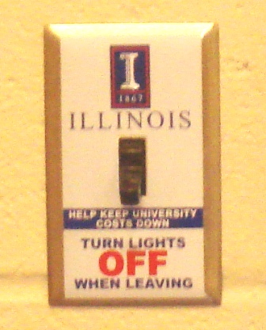

Typical Wall Switch to be replaced by

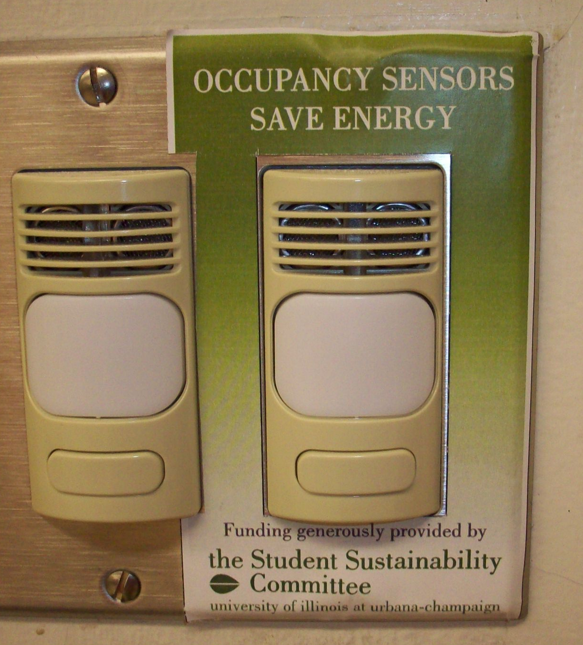

Automatic Occupancy Sensor

