APPLICATION INFORMATION
Project Lead Contact Information
Name: Morgan Johnston
E-mail: mbjohnst@illinois.edu
Phone: 333-2668
Address: 1501 S. Oak, Champaign, 61820
Title: Transportation Demand Management Coordinator
Organization/Department: Transportation Demand Management / Facilities & Services

I. Detailed Project Description:
Please include:
- Project goals.

The goal of this project is to provide standard bicycle parking at three locations on campus: Freer Hall, the Undergraduate Library, and the Agricultural Engineering Sciences Building. This will encourage bicycle riding and support the Campus Area Transportation Study (CATS) mission “to better accommodate pedestrian, bicycle, transit, and vehicle movements in a more user-friendly environment.” This is also one of the amenities recommended by the University of Illinois at Urbana-Champaign Multi-Modal Transportation Study recommendation to “provide other amenities to accommodate existing bicyclists and attract new ones.”

The three locations in this proposal are selected due to their relationship with other bicycle initiatives, prominent location, or immediate need. Freer Hall is home to the only campus owned bicycles, which should be provided with appropriate bicycle parking, to protect the University’s assets. The Undergraduate Library is located in the heart of campus, and a majority of students use their building regularly. The bicycle racks in this location will be seen by and used by campus visitors, students, faculty, and staff. The Agricultural Engineering Sciences Building has a complete lack of appropriate bicycle parking. Students riding a bicycle to this building have no options for securing the bike, so a rack should be provided to fill this need.

There is no fund available at Facilities & Services or elsewhere on campus to provide bicycle parking in built-up locations. New bicycle parking areas are only installed through the construction of a new building or with individual department funds. There are many locations on campus with old inappropriate racks which cause damage to bicycles that use them, or a complete lack of racks which cause cyclists to lock their bikes to trees and fences. The entire campus bike parking system needs to be upgraded, and this project will implement three styles of upgrades. At Freer Hall, we will remove old dangerous racks, and install new inverted loops in existing concrete. At the Undergrad Library, we will remove unused benches and install inverted loops in existing pavers. At the Agricultural Engineering Sciences Building, we will install a free standing rack with five loops. The project will bring experience with the installation processes, so future bike parking selections can be determined with full knowledge of the costs and timeframes.

- Definition of sustainability and the relationship of the project to this definition.

Sustainability is a complex term which aims to minimize the negative effects of present behaviors on the world of tomorrow. Bicycle riding has essentially no negative impacts on the future. There are no greenhouse gas emissions from bike riding, and no fossil fuels are consumed to power a bicycle.

- Longevity and/or permanence of project results on campus.

These locations fit into the Campus Transportation Plan, so they are intended to be permanent, long-lasting facilities. They are made from durable materials, which will easily last 50 or more years.

- Location, including any concerns that may arise from the chosen site; applicants are encouraged to consult with Facilities & Services prior to submitting their proposal to ensure selection of appropriate sites.

Freer Hall Location
This will remove the dilapidated and poorly designed bicycle parking on the north side of Freer Hall and install 21 inverted loops.
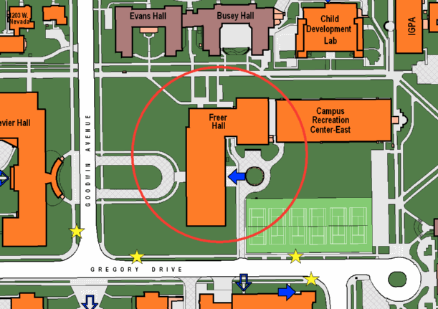

Undergraduate Library location
This will install 24 inverted loops on the roof of the Undergraduate Library, along the western wall.

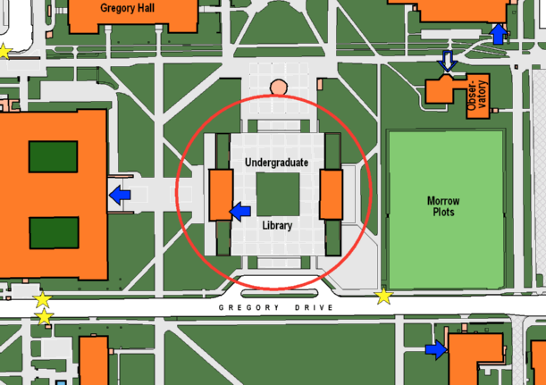

Agricultural Engineering Sciences Building location
This will install one freestanding rack with five inverted loops on the north end of the building.

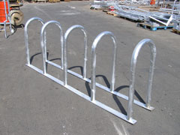
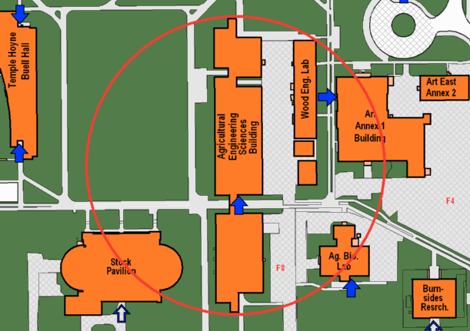

- If applicable, comparisons to similar projects at other campuses.

About ten years ago, Penn State had a similar bicycle parking problem. They lacked appropriate bicycle parking areas for the majority of campus, and cyclists parked to trees, fences, and railings. There solution was to install appropriate bicycle parking, and require the cyclists to use the designated parking areas. At this time, they rarely have to impound an illegally parked bike, because the parking supply is user friendly and convenient.

II. Budget & Fundraising:
1. Detailed budget
- Provide a detailed budget for the full project costs, including initial costs and life-cycle operation and maintenance costs. If possible, include an analysis of the project’s rate of return.

The total cost for this project is $13,272, and the departments should contribute 20 percent. Thus, the total amount requested for this project is $10,537.60.

Location | Cost | Cost Share | Amount Requested
Freer Hall | $ 4,500 | 20% | $ 3,600.00
Undergrad Library | $ 7,590 | 20% | $ 6,072.00
Agricultural Engineering Sciences | $ 1,082 | 20% | $ 865.60
Total | $ 13,172 | 20% | $ 10,537.60

- Detail both the specific budget items and the total funding amount being requested.

These numbers are based on the following details:
Freer Hall – estimate provided by F&S
 | Facilities & Services has developed the following general scope and expected cost for your review and approval
The project ID or Work Order is |  |  |  | 4422469
 | No. | ITEM | Expected Cost
 | 1 | Remove existing parking on the north side
 | 2 | Install app. 21 new U-shaped metal bike loops.
 | 3 | Coordinate project with crafts
 |  | Expected Cost (Time & Material, Straight Time) | $ 4,500.00
 |  | Add for Overtime Work | $ -
 |  | TOTAL EXPECTED COST, TIME & MATERIAL | $ 4,500.00

Undergraduate Library – estimate provided by F&S for one half of the wall.
Agricultural Engineering Sciences Building – cost of rack provided by PalmerGroup, Inc.
Rack Style | Part Number | Price
10 bk.- Surface Flange | WSH3610-SF-G | $ 682.00
Installation and management estimated as six hours at $50.00 per hour. Shipping estimated as $200.

- If the Student Clean Energy Committee does not fund the full requested amount, will the project be able to move forward?

The cost of upgrading bicycle parking throughout campus does not have any other funding source available. In other cities, the Clean Air Act provides grant funding for this type of project, but, in Champaign-Urbana, the air does not meet the requirements for those funds.

2. Fundraising
- List any grants or other sources of funding that have been obtained or applied for. If these funds are limited to a certain component of the project, please specify

The departments are willing to share the cost of the bicycle parking installations. Because departments are typically only responsible for new building construction or interior building reconstruction, we request a cost share of 20 percent, at most. Additionally, the Transportation Demand Management department will provide administrative tasks for this project and accept the unforeseen costs of implementation.

- NOTE: Preference will be given to those projects that seek additional funding from other sources including the Illinois Clean Energy Community Foundation, Environmental Council, UIUC departments, SORF, and agencies like the US Dept. of Energy or the EPA. This priority is given to encourage cost sharing and to allow the funds available to support a greater number of sustainability projects on campus.

III. Timeline
Provide a detailed project timeline.
- If the project is dependent on the receipt of funding from this committee, provide an estimated timeline listing the length of time from start to finish and detailing the length of time that each component will take.

Once funds are received, the materials will be ordered, shipped, and installed.
Order materials: two weeks
Shipping: six weeks
Installation: eight weeks

The total timeline from start to finish is four months.

- If the project is ongoing or has a specific start date, please include a timeline with specific dates from the start of the project until completion.

IV. Energy, Environmental, Social and Economic Impact
A. Renewable Energy Projects
This project will not generate renewable energy.

B. Energy Efficiency Projects
This project does not directly impact energy usage. However, by providing adequate bicycle parking, the University will encourage the use of active modes of transportation, rather than automobiles. A recent survey of Illinois students shows that nine percent use a bicycle as their primary mode of transportation, and nearly half of the students surveyed own a bicycle. Provision of adequate bike parking and other bicycle facilities have the immediate potential of increasing the use of biking as a primary mode.

C. All Projects

Environmental Impact
- Effect on greenhouse gases

The direct connection between appropriate bicycle parking and a reduction in greenhouse gases is nearly impossible to quantify. However, this is one part of the overall transportation goal to double the number of people using bicycles as a primary mode of transportation. This project will install 50 new bicycle parking loops, which will contribute to that long range goal.

The long range reduction in greenhouse gas emissions can be estimated as follows: assuming 2,500 new cyclists and a minimal impact of one gallon of gasoline savings per new cyclist per month, that is a reduction of 48,500 pounds of CO2 per month, based on 19.4 pounds of CO2 per gallon of gasoline.

- Please detail any other significant positive environmental impacts; use quantifiable metrics where possible.

This project has the potential to have a significant positive environmental impact on campus through an increase in bicycling.

- Please detail any significant negative environmental impacts from project creation to disposal and any efforts that you will undertake to mitigate these impacts.

There will be some metal removed from the north side of Freer Hall. It will be recycled at the Waste Transfer Station. There are no other negative environmental impacts.

Social Impact
Detail both positive and negative social impacts, if applicable.

Increased utilization of bicycling has many positive social benefits. These include increased health and stress-relief for the cyclists. Society also has benefits from increased health of citizens and reduced greenhouse gas emissions. Additionally, there is a positive social impact because there will not be bicycles parked improperly on fences, railings, and trees.
There will be no negative social impacts from provision of appropriate bicycle parking.

Economic Impact
Detail both positive and negative economic impacts; use quantifiable metrics where possible.

Based on a reduction in gasoline use of 2,500 gallons per month, and an average gasoline price of $2.50 per gallon, the savings equal $75,000 per year for undergraduate students.
Additionally, Facilities & Services will not incur the expense of impounding bicycles parking incorrectly. Historically, the task of regularly impounding all bikes parked illegally on campus required two full time employees, which can be estimated as $80,000 per year.

V. Outreach and Education
The Student Sustainability Committee strives to fund projects that will be highly visible and have a positive impact the lives of the UIUC students that pay the fee. Selected projects will be required to publicize their project in press releases and/or presentations and mention the support of the UIUC Student Sustainability Committee. It is also expected that they will prepare a poster for display at the annual Environmental Horizons conference. With that focus, please address the following:
- visibility of the project to students

The primary users will be students. The three locations are at academic buildings and along major walkways for campus, and the Undergraduate Library is prominently located for students and others. Additionally, the role of the Student Sustainability Committee in the creation of these new bicycle parking areas will be announced to bicyclist organizations, including the three bicycle-oriented Registered Student Organizations: Illini 4000, Illini Racing, and the student chapter of The Bike Project.
Upon request from the Student Sustainability Committee, Transportation Demand Management will investigate the installation of a plaque acknowledging the reliance on the committee’s assistance for implementation of these areas.

- role that students will play in the project

Courtney Barber was a student intern with Transportation Demand Management who assisted with the needs assessment at the Freer Hall bicycle parking location, and a student intern at Facilities & Services created the plan drawing for the Undergraduate Library. In the future, student assistance with locating new parking areas will be important.

- opportunities for involvement in classroom curriculum

To review the needs for bicycle parking throughout campus, the current facilities can be evaluated as part of an Urban Planning course. The students can use ARCGIS to record the current parking areas and make recommendations for additional bicycle parking installations.

- media opportunities

Transportation Demand Management is regularly contacted by the media for news about bicycling and other transportation issues for the University. The installation of new bicycle parking through assistance from the Student Sustainability Committee will be likely to have articles in the Daily Illini, Inside Illinois, and possibly community news. It will also potentially be included in the student run channel UI-7 news cast. We will recognize the Student Sustainability Committee as the source of funds.

- any additional information on methods the project will use to educate the students and the public about clean energy technologies

While all bicycle improvements will work together to educate students and others about active transportation options, the installation of bicycle parking will not be an educational tool in and of itself.

