Proposal for the

Student Sustainability Committee

Power plant Carbon Sequestration Via Algae Biodiesel Production
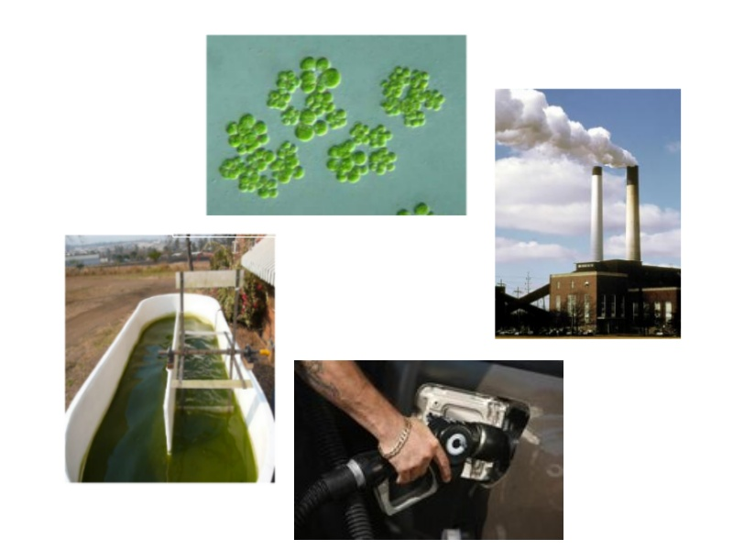

September 2008

University of Illinois at Urbana-Champaign

Applicant Information

Project Lead Contact Information
Name: Derek R. Vardon
E-mail: derekvardon@yahoo.com
Title: Vice President of UIUC Water Environment Federation Chapter
Department: Civil and Environmental Engineering
Phone: (630) 781-9509
Address: 4125 Newmark Lab
205 N. Mathews Ave
Urbana, IL 61801

Secondary Contact Information
Name: Lance Schideman, Ph. D., P.E.
E-mail: schidem@illinois.edu
Title: Assistant Professor
Department: Agricultural and Biological Engineering
Phone: (217) 244-8485
Address: 332N AESB, MC 644
1304 W. Pennsylvania Ave.
Urbana, IL 61801

I. Project Description
Looking towards the future, cost-effective alternatives for renewable fuels are desperately needed that will help mitigate the economic, environmental, and national security concerns inherent in our current reliance on fossil fuels. In addition, because our current power industry infrastructure is overwhelmingly dependent on fossil fuels, it is important develop technologies that can sequester the carbon dioxide emissions that have lead to mounting concerns about global climate change. One promising alternative that has been demonstrated to successfully address both of these major concerns is to sequester carbon dioxide from power plant exhaust gasses into algae biomass that can subsequently be converted into biofuels and other useful co-products. In comparison to other carbon sequestration options, this approach has the distinct advantage of generating value added products that can help pay for the environmental benefits received.
Algae have several key advantages including: higher growth rates than other plant species, the ability to grow on marginal lands, the ability to consume excess nutrients in eutrophic waters, and high oil content in certain species. Some algae species have been shown to be sufficiently high in oil content that less than 20 million hectares (10% of arable US land) could potentially produce the entire oil consumption of the US transportation sector (approximately 35 quads per year) [1]. Thus, algae based biofuels could effectively replace liquid petroleum fuels without significantly compromising the availability of land for food production-- a critical limitation of current bioenergy scenarios. Furthermore, because algae can be grown on degraded lands and waterbodies that are not suitable for agriculture, the competition between food and fuel can be fully mitigated. Finally, since algae based oils can be readily converted to biodiesel, they can provide a renewable source of carbon neutral energy that is compatible with current diesel engines and fuel distribution infrastructure.
Therefore, the construction of an Algae Biodiesel Production Facility is proposed to establish the University of Illinois at Urbana-Champaign as one of the nation’s leading institutions for developing solutions that simultaneously address the energy and environmental problems of our day. The facility would demonstrate the ability to provide a sustainable source of biodiesel fuel for the university’s vehicles with algae grown, harvested, and processed on campus.

Sustainability
Sustainability has been defined by the World Commission on Environment and Development as that which ‘meets the needs of the present without compromising the ability of future generations to meet their own needs’. This concept embodies our mission to provide sustainability on three levels: environmental, economic, and social. Each level is addressed by completing the following goals:

Project Goals
- Produce a renewable source of fuel with multiple environmental benefits. Biodiesel produced from algae grown on campus requires three main inputs: carbon dioxide, sunlight, and nutrients (primarily nitrogen and phosphorus). Flue gases from the university power plant will provide the needed carbon dioxide, and it will be converted to oxygen by the algae via common photosynthetic pathways, which reduces the greenhouse gas emissions associated with the power plant. Harnessing sunlight energy through photosynthesis is certainly among the most natural, environmentally-friendly means of obtaining energy, which has withstood the test of time and will continue to sustain life for many generations to come. Contemporary algae biofuel operations use commercial fertilizers to supply the major nutrients, which adds to the process cost and slightly reduces the net carbon sequestration because of the energy used to produce these fertilizers. In this project, we will instead target the use of excess nutrients from municipal wastewater, which are commonly discharged to waterbodies and contribute to major environmental problems such as eutrophication and hypoxia in the Gulf of Mexico. Thus, this approach of harvesting wastewater nutrients for the production of algae biofuels provides a double environmental benefit. The primary end product sought in this project is biodiesel derived from the algal oils, which typically account for 20-50% of the total biomass for target algal species. In addition, algae can be a rich source of desirable nutritional products such as omega-3 fatty acids and beta-carotene. After extraction of any other valuable co-products, the remaining biomass can be used for animal feed or fertilizer. Overall, the process will mitigate several key environmental problems by converting pollutants into a source of energy for transportation.
- Provide an economically viable solution. Algae are capable of reproducing more rapidly and supplying higher quantities of energy-rich oil on marginal quality land than other vegetation sources. Since algae do not compete as a human food source, the negative impact on the global food economy is also mitigated. In fact, using the leftover algae biomass derived from waste carbon dioxide for livestock feed has the potential to displace other crops fed to animals that could actually increase the food supply for humans. As noted above, the proposed concept of using wastewater nutrients has the potential to enhance the economic balance of current algae farming systems. We will also work to identify and extract high-value nutritional products to further bolster economic benefits. Finally, the fact that biodiesel derived from algae oils is compatible with existing engines and fuel infrastructure reduces the barriers to broad societal acceptance and provides a significant cost advantage. All of these factors make algae based biodiesel an attractive and economically competitive choice when compared to other fuel alternatives.
- Partner with others for achieving project goals. Collaboration between multiple organizations will maximize the use of resources, facilities, and personnel. Engineering and design will be coordinated with personnel from SeamBiotic Ltd, which has successfully operated algal ponds fed with power plant flue gas for 5 years. Prof. Ami Ben-Amotz is SeamBiotic’s Chief Adviser and has agreed to personally participate in this project. The Abbott power plant here on campus has agreed to supply exhaust gases from their stacks and provide space for the algae ponds to be constructed on the power-plant campus. The Director of Utilities, Mike Larson, has provided conditional approval for access, construction, and operation of the project. His staff will handle construction of the flue gas taps downstream of the plant exhaust scrubbers. Permit requirements and regulations have been researched and problems are not anticipated due to the location of the taps. The primary student organization sponsor for this project is the local chapter of the Water Environment Federation (WEF), who will organize the design and construction of the algae ponds as well as coordinate routine operation and maintenance. The use of student involvement during the construction phase will mitigate labor union issues and provide a hands-on educational experience. Members from this group have previously been involved with the design and construction of algal ponds for biofuels production as a part of a study abroad program sponsored by the Agricultural and Biological Engineering Department, which is also providing faculty sponsorship for this project. In addition, the local chapter of the Engineers Without Borders (EWB) and their UIUC Biodiesel Intiative group will partner together with this project to harvest and process the algae oil to biodiesel. The EWB Biodiesel Initiative, which was also supported by a grant from the Student Sustainability Committee, is currently establishing the infrastructure to collect and convert waste oil on campus to biodiesel for use in the campus motorpool vehicles. This algae biofuels project will coordinate with and build on the investment in the EWB Biodiesel Initiative and will distribute the project benefits to the entire campus community. In the event that the EWB Biodiesel Initiative is not able to process the extracted oil, the conversion can also be carried out on campus at the Illinois Sustainable Technology Center or in a laboratory setting due to the small volume of oil involved. In summary, this project will engender broad support and involvement from a diverse network of interested students and professionals that will ensure project success.

Project Description
Algae used to sequester carbon dioxide and produce biofuel will be grown in a simple, cost effective open-pond system. Initially, the algal strain nannochloropsis will be cultured in the laboratory and spiked at sufficient density into two shallow ponds with a total area of approximately 100 m² and filled with an artificial seawater. An example of the algae ponds constructed by UIUC students is provided on the proposal cover sheet and Figure 1 along with algae ponds used by the SeamBiotic. Carbon dioxide will be fed through distribution lines supplied with power plant exhaust after the scrubbers. Nutrients will be added to support algae growth and cell density will be monitored by with periodic sampling. The seawater will be circulated using a simple paddle wheel device to ensure homogeneity. The pond surface will have the option to be covered with a transparent plastic film to allow sunlight in but prevent foreign contaminants from entering the system.
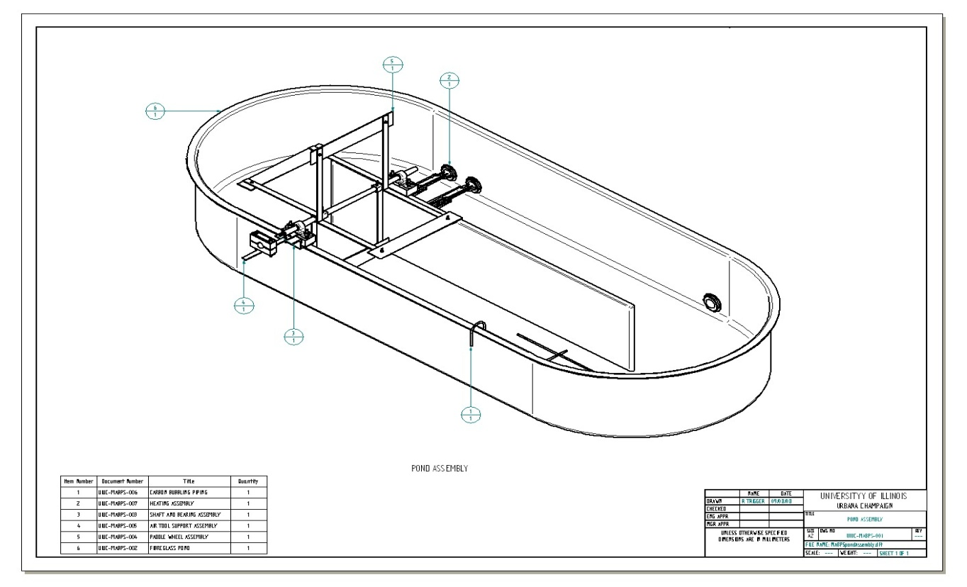
(a)
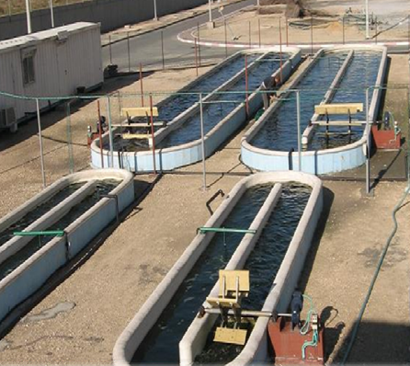
(b)
Figure 1. (a) Isometric drawing of algae pond constructed by UIUC students for study abroad program in South Africa (b) Picture of algae ponds operated by SeamBiotic in Ashkalon, Israel.
The algae will be cultured in a laboratory setting and seeded to the reactors at the pilot plant in batches. Once a sufficient cell density has been reached, the algae will be harvested manually with a cheese-cloth strainer and placed in the sun to dry. The oil and other valuable co-products produced within the algal cells will then be extracted using solvents and/or surfactant emulsions. The remaining algae cake will be processed into animal feed and/or fertilizer. The extracted algae oil will be sent to the Engineers Without Borders Biodiesel Facility for processing. The converted algae biodiesel will be added to the fuel distribution tank system to power Facility and Service vehicles.
This project is designed to demonstrate the technology to sequester carbon dioxide from the UIUC power plant into algae biomass that can subsequently be converted to biofuels and other valuable co-products. Although the size of the facility is modest and would only provide a minor reduction of carbon dioxide emissions as currently proposed, it would provide the necessary design parameters and confidence to support the design of a larger installation at a later time. The proposed size allows process parameters to be more easily manipulated and managed so that a full-scale design can be better optimized. Once these conditions are established, plans have been developed to scale the project 10-fold to increase the capacity and reduce operational costs due to economies of scale. If approved, scaling is expected to be implemented over the 2010-2011 academic year.

Location
The algae bioreactor production facility will be constructed at the Abbott power plant that is located on 1117 South Oak Street in Champaign. Exhaust emissions from both the coal and natural gas stacks will be tapped and fed to two 50 m² ponds located on the roof of the southwest corner of the facility. Harvested algal biomass will be transported to the EWB biodiesel facility for conversion into biodiesel. The diesel fuel will then be distributed to power Facilities and Service vehicles.

Support of University Research Mission
Although the primary purpose of this project is to demonstrate a technology that could eventually be used to cost-effectively provide a significant reduction of the carbon dioxide emissions of the University of Illinois community by converting them to a useful biofuel product, it is also noteworthy that this project will be conducted to support the university’s research mission. Algae biofuels are an important emerging frontier in research and similar projects to the one proposed are in operation at several universities that have partnered with commercial companies to develop, patent, and implement algae biodiesel technology. The table below provides of list and brief description of the facilities. This project will provide an opportunity to showcase UIUC research innovations related to algal biofuels and provide the raw algal material for identification, extraction of highly valuable co-products.

University | Description | Partner
Colorado State University  Massachusetts Institute of Technology  Utah State University  University of Minnesota | Established in 2006, reactor comprises 17,500 sq ft.  Plant has been operational since 2005 and is coupled to a 20-MW power plant.  Bioreactors work in conjunction with anaerobic digesters to supply CO₂ and nutrients from biowaste.  Recently received funding to advance research from bench to pilot-scale. | Solix Biofuels  Fort Collins, Colo.  GreenFuel Technologies  Cambridge, Mass.  Sunlight Direct, LLC  Oak Ridge, Tenn.  Xcel Energy  Minneapolis, Minn.
Table 1 List of pilot-scale algae production facilities in operation at universities across the country

II. Budget & Fundraising

Detailed Budget
Funds are requested to cover expenses associated with the construction and operation of the algae biodiesel production facility. Implementation of the project is dependent on funding from the Campus Sustainability Committee. Below is an itemized budget of the anticipated costs. It is anticipated that project will be economically sustainable since long-term labor and operational costs will be reduced further by utilizing volunteer members from the Water Environment Federation student organization to support harvesting and process operations.
Itemized Budget | Expected Cost
INITIAL CAPITAL INVESTMENT  Open Pond System  - Structure, Poly liner, Covers  Algae Cultivation  - Algae strains, Lab cultivation supplies  CO2 Delivery System  - Piping, Monitoring Equipment, Labor  Harvesting and Oil Extraction  - Centrifuge, Dryer, Press, Chemicals  1st YEAR OPERATIONAL COSTS  Labor  - Student Wages (600 hrs @ $9/hr)  Algae Cultivation  - Nutrients, Artificial Seawater | $4800  $1000  $3000  $1000  $5400  $800
TOTAL REQUESTED | $16,000
Table 2 Budget for the proposed algae biodiesel production facility

Fundraising
Other sources of funding will be applied for in conjunction to the Campus Sustainability Grant. A proposal to the Illinois Clean Energy Community Foundation, Department of Energy, and Grainger Foundation will be submitted to expand the facility and supplement future operational costs. Furthermore, proceeds from the sale of biodiesel, animal feed, and fertilizer will be reinvested in the project and fundraising will also be conducted by the involved student organizations.

III. Timeline
The project aims to produce measurable, time-bound outcomes for stages of completion.
Project Phase Description | Anticipated Date
Initial Construction  - Flue gas extraction system  - Open pond construction  Operation  - Spike ponds and cultivate algae  - Begin weekly harvest and extraction  Outreach  - Website and video uploads of facility  - Demonstration tours | May 2009  July 2009  September 2009
Table 3 Timeline for plant construction, operation, and community outreach

IV. Environmental, Energy, and Economic Impact
The Algae Biodiesel Production Facility will sequester carbon dioxide released from power plant exhaust that would otherwise contribute to greenhouse gases. Concurrently, the facility will provide a renewable, carbon neutral fuel source for transportation.

Environmental Impact
Algae serve a dual purpose by capturing carbon emissions from power plant exhaust and producing a fuel source that is less detrimental to the environment. During growth, algae consume ~2 kg of carbon dioxide for every kg of biomass produced. Based on the design size of the plant (100 square meters) the 2 kg of algae grown each day would capture approximately 1.5 metric tons of CO₂ over a year of operation.
The release of greenhouse gas emissions is also reduced during the combustion of biodiesel compared to standard diesel as shown in Table 4. Traditional diesel fuel releases 10.1 kg of CO₂ per gallon of gasoline. If B100 was used as a substitute, 4.27 kg of CO₂ would be spared per gallon of gasoline. When this saving is calculated over for the amount of fuel produced in a year, 0.25 metric tons of CO₂ per year would be spared. In total, the plant is expected to save 1.75 metric tons of CO₂ per year.

Fuel | CO₂ | NO_{x} | SO₂ | Particulates | VOC
B20  B100 | -13.1  -42.7 | +2.4  +13.2 | -20  -100 | -8.9  -55.3 | -17.9  -63.2
Table 4 Average changes in percent mass of emissions from diesel engines using relative mixtures of biodiesel to standard fuel [2]

Renewable Energy Impact
Vegetative sources for biofuel production must be able to generate large quantities of oil in order to compete with fossil fuels. Algae are the only feasible solution due to their significant oil yield per area. The following table highlights the dramatic differences between algae and other potential crops.
Crop | Oil Yield (L/ha) | Land area (M ha) | Percent of existing US cropping area
Corn  Soybean  Canola  Coconut  Oil Palm  Microalgae (30% oil by biomass) | 172  446  1,190  2,689  5,950  58,700 | 1540  594  223  99  45  4.5 | 846  326  122  54  24  2.5
Table 5 Comparison of sources of biodiesel to meet 50% of all transport fuel needs in the United States [1]
The expected oil yield from an algae pond system will be significant compared to what would be produced from traditional terrestrial crops. The algae pond systems operated by Seambiotic have yielded 20 grams of biomass per square meter per day with a strain that provides 30% of the biomass as oil. Given the 100 m² of the facility, it is expected to produce 0.6 kg of oil per day, which is slightly over 1 gallon of oil per week (3.63 kg/gallon of oil). In comparison, if the same area was used to grow high-oil corn only 0.0029 gallons of oil per week (0.29%) would be produced. Alternatively, soybeans would not fair much better with a yield of 0.0076 gallons per week (0.76%). In total, the plant is expected to generate approximately 60 gallons of oil per year.

Economic Impact
The production facility recovers the construction and operational costs through the production of fuel and fertilizer. The proposed plant is capable of supplying ~60 gallons per year. The current cost of petroleum based diesel fuel is $4.70 per gallon which equates to a cost savings of $280 per year for transportation fuel. In addition, once the oils are processed, the remaining biomass is rich in protein, carbohydrates, and other nutrients [3]. The remaining 700 kg of biomass produced per year can be processed into fertilizer or animal feed at a going rate of $0.50/kg for a total of $350 per year. In total, the combined revenue generated from the plant is $630 annually. As mentioned earlier, the economic impact of the immediate project is modest, as the primary purpose is to demonstrate the successful operation of a pilot scale facility. This effort will support a larger full-scale design that would leverage economies of scale and have a truly significant economic impact.

V. Outreach and Education
The Algae Biodiesel Production Facility will serve to educate the public and provide an opportunity for students to make a positive impact in the community.

Visibility of Project to Students
The scale and location of the facility adjacent to the power plant will provide a high visibility landmark and statement of support for environmental improvement. Demonstration tours will be given on a frequent basis to students and the public. Informational displays will be located at the facility to explain the benefits of biodiesel and potential applications. The project will be highlighted during Engineering Open House and Quad Day by the student organizations, and advertisements will be placed on vehicles powered from algae biodiesel to inform motorists of alternative sources of transportation fuel.

Role Students Play
As stated earlier, operation and maintenance of the plant will primarily be conducted by students on campus. Due to the simple design and operation of the plant, undergraduate students regardless of major can contribute to the facility. Students will be encouraged to assist with all stages including growth, harvest, processing, and conversion of algae oil into biodiesel.

Classroom Curriculum Opportunities
Plant design characterization and various research projects can serve as part of an independent study curriculum for students. Susan Herricks, the WaterCAMPWS Education Program Coordinator, has agreed to incorporate the facility in their outreach program for K-12 students. The site can provide a hands-on educational experience for younger generations and expose them to alternative forms of energy.

Media Opportunities
Educational information about carbon sequestration through algae growth and biofuel production will be disseminated through an interactive website designed by the student organizations. From the initial construction to weekly harvesting, operations and procedures at the facility will be open source and posted on the site to encourage the exchange of information and sharing of resources. Videos will also be uploaded to YouTube to engage a worldwide audience on the topic of renewable green energy. The local media will also be notified, and details can be highlighted in the News Gazette and Daily Illini.

VI. References
1. Chisti, Y., Biodiesel from microalgae. Biotechnology Advances, 2007. 25(3): p. 294-306.
2. Demirbas, A., Importance of biodiesel as transportation fuel. Energy Policy, 2007. 35(9): p. 4661-4670.
3. Mirón, A.S., et al., Shear stress tolerance and biochemical characterization of Phaeodactylum tricornutum in quasi steady-state continuous culture in outdoor photobioreactors. Biochemical Engineering Journal, 2003. 16(3): p. 287-297.

