Funding Criteria
A. General Rules
- Students, faculty, and staff are encouraged to submit requests for funding. Student-led projects require a faculty or staff sponsor in order to have funds awarded.
- Funding can only go to university-affiliated projects from students, faculty, staff, and departments.
- All SSC projects must make a substantial impact on students. This may be a direct impact or an impact through education and engagement. All SSC funding is 100% from student green fees, so the projects funded by the students must benefit them.
- SSC encourages innovation and new technologies – creative projects are encouraged to apply.
- Unless a type of expense is specifically listed below as having restrictions, SSC can generally fund it. The items referenced below should not be taken as comprehensive list.
B. Things SSC Can Fund, On A Case-By-Case Basis
- SSC can fund feasibility studies and design work; however, it must work toward ultimately addressing a sustainability need on campus.
- SSC can fund staff positions that are related to improving campus sustainability. Strong preference will be given to proposals receiving matching funding from departments and/or plans for maintaining continuity of the position after the end of the initial grant.
- SSC can fund outreach events with a central theme of sustainability, provided their primary audience is the general campus community.
- SSC discourages funding requests for food and prizes but will consider proposals on a case by case basis that prove significant reasoning.
- SSC can fund repairs and improvements to existing building systems as long as it works toward the goal of improving campus sustainability; however, a preference is shown to projects utilizing new or innovative ideas.
- SSC can provide departments with loans for projects with a distinct payback on a case by case base. Loans will require a separate memorandum of understanding between SSC and departmental leadership pledging to repay the award in full and detailing the payback plan.
C. Things SSC Will Not Fund:
- SSC will not fund projects with a primary end goal of generating revenue for non-University entities.
- SSC will not fund personal lodging, food, beverage, and other travel expenses.
- SSC will not fund any travel expenses.
- SSC will not fund tuition or other forms of personal financial assistance for students beyond standard student employee wages.

Your Step 2 funding application should include this application, the supplemental budget form, and any letters of support.
Please submit this completed application and any relevant supporting documentation to Sustainability-Committee@Illinois.edu. The Working Group Chairs will be in contact with you regarding any questions about the application. If you have any questions about the application process, please contact the Student Sustainability Committee at sustainability-committee@illinois.edu.

General & Contact Information

Project Name: Decreasing energy usage in the INHS Fish Collection
Total Amount Requested from SSC: $171,600

Project Topic Areas: Land & Water Education Energy
Transportation Food & Waste

Applicant Name: Christopher A. Taylor
Campus Affiliation (Unit/Department or RSO/Organization): Prairie Research Institute
Email Address: cataylor@illinois.edu

Check one:
This project is solely my own OR
This project is proposed on behalf of (name of student org., campus dept., etc.):

Project Team Members
Name | Department | Email
Caitlin C. Bloomer – student lead | Prairie Research Institute | Bloomer3@illinois.edu
Christopher A. Taylor | Prairie Research Institute | cataylor@illinois.edu
Shari E. Effert-Fanta | Prairie Research Institute | sfanta@illinois.edu
Name | Department/Organization | Email Address

Student-Led Projects (Mandatory):
Name of Faculty or Staff Project Advisor: Christopher A. Taylor
Advisor’s Email Address: cataylor@illinois.edu

Financial Contact (Must be a full-time University of Illinois staff member)
Contact Name: Alan Dudley
Unit/Department: Prairie Research Institute
Email Address: adudley@illinois.edu

Project Information
Please review the proposal materials and online content carefully. It is highly recommended you visit a working group meeting sometime during the proposal submission process.

Please provide a brief background of the project, its goals, and the desired outcomes:
You may copy and paste your Step 1 application answer if nothing has changed.
The Illinois Natural History Survey Fish Collection is a nationally recognized research museum. The Collection contains approximately 1.3 million fish specimens and is housed in six rooms in the basement of the Natural Resources Building (NRB) on the UI campus.

The NRB was built in 1939 and all exterior windows in the basement are original, single-pane windows. The NRB does not have central air conditioning (AC) and climate control is achieved with window-mounted AC units. Because of the older, inefficient windows and AC units (Fig. 1) in the rooms housing the Fish Collection, we are forced to run the AC units for nine months of the year to reduce the room temperatures and humidity levels. Additionally, drainage around NRB is extremely poor and mold growth is a constant threat. To keep mold growth in check, we need to continuously run six industrial-size dehumidifiers (Fig. 2).

To reduce energy consumption in Fish Collection rooms, we propose to:
1) remove old window AC units
2) install new interior window inserts that will increase the R-value of the windows
3) install new external AC units with ductwork that will go through the walls of NRB.

We request funding from SSC to meet the first two of these deliverables. We will be requesting institutional funds from PRI to accomplish the third objective. This is a critical time to undertake this project as approximately $12,000 in mold abatement activities have been conducted in the past four years.

Where will the project be located? Are special permissions required for this project site?
If special permission is required for this location, please explain and submit any relevant letters of support with the application.
All project activities will take place in the Natural Resources Building on the University of Illinois campus. No special permissions are required.

Other than the project team, who will have a stake in the project? Please list other individuals, groups, or departments affiliated directly or indirectly by the project. This includes any entity providing funding (immediate, future, ongoing, matching, in-kind, etc.) and any entities that benefit from this project.
Please attach letters of commitment or support at the end of the application.
Other research staff at PRI will have a stake in the project in that will improve working conditions in an active research laboratory. We are requesting additional funding from the PRI (see attached letter of support).

How will this project involve and/or benefit students?
This includes both direct and indirect impact.
As an active research laboratory, the INHS Fish Collection hosts UIUC undergraduate and graduate students on a yearly basis. The Fish Collection usually has two undergraduate hourly workers on staff assisting with collection management activities. These hourlies further their education by receiving training and direct experience in all aspects of museum specimen curation and data management. Two to three UIUC graduate students actively work in the Fish Collection in any given year collecting data required to complete their graduate research projects. The Fish Collection also hosts tours by UIUC undergraduate classes. We average two classes per year with an average 15 students per class. During the tours, students learn about the uses of preserved museum specimens and their value to the scientific community.

Undergraduate hourly workers will be involved in the proposed project by assisting Fish Collection staff with the temporary movement and storage of museum specimens while window work is being conducted. Educational opportunities will be improved by the proposed project by the removal of the large, industrial-sized dehumidifiers that currently sit in the middle of collection rooms. Their removal will allow for increased tour group sizes and allow for easier movement around the collection spaces.

How will you bring awareness and publicize the project on campus? In addition to SSC, where will information about this project be reported?
We will advertise all aspects of the project as it progresses from start to finish on PRI, INHS, and Natural Resources and Environmental Sciences Department social media platforms.

Figure 1
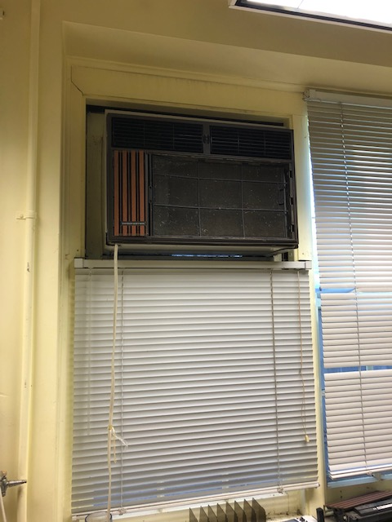

Figure 2
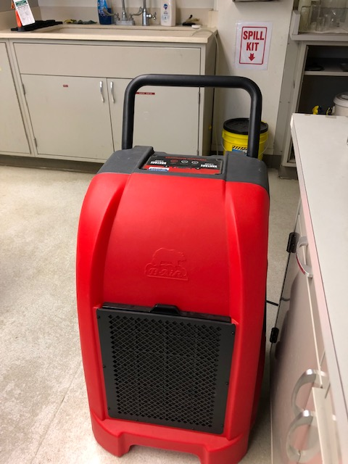

Financial Information
In addition to the below questions, please submit the supplemental budget spreadsheet available on the Student Sustainability Committee website. Submission of both documents by the submission deadline is required for consideration of your project.

Have you applied for funding from SSC before? If so, for what project?
No

If this project is implemented, will you require any ongoing funding required? What is the strategy for supporting the project in order to cover replacement, operation, or renewal costs?
Please note that SSC provides funding on a case by case basis annually and should not be considered as an ongoing source of funding.
No

Please include any other obtained sources of funding. Have you applied for funding elsewhere?
Please attach any relevant letters of support as needed in a separate document.
We are requesting funding from the Prairie Research Institute to cover the cost of purchasing and installing new external AC units for climate and humidity control in the Fish Collection rooms once the old window AC units are removed and the window inserts are installed.

Environmental, Economic, and Awareness Impacts

How will the project improve environmental sustainability at the Urbana-Champaign campus? If applicable, how does this project fit within any of the Illinois Climate Action Plan (iCAP) goals?
The iCAP has an overarching goal of carbon neutrality for the university. This project will significantly improve energy consumption rates from one of the older buildings on campus. This project specifically supports the following iCAP energy goals:
2.2 [F&S] Reduce Energy Use Intensity (EUI) of university facilities from the FY08 baseline by: 45% by FY30, 50% by FY40, and 60% by FY50.
2.2.2 [Units w/F&S] Reduce the total annual energy consumption of each college-level unit by at least 20% from an FY15 baseline by FY35.

By reducing the use of industrial dehumidifiers in the space, we can accommodate larger tour groups and classes using this space. This supports the iCAP energy goal:
2.2.1 [Provost Office] Improve efficiency of space use by minimizing the square footage per person and updating the Space Policy in the Campus Administrative Manual (CAM) by FY23.

How will you monitor and evaluate the project’s progress and environmental outcomes? What short-term and long-term environmental impacts do you expect?
Some examples include carbon emissions, water conservation, green behavior, and reduced landfill waste.
Applicant Taylor has an office in the NRB building and he will monitor the progress of the project on a daily basis. He will work with contractors and F&S to mitigate any delays. Once complete, we expect the short and long-term environmental impacts of the project to begin immediately in form of less electricity usage. The window inserts should significantly reduce or eliminate the need to run dehumidifiers during warmer months. Temperature and humidity will be monitored in each Fish Collection room and dehumidifier run-time will be adjusted to keep humidity below 50%. We will record dehumidifier run-time both before and after the completion of the project to judge effectiveness. We will be unable to document electricity usage by AC units, however, we assume that new external AC units will be more energy efficient that 5-10 year-old window AC units currently in use.

What are your specific outreach goals? How will this project inspire change at UIUC?
We will advertise all aspects of the project as it progresses from start to finish on PRI,INHS and Natural Resource and Environmental Science Department social media platforms. With better working conditions and increased media attention, we will encourage students to make more use of the Fish Collection as a university resource for research. By discussing the SSC funded improvements with tour groups and classes, we can improve our students’ understanding of stewarding historic resources and the importance of sustainably managing these collections.

If applicable, how does this project impact environmental injustice or social injustice?
The INHS Fish Collection provides one of the only on-campus opportunities to gain experience in museum curation and ichthyology taxonomy research. We ensure all our undergraduate hourly positions are paid to guarantee that these opportunities remain accessible to all socio-economic backgrounds. This project will improve the working conditions of our student workers and allow us to continue providing safe work experience opportunities to the UIUC community.

