Thank you for your commitment to green initiatives at the University of Illinois. One of the ongoing requirements listed in the terms of the funding agreement for your project is the submission of semesterly reports with key information about your project. In addition to this form, please provide additional financial documentation and/or progress photos if available.

Please be as accurate as possible in describing the project (including possible setbacks or challenges in meeting the initial goals of the project). Not fully meeting your project's goals will not disqualify you from making future funding requests as long as your reports are as complete and accurate as possible. If you have any questions, please contact the Student Sustainability Committee, at sustainability-committee@illinois.edu.
Project Name: Towards a Battery-Free Environment Sensing System for Urban Heat Island Identification

Date of Report Submission: 1/11/2024

Project Purpose:
Briefly, the purpose of the project is to develop cheap battery-free sensors to monitor air temperature and humidity to identify and monitor urban heat islands in Urbana-Champaign.

Detailed Accounting of Expenditures to Date:
We have spent $186.98 on our prototype and power profiler kit. Below there is a screenshot and I am also attaching an excel file with the details. Please let me know if you have any questions.
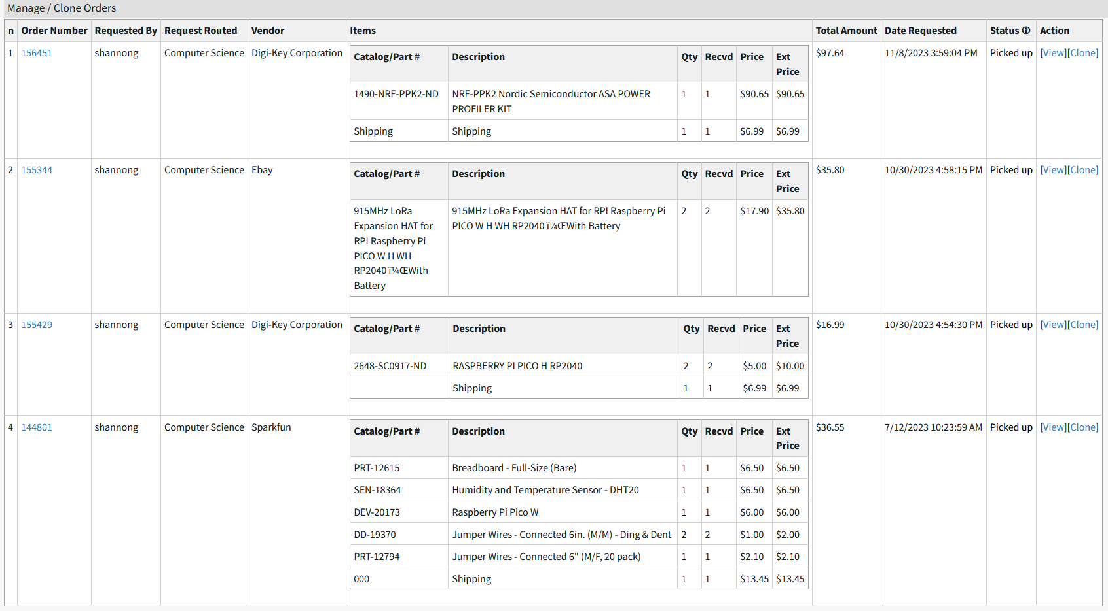

Project Progress to Date:
We have been granted permission by the city of Champaign to place our sensors in public ways!
Right now, we are waiting for the lawyers to finish up the contract documents, and we will deploy our sensors soon. The city of Urbana has also granted us permission and will use the same contract we are drafting with Champaign, so it should be a faster process. We’ve met with the public works departments of both cities, and they are very excited about getting access to the data we will collect. The city of Champaign also contacted us recently to ask if we could add more sensors to our devices so they can also monitor wind speed, surface temperature, and solar radiation. We haven’t heard back from them yet, but they are interested in working something out with us. My hope is that we can get NCSA involved and guarantee long-term maintenance of the devices and data.
Finally, we made good progress with our prototypes. We finished a communication design that we will test this upcoming semester and will make additional purchases to test our deployment.

We believe we are on track to meeting our goals by the December 2024 deadline.

Student Involvement and Outreach to Date:
The students led the effort of contacting people mentioned above.

Marketing and Promotion Efforts to Date:
We have not promoted or marketed the project yet.

Additional Comments:
We have contacted researchers from the Civil and Environmental engineering department, and they were very excited about our project. They will use the air temperature and humidity data to train their models to predict the weather in a city-scale. Right now, they have no access to data in Urbana-Champaign and have been focusing on Chicago.

