# *Thank you for your commitment to green initiatives at the University of Illinois. One of the ongoing requirements listed in the terms of the funding agreement for your project is the submission of semesterly reports with key information about your project. In addition to this form, please provide additional financial documentation and/or progress photos if available.*

# *Please be as accurate as possible in describing the project (including possible setbacks or challenges in meeting the initial goals of the project). Not fully meeting your project's goals will not disqualify you from making future funding requests as long as your reports are as complete and accurate as possible. If you have any questions, please contact the Student Sustainability Committee, at* [*sustainability-committee@illinois.edu*](mailto:sustainability-committee@illinois.edu)*.*

**Project Name:** **Towards a Battery-Free Environment Sensing System for Urban Heat Island Identification**

**Date of Report Submission:** 9/3/2024

**Project Purpose:**

Briefly, the purpose of the project is to develop cheap battery-free sensors to monitor air temperature and humidity to identify and monitor urban heat islands in Urbana-Champaign.

**Detailed Accounting of Expenditures to Date:**

**Project Progress to Date:**

We found that a shortcoming of relying on the public dataset of city-owned trees is that we underestimate the number of trees that are privately owned (which can be very significant). To address this shortcoming, we found a machine learning model that counts trees given an aerial photograph of the area. Additionally, we developed a simulation for accounting large number of devices—making sure that our server could handle several hundred transmissions at the same time and without losing any data. Furthermore, containerized our services using Docker for ease of deployment. This will allow anyone to easily deploy them. Our next step is to continuously collect data until the Summer to make sure we can restart our services should they fail, and that everything is working smoothly for when the devices are deployed in the Summer in Boston.

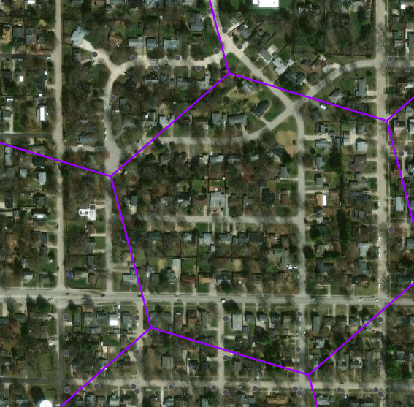

**Student Involvement and Outreach to Date:**

The students worked on everything that is mentioned and showed above.

**Marketing and Promotion Efforts to Date:**

We were finalists for the Fiddler award and requested that they share the news and mention the SSC. They haven’t released the news yet. TEC contact: Urvashi Jha urvashij@illinois.edu

**Additional Comments:**