# *Thank you for your commitment to green initiatives at the University of Illinois. One of the ongoing requirements listed in the terms of the funding agreement for your project is the submission of semesterly reports with key information about your project. In addition to this form, please provide additional financial documentation and/or progress photos if available.*

# *Please be as accurate as possible in describing the project (including possible setbacks or challenges in meeting the initial goals of the project). Not fully meeting your project's goals will not disqualify you from making future funding requests as long as your reports are as complete and accurate as possible. If you have any questions, please contact the Student Sustainability Committee, at* [*sustainability-committee@illinois.edu*](mailto:sustainability-committee@illinois.edu)*.*

**Project Name:** **Towards a Battery-Free Environment Sensing System for Urban Heat Island Identification**

**Date of Report Submission:** 9/3/2024

**Project Purpose:**

Briefly, the purpose of the project is to develop cheap battery-free sensors to monitor air temperature and humidity to identify and monitor urban heat islands in Urbana-Champaign.

**Detailed Accounting of Expenditures to Date:**

**Project Progress to Date:**

We identified the concentration of public trees in Champaign, and the location of the public streetlights where we will place our devices. We also tested our prototype and determined the range that we can achieve in practice. Now we have to test how it fares against weather and how reliable is the data transmission. We also figured out the right way of deploying the sensors and determined what metadata we need to include with the sensor’s readings.

We were finalists for NCSA’s Fiddler Award ([link](https://tec.illinois.edu/news/66472)). I asked them to mention the SSC and the great work you all are doing but they haven’t released the news yet.

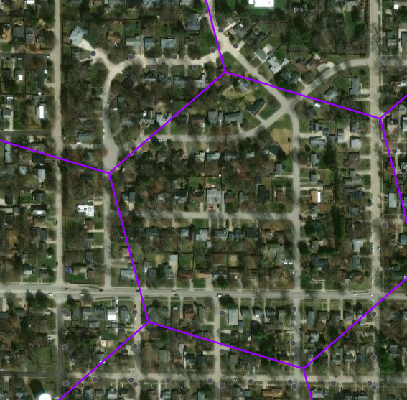

**Student Involvement and Outreach to Date:**

The students worked on everything that is mentioned and showed above.

**Marketing and Promotion Efforts to Date:**

We were finalists for the Fiddler award and requested that they share the news and mention the SSC. They haven’t released the news yet. TEC contact: Urvashi Jha urvashij@illinois.edu

**Additional Comments:**

We have contacted the city of Boston and they will allow us to deploy our sensors in Boston next to their equipement for groundtruth measurements!