# *Thank you for your commitment to green initiatives at the University of Illinois. One of the ongoing requirements listed in the terms of the funding agreement for your project is the submission of semesterly reports with key information about your project. In addition to this form, please provide additional financial documentation and/or progress photos if available.*

# *Please be as accurate as possible in describing the project (including possible setbacks or challenges in meeting the initial goals of the project). Not fully meeting your project's goals will not disqualify you from making future funding requests as long as your reports are as complete and accurate as possible. If you have any questions, please contact the Student Sustainability Committee, at* [*sustainability-committee@illinois.edu*](mailto:sustainability-committee@illinois.edu)*.*

**Project Name:** ADAPTHAUS

**Date of Report Submission:** 01/22/2021

**Project Purpose:**

The project that was funded is ADAPTHAUS (Net-Zero, Energy-Efficient, Solar Powered, Adaptable Smart Home), named after its concept of flexibility and adaptability, which aims to provide a sustainable and affordable housing solution for its users. ADAPTHAUS maintains a high sustainability quotient through efficient systems integration, local material procurement, recyclability, reusability, and energy efficiency. ADAPTHAUS is the official Team Illinois project entry to the 2021 U.S. Solar Decathlon Build Challenge, a U.S. Department of Energy sponsored international competition. Due to COVID-19, the Build Challenge has been moved to April 2021 (Which was supposed to happen in May 2020). We also hope to increase awareness about affordable green housing and the benefits of energy efficiency throughout the university campus as well as the Urbana-Champaign community.

We will be donating the house to Habitat for Humanity and the General contractor we hired in Darcy Construction in Champaign.

**Detailed Accounting of Expenditures to Date:**

|  |  |  |
| --- | --- | --- |
| **EXPENSE NAME/TYPE** |  | **FINAL AMOUNT\*\*\*** |
| MSA (Geo-Tech) |  | 2,800 |
| Law-Firm Fees |  | 150 |
| Interns |  | 337 |
| General Contractor |  | 350,000 |
| Landscape Contractor |  | 30,000 |
| Shipping |  | 2,750 |
| Darcy Construction Drawings |  | 2,500 |
| Insurance |  | 1,200 |
| MARFA |  | 3,500 |
| Small Items |  | 2,000 |
| **Total** |  | $395,237 |

**Project Progress to Date:**

SOLAR DECATHLON BUILD CHALLENGE TIMELINE

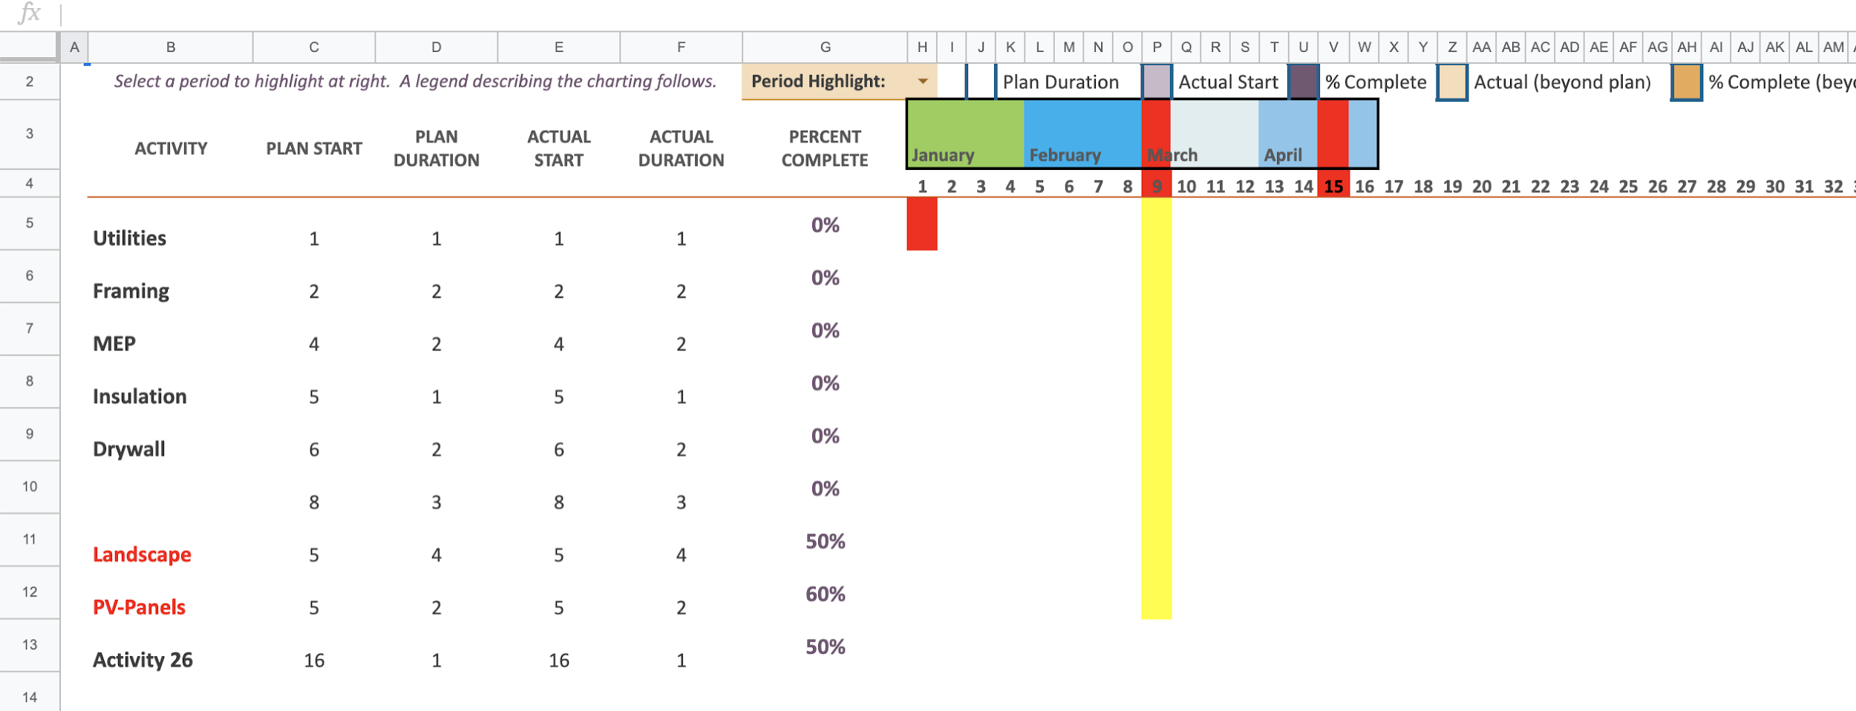

**Student Involvement and Outreach to Date:**

This project is entirely student-led from undergraduate freshmen to Ph.D. students. We have 12 subteams which are Architecture, Building integration and Envelope Team, HVAC, lighting and automation, construction Management, Photovoltaics, and Electrical, Life Cycle Assessment, application Development, Landscape, Structural Engineering, Water, and communications/marketing. Every sub-team came with their roles in the development and construction of the ADAPTHAUS. As of now, we have 70 students working on this project while learning about energy efficiency and constantly striving to build a cleaner and greener community around us. Every member also had the responsibility of finding sponsorship from companies for the materials their sub-teams were in charge of; for example, the structural team got sponsorship for wood because they designed the structural framing.

**Marketing and Promotion Efforts to Date:**

We currently have an Illinois Solar Decathlon video on our youtube page, as well as an executive member who is in charge of promoting our project, successful grant applications, and sponsorship on various social media platforms that include Facebook, Instagram, and LinkedIn. The marketing team is currently working hard to recognize our sponsors and expanding the digital reach. We have been awarded the SSC microgrant fall 2020, and with some of the money from this microgrant, we plan to film a video about the completed ADAPTHAUS project. This video will be used to promote the competition, future sponsorship use to attract companies, educational purposes, and for recruitment.

**Additional Comments:**

The competition will now be virtual.