Funding Criteria
A. General Rules
- Students, faculty, and staff are encouraged to submit requests for funding. Student-led projects require a faculty or staff sponsor in order to have funds awarded.
- Funding can only go to university-affiliated projects from students, faculty, staff, and departments.
- All SSC projects must make a substantial impact on students. All SSC funding is 100% from student green fees, so the projects funded by the students must benefit them.
B. Things SSC Can Fund, On A Case-By-Case Basis
- SSC can fund feasibility studies and design work; however, it must work toward ultimately addressing a sustainability need on campus.
- SSC can fund staff positions that are related to improving campus sustainability. Strong preference will be given to proposals receiving matching funding from departments and/or plans for maintaining continuity of the position after the end of the initial grant.
- SSC can fund outreach events with a central theme of sustainability, provided their primary audience is the general campus community.
- SSC discourages requests for food and prizes but will consider proposals on a case by case basis.
- SSC can fund repairs and improvements to existing building systems as long as it works toward the goal of improving campus sustainability.
- SSC can provide departments with loans for projects with a distinct payback. Loans will require a separate memorandum of understanding between SSC and departmental leadership pledging to repay the award in full and detailing the payback plan.
C. Things SSC Will Not Fund:
- SSC will not fund projects with a primary end goal of generating revenue for non-University entities.
- SSC will not fund personal lodging, food, beverage, and other travel expenses.
- SSC will not fund any travel expenses.
- SSC will not fund tuition or other forms of personal financial assistance.

Instructions
Submit this completed application and one map, graphic, or picture to Sustainability-Committee@Illinois.edu. Please adhere to the session word counts. The committee holds the right to decline applications over the designated word counts. If you have any questions about the application process, please contact the Student Sustainability Committee Coordinator at sustainability-committee@illinois.edu.

Project Name: ADAPTHAUS (Illinois Solar Decathlon)
Total Amount Requested from SSC: $10,000
Primary Project Leader Name & Email: Mayur Mistry, mmistry2@illinois.edu

Project Abstract: In less than 100 words, briefly describe your project.
Illinois Solar Decathlon is designing and building a net-zero energy house, called ADAPTHAUS, as part of the 2020 Build Challenge sponsored by the US Government Department of Energy.

 | Education | Energy | Food & Waste | Land & Water | Transportation
Project Category | x | x

Project Team Member List (student projects must include their faculty/staff advisor’s information)
Name | RSO/Department | Email Address
Jonah Messinger | Illinois Solar Decathlon (RSO) | jonahfm2@illinois.edu
Chris Meilinger | Illinois Solar Decathlon (RSO) | cam11@illinois.edu
Mayur Mistry | Illinois Solar Decathlon (RSO) | mmistry2@illinois.edu
Nava Wolgel | Illinois Solar Decathlon (RSO) | nwolgel2@illinois.edu
Professor Wang | ABE (Department) | xwang2@illinois.edu,

Questions | Yes | No
Is this a student-led project? | x
If applicable, have you received approval from Facilities & Services and/or site manager? | x
Do you have a plan for ongoing funding beyond SSC? (SSC cannot guarantee ongoing financial support) | x
Beyond SSC, do you have sources contributing funding or support (ex. staff time, external grants, etc.) to this project? | x
Have you applied for SSC funding previously? | x

Project Timeline
SSC funding agreements remain active for two years. Please list your project’s timeline and/or milestones.
Timeline for the Project
We have two different timelines, one timeline is for the design and construction drawings that we have to submit to Solar Decathlon and the second timeline is the construction timeline of our work with industry partners.

Solar Decathlon Competition Timeline:
- 50% Design Drawings, April 2019
- 95% Construction Documentation, November 2019
- 100% Construction Documentation, February 2020
- Solar Decathlon Jury testing, First Week of June 2020
- National showcase, July 2020

Construction Timeline:
- Site Surveying, February 17th - 21st
- Final Contracting with General Contractor, February 21st
- Excavate, Pour Foundation, and Utilities, Starts March 2nd
- Start Fabrication of Modules, End of March
- Inspect and Transport Modules to Site, May 4th
- On-Site Work Including: Solar Panel Installation, Exterior Cladding, Roof Mini-Split unit, Wood Decking, Canopy, May 5th - First Week of June for Jury Testing
- Transport and Install Second Module from National Showcase, July 2020
- Final Site Activities and Punch List, July - August 2020

Additional Information:
Illinois Solar Decathlon was fortunate to receive substantial funding from SSC last semester and we are extremely grateful for the support from SSC. We are reaching out again for a smaller funding request ($10,000) because one of the non-SSC grant applications Illinois Solar Decathlon was hoping to receive funding from, did not end up working because the grantor did not want to support construction costs and were more interested in public engagement. Additionally, our general contractor costs seem to be higher than originally anticipated. We are trying to reduce these costs but achieving this reduction will be difficult. A formal quote from the general contractor is being prepared by the general contractor and will be given to Illinois Solar Decathlon shortly. If the SSC would like, Illinois Solar Decathlon would be happy to provide this quote. Also, we are anticipating significant costs for contractor work on the National Mall in DC, where we will present one of the modular units that is part our modular home. Since our last application our team has finished 100% of construction documentation and we are going to be breaking ground on our project site within a few weeks. We have also made great strides logistically with the university. In conjunction with the Contracts Services Office and the Provost’s Office, we have decided to establish a non-profit, SolHomes, INC., to manage the project.

Project Description
In 250 words or less, describe your project. What does your project hope to accomplish? What are your project’s deliverables? Bullet points welcome.
- Built Project: We are designing and building a three-module home that can shift in favor of populations that are liable to see lifestyle changes in the coming years. Our design revolves around the two major pillars of affordability and adaptability.
- Our interior design focuses highly on space efficiency by using movable partition walls and flexible furniture to have multipurpose rooms. The house also maintains a high sustainability quotient through efficient systems integration, local material procurement and manufacture, recyclability, reusability, and energy efficiency. The building design is highly sensitive to the local climate, and through its orientation and the design of its envelope, fenestrations, cladding materials, and building materials, accommodates for changes between seasons.

Environmental Impact
In 200 words or less, how does your project increase environmental stewardship at UIUC? If applicable, what is the carbon, water, waste, and/or energy savings? Does your project relate to the iCAP? Bullet points welcome.
- This house will expand the ever-growing demonstrations of practical, sustainable, and renewable energy production. In terms of energy usage, our house will be net-zero and we are using solar panels and batteries for energy storage. We are also integrating tankless water heaters as well as greywater and rainwater systems for efficient water usage. Our building structure is made from recycled steel and we aim to procure materials locally. Since our design is modular, we are fabricating our modules in Skender’s factory, which will reduce waste on-site.
- Our project aligns with iCAP goals because the project is increasing sustainability outreach within student groups by supporting and communicating about their efforts in the sustainability field. Addresses iCAP Chapter 10 “Curricular Education” at UIUC i.e., ABE 498 through undergraduate research, practical experiences, and add new sustainability-focused courses. Addresses iCAP Chapter 11 “Outreach” goals by supporting co- curricular student sustainability programs and strengthening sustainability outreach programs.

Student Impact
In 200 words or less, how will this project benefit students? How will students be involved with this project? What educational components are in your project? Bullet points welcome.
- Illinois Solar Decathlon is comprised of an executive board, a build competition team, two design competition teams, and a concept team, which fosters skills and knowledge development for younger organization members. We have approximately 120 undergraduate and graduate students within our registered student organization. The build team has approximately 60 students and they have made majority of the design and build decisions that will allow the house to be energy-efficient and give back to the power grid.
- This project will increase awareness of sustainable measures at the Urbana-Champaign campus. The application of passive house design principles has been educating and inspiring our students to make sustainable decisions for designing a net-zero energy house. This house will expand the ever-growing demonstrations of practical, sustainable, and renewable energy production.

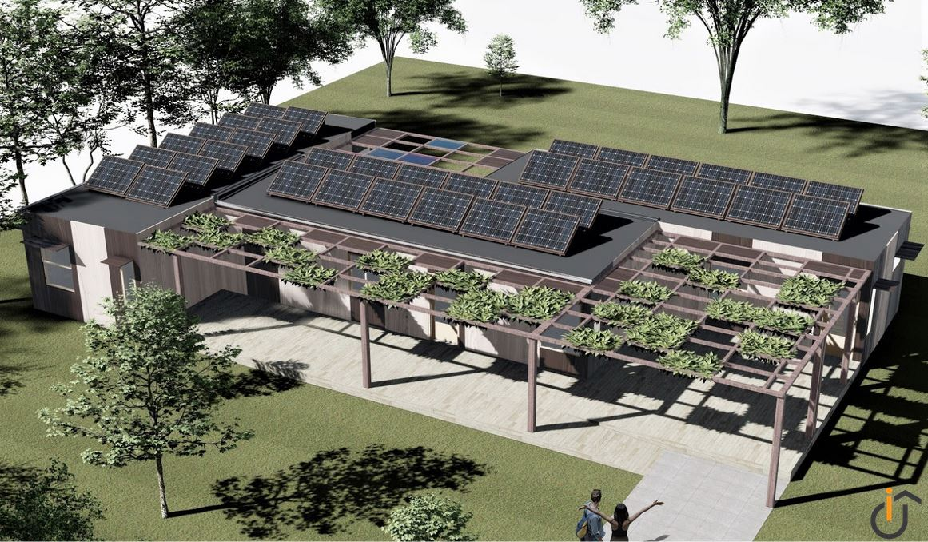

Rendering of ADAPTHAUS

