**Funding Criteria**

**A. General Rules**

1. Undergraduate and graduate students are encouraged to submit requests for funding up to $750. All projects require stakeholder support in order to have funds awarded.
2. Funding can only go to university-affiliated projects on university property submitted from students.
3. All SSC projects must make a substantial impact on students. This may be a direct impact or an indirect impact through education and engagement. All SSC funding is 100% from student green fees, so the projects funded by the students must benefit them.
4. SSC encourages innovation and new technologies – creative projects are encouraged to apply.
5. Unless a type of expense is specifically listed below as having restrictions, SSC can generally fund it. The items referenced below should not be taken as comprehensive.
6. SSC generally won’t fund reimbursement requests.

**B. Things SSC Can Fund, On A Case-By-Case Basis**

1. SSC can fund feasibility studies and design work; however, it must work toward ultimately addressing a sustainability need on campus.
2. SSC can fund outreach events with a central theme of sustainability, provided their primary audience is the general campus community.
3. SSC can fund repairs and improvements to existing building systems as long as it works toward the goal of improving campus sustainability; however, a preference is shown to projects utilizing new or innovative ideas.

**C. Things SSC Will Not Fund:**

1. SSC will not fund projects with a primary end goal of generating revenue for non-University entities.
2. SSC will not fund personal lodging, food, beverage, and other travel expenses.
3. SSC will not fund tuition or other forms of personal financial assistance for students beyond standard student employee wages.
4. SSC will not fund micro grant proposals that solely request staff, faculty, or student stipends.
5. SSC will not fund capital projects using micro grant funding.
6. SSC will not fund staff or faculty projects using micro grant funding.

**Your SSC funding application should include this application and a detailed itemized budget.**

*Please submit this completed application and any relevant supporting documentation to* [*Sustainability-Committee@Illinois.edu*](mailto:Sustainability-Committee@Illinois.edu)*. The Working Group Chairs will be in contact with you regarding any questions about the application. If you have any questions about the application process, please contact the Student Sustainability Committee at* *sustainability-committee@illinois.edu.*

**General Information**

Project Name: Spaceshot

Total Amount Requested from SSC (≤ $750): $722

Project Topic Areas: ☐ Land & Water X Education ☐ Energy

☐ Transportation ☐ Food & Waste

**Contact Information**

Applicant Name: Jeremy Huang

Campus Affiliation (Unit/Department or RSO/Organization): THRUST

Email Address: jeremyh3@illinois.edu



**Project Information**

*Please review the proposal materials and online content carefully. It is highly recommended you visit a working group meeting to talk through your proposal before you submit it.*

*1) Provide a brief background of the project, its goals, and the desired outcomes.*

The Spaceshot Rocket is a solid-fuel two-stage rocket designed to reach the Karman line (edge of outer space) at 328,000 ft (100 km) in altitude.The goal of this project is to develop a simple rocket which would be able to sustainably reach the Karman line using less fuel than other launch vehicles. This was accomplished by decreasing the diameter of the rocket as much as possible to reduce drag and by using novel weight reduction techniques. We use advanced alloys and composites to reduce the weight of the rocket. As such, we reduced the fuel required for a launch of a similar payload by a factor of 5. Furthermore, while most rockets only fly once and are discarded, Spaceshot is fully reusable, with only minor refurbishment required between flights. Emphasis was placed on using commercial off the shelf motors (COTS) in order to reduce build time and increase reliability. To develop a rocket with a quick build time, the individual parts were made to be easily manufactured with every part being produced using a lathe, CNC, or other composite layup means easily accessible to our organization.

*2) How will this project improve sustainability at UIUC?*

The spaceshot rocket will have instruments on it to measure properties of the environment in the upper atmosphere at the edge of space. There will be an ozone sensor on the avionics unit to measure atmospheric ozone in the mesosphere. There are several other similar sensors that measure different parameters which we are considering adding to the rocket. These devices are especially important since the mesosphere is an area of the atmosphere that is too high to be accessed by balloons and too low to be accessed by satellites. As a result, this part of the atmosphere is not monitored nearly as often as the lower layers, and by taking climatological measurements there we can provide UIUC’s climate scientists with a unique data set that they cannot obtain anywhere else. Additionally, we hope that by imaging the Earth from space, every person at UIUC will see the unexplainable beauty of our planet and be inspired to be a better environmental custodian. As mentioned before, this rocket is reusable, meaning we will launch it into space several times without having to build new rockets or discard them wherever they fall as many rockets today do.

*3) Where will the project be located? Do you need special permissions to enact the project at this site? If so, please explain and attach a letter of support to your application.*

We will be launching the full Spaceshot rocket from the Black Rock launch site in Northern Nevada. It is a dried lakebed that is used for high powered rocketry launches and has a pre-approved FAA clearance, so we can launch the rocket into space without issue. The launch site has safety protocols necessary for operating high powered rockets. Several of our members are already certified in high powered rocketry, and thus no special permissions are needed. However, we will be launching both stages of our Spaceshot Demo rocket (Ares) at a local launch site near Rantoul. For this launch, we will be partnering with Central Illinois Aerospace. Central Illinois Aerospace is a rocketry club based around Champaign, with members of the rocket club acting as advisors to our teams in the years past. This rocket (Ares) will be testing all the procedures with the avionics units which will be used in the future space rocket and will test many other important aspects including staging. There are no special permissions required and no clearances either for this launchsite. Since the altitude that Ares will be launched to won’t exceed 7,000 ft, there will be even less of an issue launching since many people with the club fly to similar altitudes on a monthly basis.Below are figures of the Ares (Demo) rocket and the Full Spaceshot rocket which will be going to the Karman line.

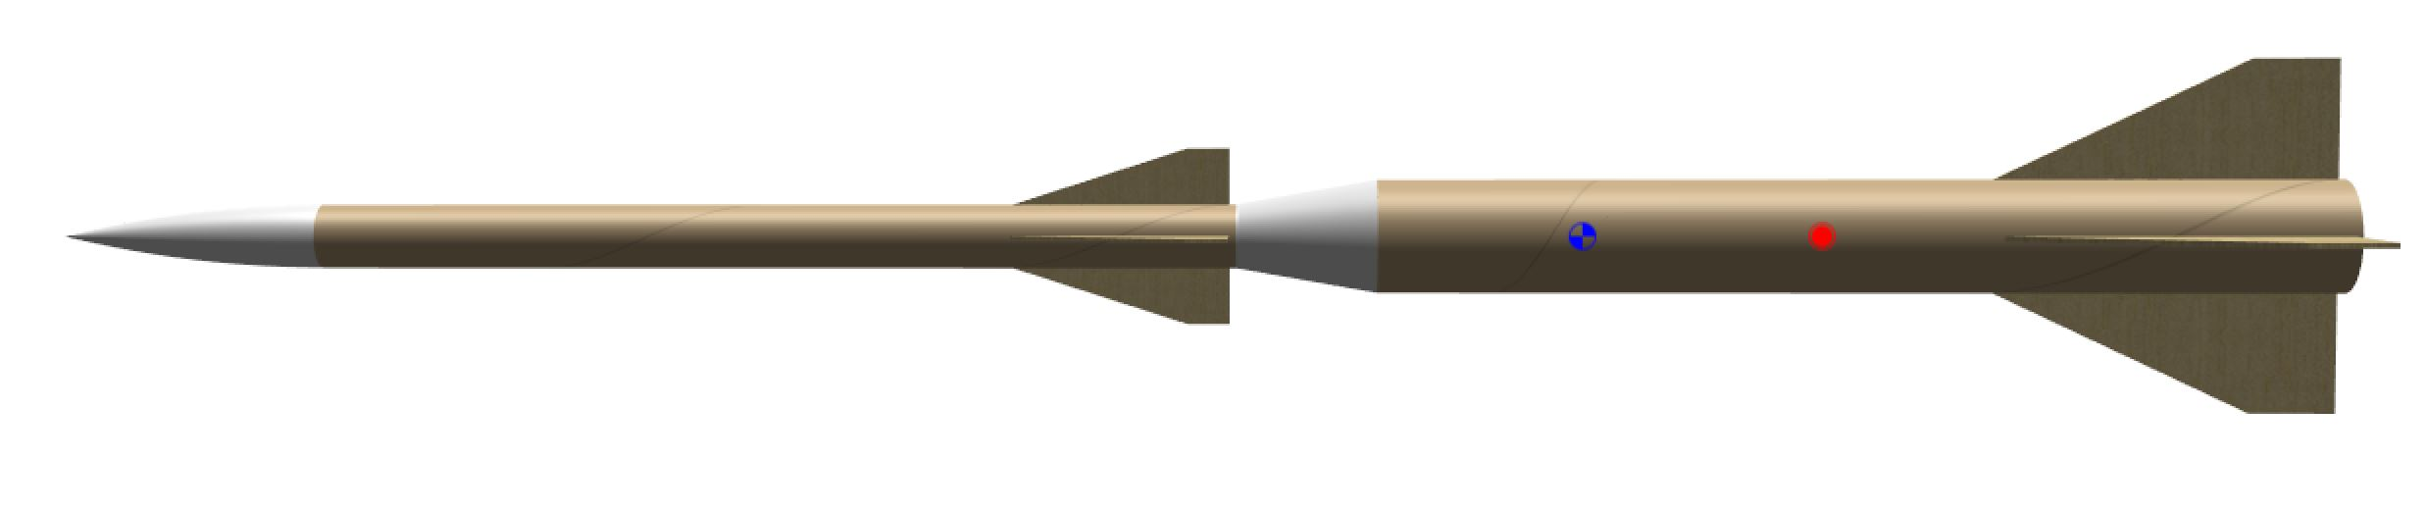

Figure: Ares Rocket with 2nd stage (top) and 1st stage (bottom)

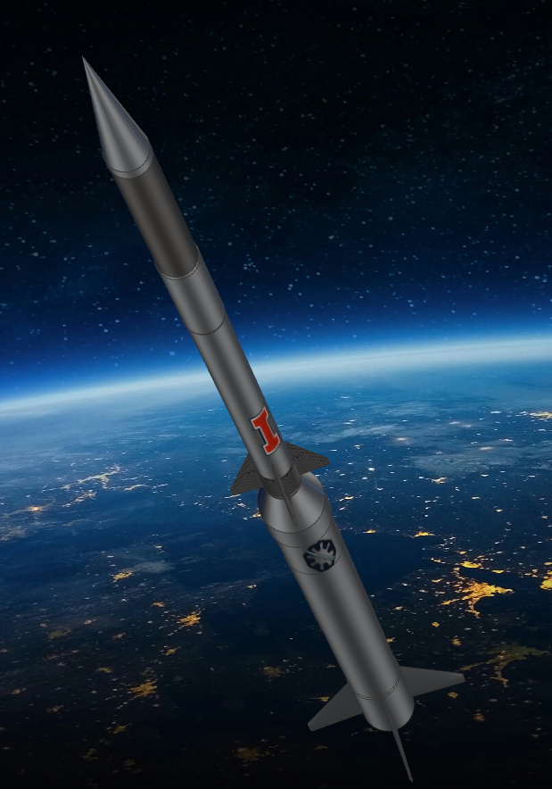

Figure: Full Spaceshot with 2nd stage (top) and 1st stage (bottom)

*4) Other than the project team, who will have a stake in the project? Please list other individuals, groups, or departments indirectly or directly affiliated to this project. This includes any funding entities (immediate, future, ongoing, etc.) and any entities that will be benefiting from this project*

Only THRUST has any stake in this project. While we do receive technical input and support from the Aerospace and ECE departments, they do not have any stake or jurisdiction in the project.

*5) How will you ensure the sustained existence/maintenance of this project (including reporting requirements) once you are no longer involved? If the project will conclude while you are involved, what will happen to the materials purchased for the project and how will you return the project site to its original condition?*

Our Organization has an extensive management structure with project managers being a key part in that hierarchy. Aerospace junior Michael Ardovitch currently serves as the project manager, and next year’s project manager is a member of the spaceshot team who has been actively working on the rocket’s design for the last year. All the members currently working on the project will be fully involved next year and until the rocket launches into space. Furthermore, we have documentation for every part of this project, ensuring that future students will be able to understand every design decision we have made. Assuming the rocket launches in June of 2022, after the flight it will be recovered and prepared for another flight into space since this rocket is reusable.

*6) Please indicate how this project will involve or impact students. What role will students play in the project?*

Our team is entirely student based and led, and our members will gain a great deal of hands on experience with high powered rocketry. This would be one of the first student made rockets to ever broach the Karman line, and thus provide knowledge to our students that makes them highly valuable for industry positions. One of our goals with this project is also to generate interest in the niche field of rocketry within other students at the University of Illinois! We want to show students that everyone is capable of rocket science, and get the University recognition in the high powered rocketry field and in the climatological research field.

*7) Have you applied for funding with SSC previously? If so, for what project?*

We have not applied for SSC funding in the past.

**Scope, Schedule, and Budget Verification**

*What is the plan for project implementation? Describe the key steps of the project including the start date, target completion date, target date for submitting a final report, and any significant tasks or milestones. Please be as detailed as possible.*

Spaceshot began as a project in the Summer of 2020. Since that time, the team has performed numerous simulations of the rocket to validate the design. We initially focused on developing the framework for making the full sized rocket which will eventually reach space. The design was mainly what the team was focused on throughout the summer and the first semester of this school year. However, after speaking with our mentors, who are very familiar with high power rocketry, our team decided to pivot into creating our first demo rocket named Ares. As such, we spent a major part of this semester designing and building parts of this demo rocket. This rocket will be testing all the procedures with the avionics units which will be used in the future space rocket and will test many other important aspects including staging. We plan to launch the 2nd stage of Ares within the next few weeks or within the start of the next school year. If this part of the project is funded, we hope to launch the 1st stage of Ares within a few weeks after the start of the next school year. We have already developed a technical report for the Ares rocket and are currently working on a technical report for the 2nd stage of the space rocket which we hope to have done by this September. Once the final simulations and the report are completed, we plan to start construction of the 2nd stage and launch it by the end of the year. Once we have launched the 2nd stage of the full rocket, we plan to build the 1st stage in time for an inaugural launch to space in the early summer of 2022. A table of our anticipated timeline can be found below.

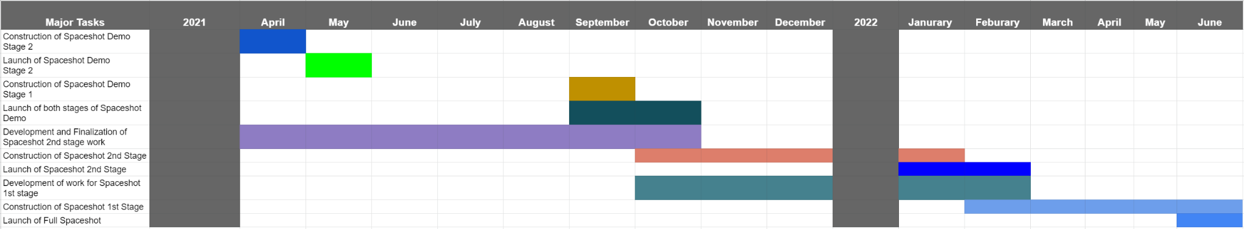

*List all budget items for which funding is being requested. Include cost and total amount for each item requested. Please be as detailed as possible. You are welcome to submit a separate budgeting document.*

A detailed Bill of Materials (BOM) can be found at the end of this application.

This microgrant will be mainly for funding the 1st stage of the Ares (Spaceshot Demo Rocket). As such, this BOM is split into a few sections including avionics, structures, recovery and propulsion.

Avionics costs include any costs that will be needed for the flight computers which will be used on the Ares rocket. In this case, the funds involve purchasing a featherweight GPS unit. This unit is highly rated to track rockets all the way to the Karman line with the correct antennas. With the launch of Ares, this GPS unit will be used to track the 1st stage of the rocket after it launches. The total cost comes to $160.

Structures costs include any of the costs used to physically build the rocket. In this case, this entails the phenolic tubes which will make up the body of the rocket, fiberglass fins and tube which will hold the engine as well as centering rings to keep the engine in place inside the rocket. The total cost comes to $160

Recovery costs include any components which will be used to safely land the rocket after it launches. In the Ares rocket, this will involve a drogue and main parachute. The drogue parachute will slow down the rocket to a reasonable speed before the main parachute deploys. These costs will also cover a chute release, an electronic unit which will be wrapped around the main parachute to prevent it from deploying prematurely. Once the desired altitude is reached, the chute release will release and the main parachute will deploy.The total cost comes to $180.

Propulsion costs cover the rocket engines we intend to use for this project. These rocket engines are 100% commercial and so the only involvement we would have is in purchasing the rocket motor. These rocket motors are solid fueled and are used very commonly in amateur rocket launches through organizations such as Tripoli and the National Association of Rocketry (NAR). Our team has all the certifications needed to purchase any of these motors. With these motors, there will be 2 flights of the Ares 2 stage variant. The first flight will occur on a smaller engine and lift the rocket to an altitude of 3,000 ft. The second flight will occur on a larger motor and lift the rocket to an altitude of 7,000 ft. The total cost comes to $180.

These are not the complete expenses for the spaceshot project, but are only the costs necessary to bring the first stage of Ares (demo) rocket to completion.

*If the project is implemented, will there be any ongoing funding required? What is the strategy for supporting the project in order to cover replacement, operation, or renewal costs? (Note: SSC provides funding on a case by case basis and should not be considered as an ongoing source of funding)*

THRUST has access to ongoing funding during the project’s duration from sources such as the University Aerospace and ECE departments and corporate sponsors. That being said, Spaceshot will be a costly project for THRUST, and the Micro Grant will play a significant role in helping us fund this project.

*Please include any other sources of funding that have been obtained or applied for, and please attach any relevant letters of support.*

We have not obtained or applied for funding for Spaceshot. We have self funded the project for over $1000 of parts at this point, but we will need more funding to move forward.

*What is the plan for publicizing the project on campus? In addition to SSC, where will information about this project get reported?*

THRUST plans on publicizing the project on campus by displaying Spaceshot during Quad Day as well as on the engineering quad. THRUST is also in contact with the Aerospace Coordinator and will submit photos, project updates, and other information to the weekly aerospace newsletter. In addition, we will also post these things ourselves on our [social media channels](https://www.linkedin.com/company/thrustcorp/) and club website. Finally, THRUST will publicly display Spaceshot at its University workspace.