Summary
Improvements were made to the mechanical bay space in September of 2023. The space houses 12 freezers including 4 ultralow -80°C units but previously had no air conditioning or cooling system. A new air conditioning system was implemented as well as electrical capacity expanded by the facilities and services department. To update and improve building infrastructure for the sustainable and energy efficient storage of critical research samples, two (2-ton and 5-ton) high-efficiency American Standard air conditioning units and a 95% efficient American Standard furnace were installed at the Pest Management Laboratory by UIUC F&S trades. Material costs include the air handler units, condensing units, refrigeration lines and insulation, ductwork, furnace, PVC flue pipe, electrical panels, wiring raceways, disconnects, switches, receptacles, and thermostats. The total labor, materials, and contractor costs exceeded the SSC award by $1,156.03, which was offset by PRI Facilities. Ultimately, improved temperature moderation from high efficiency HVAC equipment will significantly decrease energy consumption and increase the lab’s sustainability.
Budget & Costs
SSC Budget | Labor Cost | Material Cost | Contractor Cost | Total Cost
$50,000.00 | $33,750.51 | $16,648.71 | $756.81 | $51,156.03
Media
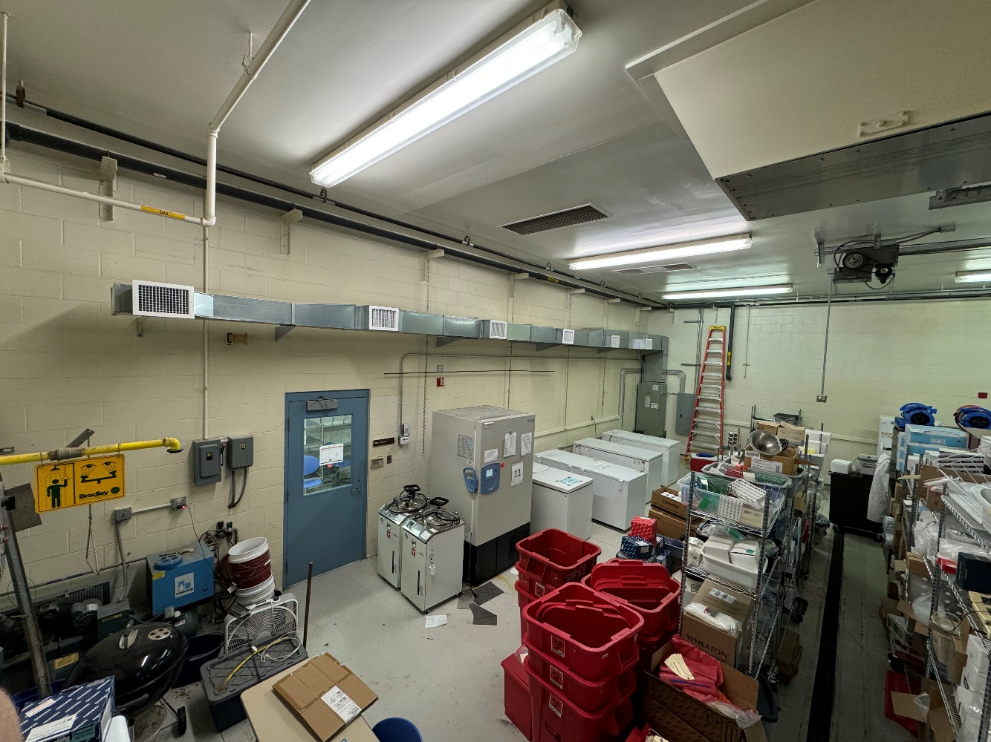
Air conditioning system installed in the Pest Management / Kinney Laboratory rm 109.

