Cultivating Indigenous Gardens within the Southern Arboretum Woodlands
Fall 2023 SSC Interim Report
Kevin McSweeney

Acc #: 1-304736-875000-acctcd-875425

Field work has been delayed as discussions about plant selection and garden design are still underway among project collaborators. Chief Benjamin J. Barnes and Joel Barnes (The Shawnee Tribe, Miami, OK) visited campus in December 2023 for discussions with Assoc. Vice Chancellor Jacki Rand, Kevin McSweeney and Arboretum Staff and Prof. Bob Schooley (Dept. Head, NRES) to discuss project plans and tour the Arboretum. Sites for woodland plantings in the Southern Arboretum Woodlands (SAW) and display gardens (e.g., medicinal, herb, vegetable) were identified in the Hartley Gardens along with opportunities for fiber (bulrush) harvesting around the ponds adjacent to Japan House.

Work started in January on site preparation in the SAW and in the Hartley Gardens in anticipation of initial Spring planting of selected gardens. Attached images show dismantling of lath structures in the Hartley Garden in preparation for establishment of display gardens and site clearance in the SAW.

Chief Barnes proposed an iterative process for plant selection for plant selection and garden design. This involves sharing of ideas and concepts among the Shawnee and other Tribes, and campus scholars in disciples such as history, plant and social sciences and colleagues in the Illinois Natural History Survey. These discussions are underway and will also include developing an outreach plan in preparation for garden installation.

In light of delays launching the crucial field component of the project, we plan to request a no-cost extension.

Attachments:
Budget
Image 1 Hartley Garden lath house demolition
Image 2 SAW site clearance

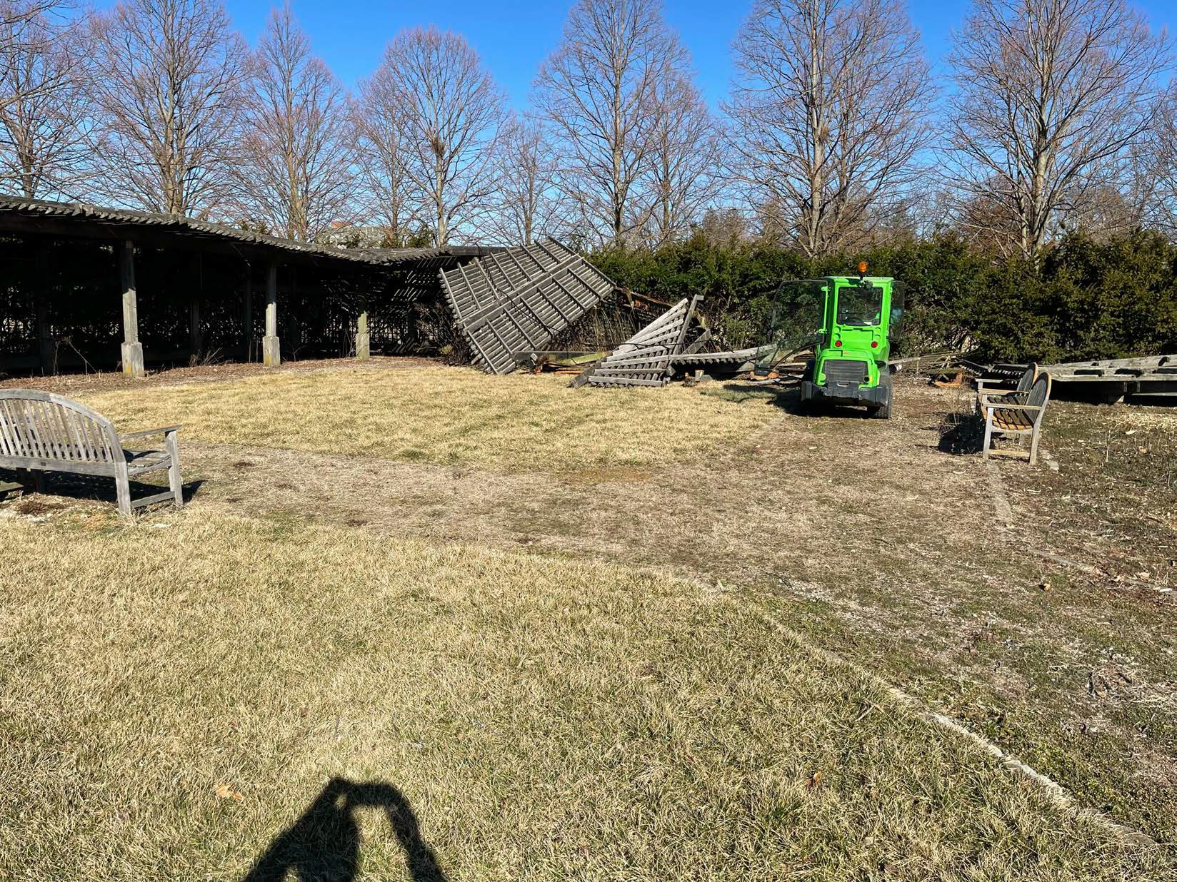

Hartley Garden Lath House Demolition

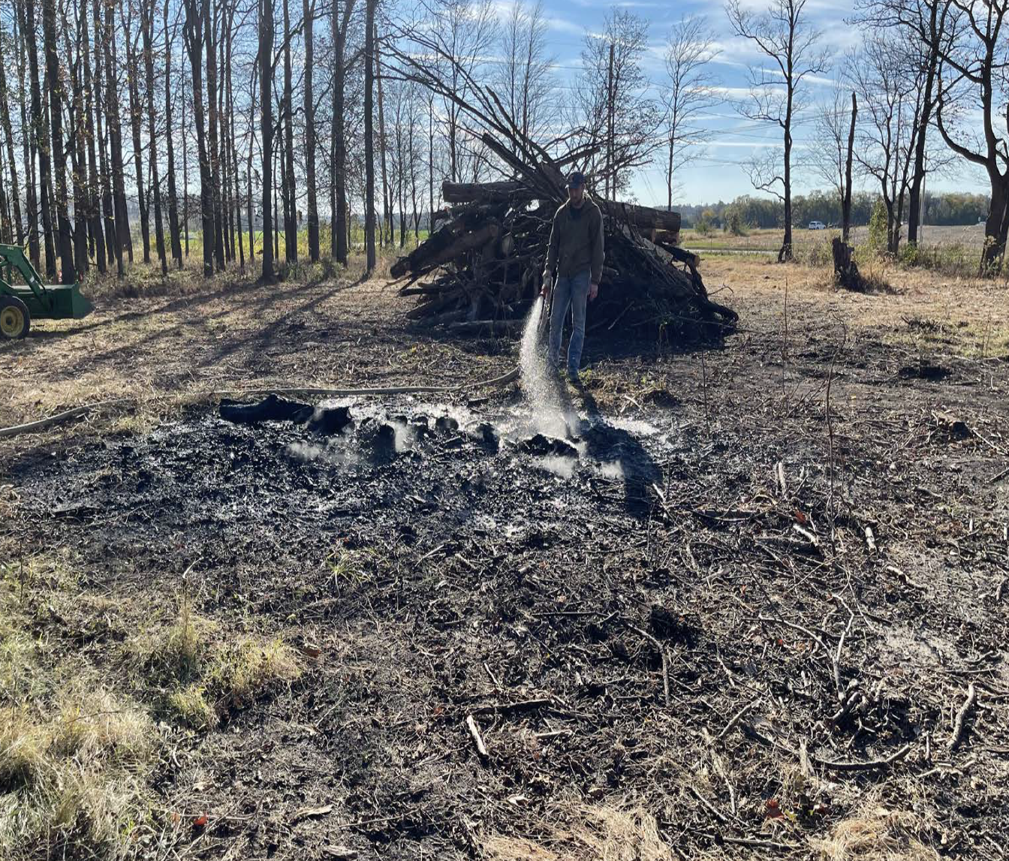

SAW Site Clearance

