Thank you for your commitment to green initiatives at the University of Illinois. One of the ongoing requirements listed in the terms of the funding agreement for your project is the submission of semesterly reports with key information about your project. In addition to this form, please provide additional financial documentation and/or progress photos if available.

Please be as accurate as possible in describing the project (including possible setbacks or challenges in meeting the initial goals of the project). Not fully meeting your project's goals will not disqualify you from making future funding requests as long as your reports are as complete and accurate as possible. If you have any questions, please contact the Student Sustainability Committee, at sustainability-committee@illinois.edu.
Project Name: Census of Trelease Woods Phase 2

Date of Report Submission: 9/13/2021

Project Purpose:
We requested funding to complete the first full inventory mapping and measuring every tree >1 cm diameter in the 24 ha Trelease Woods. During phase 1 (Fall-Spring-Summer-Fall 18-19 with SSC support) 69 students, primarily from LAS, ACES and AHS, were trained in forest inventory methods, laser mapping and species identification and collectively tagged and measured 17,675 trees. However, we were unable to complete the census (10.5 ha in the north of Trelease Woods remain to be mapped). This shortfall reflects the complexity of the challenge (organizing 8-10 teams of students working 7 days a week), weather restrictions (extremely wet Spring and early summer 2019) and under-estimation of total stem number. In our second phase of this project our objectives were to:
• Train an additional 50+ undergraduates in forest mensuration and carbon budgeting/monitoring
• Submit the census data to ForestGeo – providing access to Illinois students to forest data and internship opportunities across the global network (>70 forest sites worldwide)
• Continue our efforts this year to develop lab activities for undergrad classes that use the data to teach methods for analysis of forest carbon storage
• Educate students on the critical importance of forests in mitigating and reducing carbon emissions
• Add a new soil carbon inventory and map of Trelease Woods
• Develop a student-led environmental monitoring program at Trelease Woods aimed at correlating forest productivity and soil respiration responses to short-term climate fluctuations

Detailed Accounting of Expenditures to Date:
To date we have spent $43,005out of the $64687 available to us at the beginning of phase 2. Most of these funds ($25,108) have been used to support students as hourly workers during the Summer 2020 and Summer 2021 and during the Fall of 2020. An additional $17118 has been spent to hire graduate students (Perez, Otolski) as research assistants responsible for coordinating undergraduate census workers and for data quality control and management. A small amount ($779) has been spent on supplies for marking the plot and tagging trees

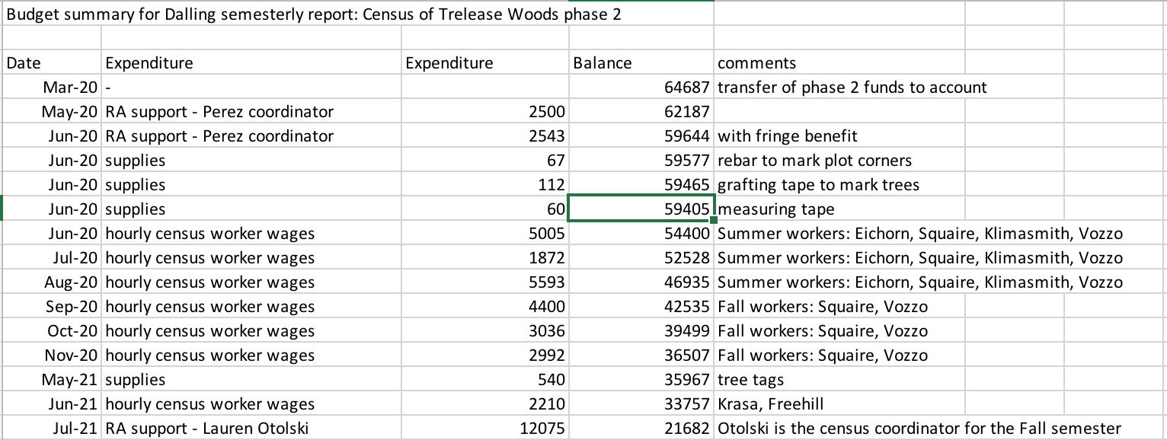

Project Progress to Date:
Please summarize your project’s progress in relation to the milestones and target dates listed in your original application.
- Completion of the Trelease Woods survey plot. COVID protocols slowed our progress on completion of the census. During Fall 2020 and Summer 2021, when social distancing needed to be maintained, we were limited to supporting a maximum of 3 students at a time in Trelease Woods. Despite this we have now completed mapping of 92% of the woods, with 4.8 acres of the 60 acre forest remaining as of September 21st, 2021. With the additional 16 NRES and 2 SIB undergrads we recruited this semester we are now on track to complete the census before Thanksgiving 2021
- Submit the census data to ForestGeo. The ultimate goal of the project is to make the full census dataset available to researchers on campus and in the international forestry community by submitting the dataset to ForestGeo. With SSC funding this semester we have recruited a Research Assistant, Lauren Otolski, who is tasked with coordinating the undergraduate census workers and with completing quality control checks of the data.
- Develop lab activities for undergraduate classes that use the data. We have integrated the existing census data into a new carbon storage lab activity for IB203 -the core undergraduate class in ecology in SIB, serving ~150 students every fall. These data are being used despite our inability to bring these students to Trelease this semester. Once the census is completed we anticipating additional lab class activities organized around using the tree data. In addition, our data are being used by 21 students in IB372, honors ecology. These students have used the dataset to support independent research projects at Trelease. Finally, Dalling presented the project to ~30 students in NRES415 Native Plant ID and Floristics.
- Add a new soil carbon inventory and map of Trelease Woods. We have completed field sampling of soils, representing in total 196 soil samples. These samples have been used to map soil nitrogen, phosphorus and base cations and are in the process of analysis for soil carbon. This should be completed by the end of the fall semester and will be done by undergrad students in the Dalling lab.
- Develop a student-led environmental monitoring program at Trelease Woods. Due to covid restrictions we have not been able to set up a program so far that involves regular monitoring of forest productivity in Trelease. We did not start this up in the fall semester as it makes more sense to begin such a program at the beginning of the growing season, rather than mid-season. This would therefore yield one complete phenological year’s dataset. We are therefore planning to start this program in the early spring (i.e., second half of the spring semester 2022) with regular measurements of litterfall and soil respiration.

Student Involvement and Outreach to Date:
Despite COVID restrictions we have been able to involve a very large number of undergrad students in this project. The students are trained in forest mapping and tree species identification and in some cases have also completed independent research in Trelease Woods. In total, we have now trained 88 students from SIB and NRES who have spent at least 4 hours per week over a semester at Trelease. (see also response above on integrating Trelease data into existing classes).

Marketing and Promotion Efforts to Date:
We are awaiting completion of the Trelease census in November to launch our major promotion event. This will be coordinated through SIB and link to NRES and will be promoted internationally by ForestGeo. We will highlight a unique feature of the Trelease census – the completion of the work by undergraduates and funded by a student stewarded organization.
In addition, we have one scientific publication resulting in part from the census work. This will also acknowledge support from the SSC.

Additional Comments:
Thanks so much for you support and patience as we have negotiated this difficult period.

