**Funding Criteria**

**A. General Rules**

1. Students, faculty, and staff are encouraged to submit requests for funding. Student-led projects require a faculty or staff sponsor in order to have funds awarded.
2. Funding can only go to university-affiliated projects from students, faculty, staff, and departments.
3. All SSC projects must make a substantial impact on students. This may be a direct impact or an impact through education and engagement. All SSC funding is 100% from student green fees, so the projects funded by the students must benefit them.
4. SSC encourages innovation and new technologies – creative projects are encouraged to apply.
5. Unless a type of expense is specifically listed below as having restrictions, SSC can generally fund it. The items referenced below should not be taken as comprehensive list.

**B. Things SSC Can Fund, On A Case-By-Case Basis**

1. SSC can fund feasibility studies and design work; however, it must work toward ultimately addressing a sustainability need on campus.
2. SSC can fund staff positions that are related to improving campus sustainability. Strong preference will be given to proposals receiving matching funding from departments and/or plans for maintaining continuity of the position after the end of the initial grant.
3. SSC can fund outreach events with a central theme of sustainability, provided their primary audience is the general campus community.
4. SSC discourages funding requests for food and prizes but will consider proposals on a case by case basis that prove significant reasoning.
5. SSC can fund repairs and improvements to existing building systems as long as it works toward the goal of improving campus sustainability; however, a preference is shown to projects utilizing new or innovative ideas.
6. SSC can provide departments with loans for projects with a distinct payback on a case by case base. Loans will require a separate memorandum of understanding between SSC and departmental leadership pledging to repay the award in full and detailing the payback plan.

**C. Things SSC Will Not Fund:**

1. SSC will not fund projects with a primary end goal of generating revenue for non-University entities.
2. SSC will not fund personal lodging, food, beverage, and other travel expenses.
3. SSC will not fund any travel expenses.
4. SSC will not fund tuition or other forms of personal financial assistance for students beyond standard student employee wages.

**Your Step 2 funding application should include this application, the supplemental budget form, and any letters of support.**

*Please submit this completed application and any relevant supporting documentation to* [*Sustainability-Committee@Illinois.edu*](mailto:Sustainability-Committee@Illinois.edu)*. The Working Group Chairs will be in contact with you regarding any questions about the application. If you have any questions about the application process, please contact the Student Sustainability Committee at* [*sustainability-committee@illinois.edu.*](mailto:sustainability-committee@illinois.edu.)

**General & Contact Information**

**Project Name:** Enhancing Ecosystem Services in the Southern Arboretum Woodlands: Habitat Improvement and Reusing Lumber

**Total Amount Requested from SSC:**

**Project Topic Areas:** X Land & Water  Education  Energy

Transportation  Food & Waste

**Applicant Name:** Kevin McSweeney

**Campus Affiliation (Unit/Department or RSO/Organization):** Arboretum/NRES

**Email Address:** mcsween@illinois.edu

**Check one:**

This project is solely my own ***OR***

X This project is proposed on behalf of (name of student org., campus dept., etc.):

UIUC-Arboretum & Dept. Natural Resources & Environmental Sciences (NRES)

**Project Team Members**

|  |  |  |
| --- | --- | --- |
| **Name** | **Department** | **Email** |
| Kevin McSweeney | NRES/Arboretum | mcsween@illinois.edu |
| Jay Hayek | NRES/Extension Forestry | jhayek@illinois.edu |
| Noah Campbell | NRES/Arboretum | noahc2@illinois.edu |
| Name | Department/Organization | Email Address |

**Student-Led Projects (Mandatory):**

Name of Faculty or Staff Project Advisor:   
Advisor’s Email Address:

**Financial Contact *(Must be a full-time University of Illinois staff member)***

Contact Name: Kelly Sullan

Unit/Department: NRES

Email Address: sullan@illinois.edu

**Project Information**

*Please review the proposal materials and online content carefully. It is highly recommended you visit a working group meeting sometime during the proposal submission process.*

**Please provide a brief background of the project, its goals, and the desired outcomes:**

*You may copy and paste your Step 1 application answer if nothing has changed.*

The goal of the project is to create a diverse mosaic of mesic woodland and savanna communities in the Southern Arboretum Woodlands (SAW) through targeted transformation of the current block-like arrangement of similar aged trees originally planted as a research plantation. A 12-acre tract in the SAW encompassing moderately well drained Catlin soil and suitable for mesic native species has been selected for this project (Figures 1 & 2). A detailed inventory of the trees within the tract will be undertaken to identify (i) trees suitable for producing high quality lumber, (ii) trees to remain as ‘nurses’ to provide canopy protection for establishment of native trees and (iii) standing dead wood trees and logs to remain to promote habitat diversity for animals, plants and microorganisms. A similar inventory will be conducted in the Illini Forest Plantations. We will use the SAW list of native trees and understory species developed by Iris Lee and reviewed by Emeritus Professors Ken Robertson and John Taft for selection of suitable species from the mesic category for planting. The understory selections include species specifically targeted for benefitting wildlife (cover, fruits for birds, flowers for pollinators etc.) Ongoing suppression of invasive species will continue as needed during site preparation and establishment of native flora. Trees selected for milling will cut by professionally certified foresters and stored at the Illini Forest Plantations. A contractor will be hired to mill the logs into lumber to specified architecturally suitable dimensions (typically 1-2” thick). The freshly sawn lumber will then be transported, stored, dried, and made available for future sustainable building projects (e.g., renovation of solar decathlon houses, planned shelter at the SAW [Figure 3], north Arboretum, and Illini Forest Plantations). Students will be hired to assist in all phases of the project and have the option of obtaining certifications in chainsaw safety, pesticide application and restoration management.

Desired outcomes include:

* 1. Establishment of species rich mosaics of savanna and woodland communities with complex structure providing an array of habitats/niches for organisms (fungi,…..small mammals) that enhance ecosystem services.
  2. Aesthetic improvement of the existing plantation landscape by creating more diverse and architecturally complex structure through irregularly shaped woodland/savanna mosaics.
  3. Sustainable re-use of harvested wood for production of lumber for departmental, college, and campus construction projects and reuse of woody debris for mulching projects.
  4. Opportunities for students to engage in the process of targeted landscape transformation and learn skills related to land management and production of lumber grade wood products.
  5. Establishment of an outdoor laboratory that is used by a broad cross-section of campus departments and other approved groups.

**Where will the project be located? Are special permissions required for this project site?**

*If special permission is required for this location, please explain and submit any relevant letters of support with the application.*

Figures 1 & 2 provide images of the project site location, which is bordered to the west by Lincoln Ave and to the south by Windsor Rd. Project Team Leader, Kevin McSweeney is the Arboretum Director and responsible for activities on site. He will consult as needed with campus, F&S and ACES colleagues, Ameren and City of Urbana as specific needs arise. For example, Ameren has already been consulted about tree trimming along their utility right-of-way.

**Other than the project team, who will have a stake in the project? Please list other individuals, groups, or departments affiliated directly or indirectly by the project. This includes any entity providing funding (immediate, future, ongoing, matching, in-kind, etc.) and any entities that benefit from this project.**

*Please attach letters of commitment or support at the end of the application.*

The Arboretum projects have received considerable in-kind and volunteer support.   The Arboretum staff operates a large chipper and chain saws (purchased from funds provided by The Departments of NRES and Crop Sciences) during volunteer work-days.  NRES Extension forester, Jay Hayek, trains students in the use of chainsaws and herbicides and assists on workdays as a volunteer and he fully expects to allocate over 100 hours to this project.  Dr. John Marlin spends many volunteer hours coordinating this and several other native planting projects. UIUC South Farms and the Turf Research Center provide additional support in terms of expertise and short-term equipment loans (grain trucks for hauling wood chips etc.). The Arboretum purchased with funds ($65,000) from the Offices of the Provost and the ACES Dean, an Avant Loader, which is an articulated vehicle designed to work with a variety of specialized attachments (e.g., forks, bucket, tree shear, winch). This vehicle with appropriate attachments will be a key tool for thinning of the woodlands, which is an important component of the proposed project. A private donor has provided funds for purchase of a log grabber ($10k) for the Avant loader, which will appreciably improve the efficiency and safety of tree felling operations and transportation/storage of logs. The donor also provided funds ($20k) for purchase of a small utility vehicle that is dedicated for work in the SAW (Figure 4).

The Pollinatarium provides a staging area and logistical support. Additionally, several staff and faculty members have contributed time and expertise and encouraged students to help with the projects.

The Red Bison student organization is the core of the volunteer effort scheduling regular work-days.  Red Bison will soon have a shed (funded by SSC, Figures 2 & 5) installed on the project site. The shed will be used for storing their equipment and serve as a gathering space for volunteer work parties. Other campus organizations and several classes have participated in work-days at the SAW.  Numerous community members join the students on work-days.  For example, the Master Naturalist Program members receive volunteer credit for helping with campus native planting projects.

Kevin McSweeney is working with Prof. Debra Korte (Ag. Leadership Education and Communication Program) to promote the SAW as locus for High School Ag Science Teacher Education and for use by High School Land Judging teams and 4-H Chapters from around Illinois. A variety of Summer Programs hosted by campus units use the SAW and will we will continue to promote its use among these groups. These efforts are being cultivated a soft recruitment events for future Illini

**How will this project involve and/or benefit students?**

*This includes both direct and indirect impact.*

We plan to involve students in all phases and elements of the project. Red Bison (an RSO focused on restoration ecology) is establishing its new equipment storage shed on the project site. Red Bison have been a key partner with the Arboretum since work commenced at the SAW over 4 years ago and will continue to work with us on this project. Student hourlies will be hired to assist with all aspects of field work including – tree cutting, planting, invasive species management, mulching and monitoring of project objectives. Interested students will have the opportunity to obtain certification in chain saw safety and pesticide application, which are valuable additions to resume for students focused on natural resource management. Students will learn about the ‘Roots to Roof’ project from standing tree to finished dimensional lumber and possibly sustainable building construction. The project will improve the utility of the SAW as an outdoor laboratory. The SAW has seen an increase in use for UIUC classes in soil science, wildlife ecology, dendrology and plant ecology in the last 2 years. The three soil pits (Figure 6) at the Arboretum have also been used by high school vocational agricultural students, students from other universities and the UDSDA-NRCS for training workshops.

Student involvement is a key to this project. Well over 300 have volunteered. Red Bison has regular work-days at the SAW. Community involvement has included Master Naturalists, Master Gardeners, a Boy Scout troop and several service organizations. Students take advantage of the opportunity to experience first-hand some of the activities that are a part of working in natural resource professions. Many of them receive herbicide training and some obtain licenses from the Illinois Department of Agriculture. Others complete chain saw training and use powered weed trimmers. Several of the students were interviewed by local news stations.

The project exposes students to a wide range of experiences. They prepare seeds, plant them in the greenhouse, and transplant them to the field. They have the opportunity to scatter seeds and plant bulbs and rhizomes in the woods. They also learn to identify various types of plants. Many of the volunteers just find it exhilarating to occasionally get outdoors and do some physical labor.

Student volunteers and hourly workers, including recent graduates, have been heavily involved with phase I of this project. The student organization Red Bison regularly schedules work-days at the site and several classes have provided credit opportunities for student participants. Additionally, many community members have worked with the students at the site. This phase will expand the opportunities. In particular, Jay Hayek (NRES-Forestry Extension) will be providing interested students with basic chainsaw (8-32 hrs) and herbicide application (8-12 hrs) training. These technical skills provide valuable additions for building student resumes along with portfolios of ‘hands-on’ experience. The Arboretum staff has run a chipper on numerous occasions when groups of up to 20 student volunteers brought material to the chipper. In short, the project has provided many students a firsthand look at a serious ecological challenge and an opportunity to help correct it. Longer term, we anticipate developing classes that explore the theory and practice of restoration ecology using the site for field investigation and practical training.

**How will you bring awareness and publicize the project on campus? In addition to SSC, where will information about this project be reported?**

NRES and the College of ACES will produce news features about the project, which are distributed through various outlets to faculty, staff, students, alumni and friends of ACES. UIUC-Extension through its Master Naturalist, Master Gardner and Forestry and Natural Resources programs will produce and distribute news and information articles about the project. These audiences include campus along with many alumni and friends of UIUC around the state. The Arboretum periodically receives requests for news stories from the News Gazette (Champaign Urbana daily newspaper) and other media outlets, which will provide an opportunity to highlight this project. In addition, we plan to host several field days to showcase the project for interested campus and community members along with urban foresters and small woodlot owners/managers.

Signage on-site will include three permanent fixtures adjacent to the soils pits with SSC acknowledgement along with rotating (temporary) signage designed to illustrate current project activities and seasonal ecological issues. A hired undergraduate student(s) will also create an interactive ArcGIS Online Story Map that will highlight the history and progress of all the aforementioned initiatives.

We plan a celebratory event for the official opening of the soil pits, which will include acknowledgement of SSCs role in developing the SAW as a campus resource for students. This event has been delayed because of meeting restrictions imposed due to the COVID-19 pandemic.

# Financial Information

*In addition to the below questions, please submit the supplemental budget spreadsheet available on the Student Sustainability Committee* [*website*](http://ssc.sustainability.illinois.edu/?page_id=2087)*. Submission of both documents by the submission deadline is required for consideration of your project.*

**Have you applied for funding from SSC before? If so, for what project?**

Enhancing Learning and Volunteer Opportunities in the Southern Arboretum Woodlands ($40k) Fall 2018

Native Plantings at the Arboretum ($50k) Fall 2016

**If this project is implemented, will you require any ongoing funding required? What is the strategy for supporting the project in order to cover replacement, operation, or renewal costs?***Please note that SSC provides funding on a case by case basis annually and should not be considered as an ongoing source of funding.*

We anticipate that volunteer efforts along with class related projects will assist Arboretum staff in long term management of the area. In addition, we will aggressively seek grants and private funding to enhance the utility of the area for education/outreach, applied research and recreation. For example, Kevin McSweeney has developed a concept note for the UIUC Foundation that outlines donor opportunities for funding the proposed shelter for the SAW (Figure B) that would serve as a hub for field classes, work parties and other gatherings. This proposed project would utilize lumber derived from this project.

We are exploring an opportunity to apply for a USDA Higher Education Challenge Grant in Fall 2020. A successful field season this year with demonstrable progress will likely improve chances of success in this competition.

**Please include any other obtained sources of funding. Have you applied for funding elsewhere?**

*Please attach any relevant letters of support as needed in a separate document.*

Please see section on other stakeholders for in-kind and direct project support. Jay Hayek, NRES Extension Forester, will be donating over 100 hours of in-kind match to this effort with a value equal to $4846.00.

# Environmental, Economic, and Awareness Impacts

**How will the project improve environmental sustainability at the Urbana-Champaign campus? If applicable, how does this project fit within any of the** [**Illinois Climate Action Plan**](https://icap.sustainability.illinois.edu/) **(iCAP) goals?**

Partial capture of carbon stored in a 55+ year-old plantation via salvage and reuse of lumber for sustainable building projects. Reuse of other woody debris for mulch. Establishment of new native plantings to enhance biomass and soil capture of carbon dioxide. Improved and diversified ecosystem services via new plantings creating multistoried canopy architecture with expectation of improved habitat for animal, plant and microbial communities. Anticipated enhancement of ecosystem services includes improved landscape hydrology, soil structure and reduction in soil erosion; more diverse, seasonally varied and abundant food sources (fruits and berries) and pollen sources (flowering trees and shrubs) for fauna; richer and more diverse substrates/habitats for microorganisms, insects and small mammals and reptiles. Aesthetic improvement of the project area through transformation of the plantation towards a deciduous woodland with savanna openings. It is anticipated that through documentation of the transformation process (photos and ArcGIS Online Story Maps), lessons will be learnt that will serve as guide and a stimulus for improving ecosystem services in similar degraded woodlands in other urban and suburban areas of east central Illinois.

The project is not designed as a classic restoration in which an attempt is made to recreate a representation of a prior native ecosystem. The site history and modifications to the surrounding landscape (e.g. drainage, urbanization) frustrate an attempt to recreate a wet grading to mesic prairie, the likely precursor native ecosystem to its subsequent tile drained modification for agriculture. The site’s more recent history as an experimental research forestry plantation adds further complexity to conceiving what might be a ‘native’ ecosystem. Our approach is to remodel the landscape through removal of undesirable species, protection of desirable species and introduction of management practices and new species that will enhance biodiversity and other ecosystem services. As such our project is a novel experiment in landscape remodeling that will test the feasibility of improving important ecosystem services and functions including: pollinator habitat and services, habitat for other insects, fungi, lichen, birds, small mammals etc.; soil and biomass carbon storage and optimal water infiltration and storage. **In this sense the project is distinctive if not unique and will add a new dimension to the exploration and investigation of sustainability at UIUC.**

**How will you monitor and evaluate the project’s progress and environmental outcomes? What short-term and long-term environmental impacts do you expect?**

*Some examples include carbon emissions, water conservation, green behavior, and reduced landfill waste.*

Aerial imagery from low-level drone flights will be used to monitor extent/success of invasive species removal. A series of student-centered research projects will be developed to collect baseline and ongoing data on soil organic carbon storage, avian, mammal and insect ecology along with extensive surveys of plants including mosses, lichens and liverworts. Phenological observations will be recorded and photographed.

**What are your specific outreach goals? How will this project inspire change at UIUC?**

This project encompasses all three elements of the university’s Land Grant Mission: Teaching, Research, and Extension. Specific outreach goals include demonstration, student engagement, experiential learning, and hands-on training. By involving our students at the onset of this project, and those efforts that preceded it, the investigators firmly believe future students will no doubt be compelled and motivated to carry the torch of all future efforts and proudly inherit their new found role as “student stewards” of the South Arboretum Woods – now and forever!

**If applicable, how does this project impact environmental injustice or social injustice?**

Not directly applicable, however, elements of the project could serve as models for re-purposing degraded land in low income neighborhoods for purposes of improving quality of life and civic pride.

__________________________________________________________________________________________

Budget Notes (COVID-19 Contingencies)

1. Funding is requested to hire Undergraduate Academic Hourlies for Summer 2020. However, it is unclear whether COVID-19 restrictions on campus will permit hiring students this summer. McSweeney has developed at the request of the Dr. Germán Bollero (Assoc. Dean Research, ACES) protocols for sanitary practices and social distancing for field work at the Arboretum. If undergraduates are authorized for Summer employment at the Arboretum, these protocols will be faithfully employed.
2. Noah Campbell has been authorized to work on Arboretum grounds as of April 13, 2020 and will be available to work on the project along with McSweeney & Hayak. In the absence of student assistance, we anticipate we could make a good start on the project. Campbell, an experienced forester is chain saw certified and has a pesticide applicators license and is scheduled to devote 75% of his time to the project. McSweeney is available to assist 2.5 days/week and Hayak is able to devout about 60 to 100 hours to the project during Summer 2020.
3. In light of the uncertainty surrounding the feasibility of conducting full-scale field work, we request that if the project is funded, consideration be given to adjusting the project timeline during this unpredictable period imposed by the pandemic.

__________________________________________________________________________________________

**FIGURES 1-6 ILLUSTRATED ON FOLLOWING PAGES**

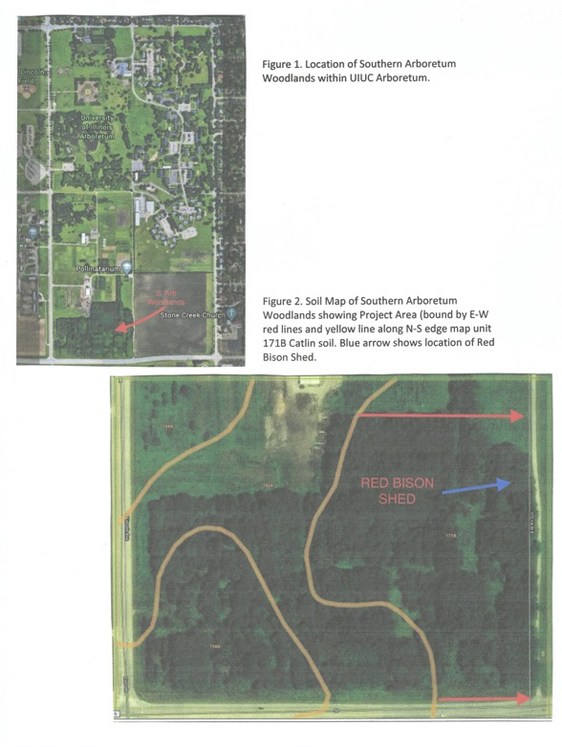

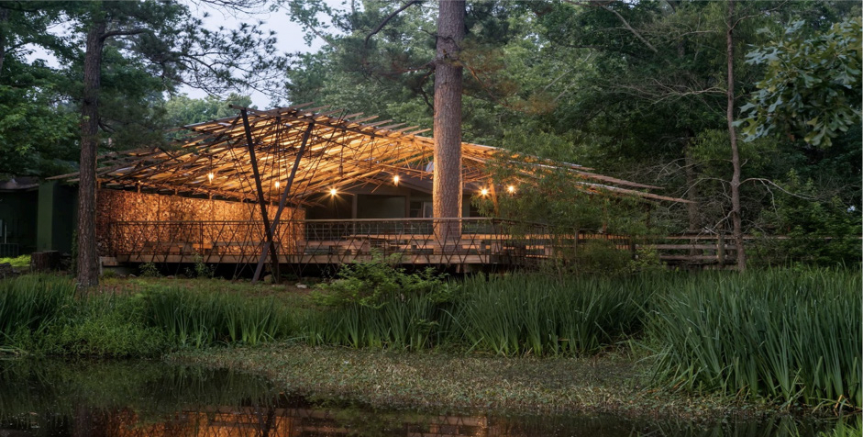

Figure 3. Representation of Wooden Shelter (We are planning for shelter in the SAW built from lumber harvested on-site).

Figure 4. Gravelly utility vehicle (A similar vehicle has been purchased for use exclusively in the SAW).



Figure 5. Red Bison Shed soon to be installed on-site at the SAW

Figure 6. Arboretum Soil Pit: Drummer silty clay loam (Illinois State Soil)