# *Thank you for your commitment to green initiatives at the University of Illinois. One of the ongoing requirements listed in the terms of the funding agreement for your project is the submission of semesterly reports with key information about your project. In addition to this form, please provide additional financial documentation and/or progress photos if available.*

# *Please be as accurate as possible in describing the project (including possible setbacks or challenges in meeting the initial goals of the project). Not fully meeting your project's goals will not disqualify you from making future funding requests as long as your reports are as complete and accurate as possible. If you have any questions, please contact the Student Sustainability Committee, at* [*sustainability-committee@illinois.edu*](mailto:sustainability-committee@illinois.edu)*.*

**Project Name:** Membrane-based Removal of Water from Oil

**Date of Report Submission:** 09/15/2020

**Project Purpose:**

Biodiesel often has emulsified water as a result of water washing. Our project involves vacuum filtration through a hydrophilic membrane to demulsify water-in-oil emulsions. In this process, tiny water droplets coalesce near the pore surface, while the aqueous phase penetrates through the membrane with oil. This leads to spontaneous formation of two separate phrases, oil and water. Through this process, the water content in kerosene sharply decreases, increasing the electric resistance by almost 40 times. The purpose is to do the same with biodiesel.

**Detailed Accounting of Expenditures to Date:**

Please detail your expenses to date. Feel free to attach an additional spreadsheet as needed.

|  |  |
| --- | --- |
| Student wages | $2328.40 |
| Equipment/supplies |  |
| Total spent |  |

**Project Progress to Date:**

|  |  |  |  |  |  |  |
| --- | --- | --- | --- | --- | --- | --- |
| **Task** | | **Timeframe (# of weeks to completion)** | | **Estimated Completion Date** | | **Actual Completion Date** |
| Gather Equipment | | 2 | | End of January 2020 | | End of January 2020 |
| Assemble System Prototype | | 2 | | Mid February | | 02/12/2020 |
| Preliminary Water Testing and System Adjustment | | 3 | | End of February | | 02/12/2020 - 03/11/2020 |
| Oil Testing- Olive Oil | | 6-9 | | End of March - Mid April | | TBD |
| Various Oil Tests | | 9 | | Late June - Mid July | | TBD |
| Biodiesel Tests | | 9 | | Late September - Early October | | TBD |

**Student Involvement and Outreach to Date:**

The entire project is student led, and all tests and calculations are completed by the undergraduate researchers. As for outreach, a comprehensive technical report including all data gathered, along with extensive background and predictive calculations has been written.

**Marketing and Promotion Efforts to Date:**

N/A

**Additional Comments:**

* Majority of testing and planned work on the system was postponed after 03/11/2020 due to COVID-19 pandemic preventing work in the laboratory.

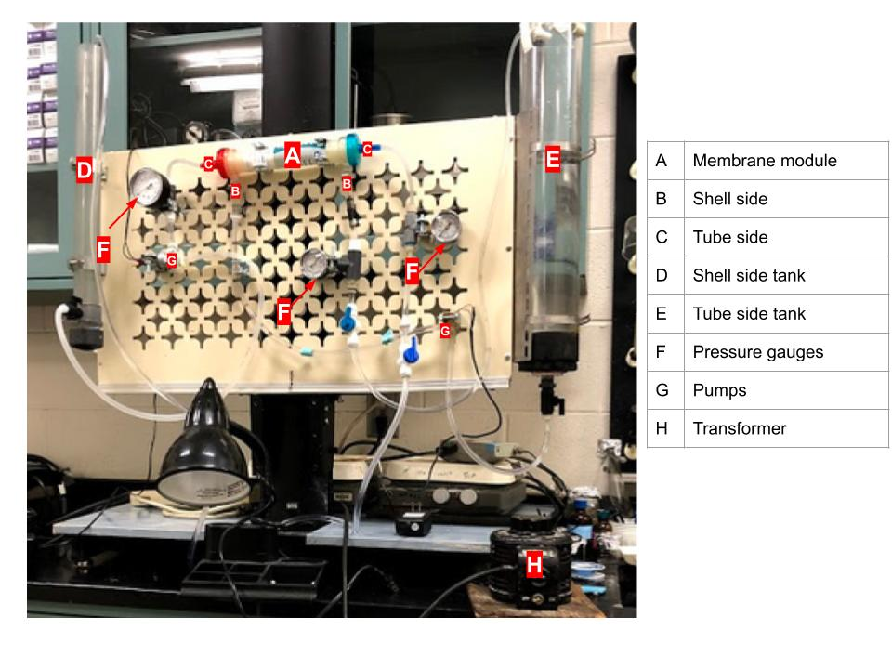

Diagram of preliminary system setup