# *Thank you for your commitment to green initiatives at the University of Illinois. One of the ongoing requirements listed in the terms of the funding agreement for your project is the submission of semesterly reports with key information about your project. In addition to this form, please provide additional financial documentation and/or progress photos if available.*

# *Please be as accurate as possible in describing the project (including possible setbacks or challenges in meeting the initial goals of the project). Not fully meeting your project's goals will not disqualify you from making future funding requests as long as your reports are as complete and accurate as possible. If you have any questions, please contact the Student Sustainability Committee, at* [*sustainability-committee@illinois.edu*](mailto:sustainability-committee@illinois.edu)*.*

**Project Name:** ***Electrical and Computer Engineering Building (ECEB) Interactive, Energy Education/Production/Use Display***

**Date of Report Submission:** 2/21/2022

**Project Purpose:**

ECEB is projected to achieve zero-net energy because of its super-efficient design and construction materials (It has already achieved LEED Platinum certification) when the installation of the building’s solar panels producing .3 megawatts of power is added to 1.2 megawatts of solar renewable energy credits (SRECs), the amount already contracted with Facilities and Services, from Solar Farm 2. Although the zero net energy certification process is not yet complete, the building is currently operating at zero net energy, as the SRECs have been purchased and Solar Farm 2 is producing more than this amount of renewable energy.

This display has three goals. The first is to teach students (3,000-4,000 pass through the lobby daily), faculty, and campus visitors (including 10,000 from Engineering Open House) about energy use while presenting relatable and significant ways they can reduce energy-consumption patterns (see explanation and pictures below).

The second is to show--in real time—energy produced by our solar installation, including research panels funded primarily by the SSC and the remainder of the array, and ECEB’s allotment from Solar farm 2, as well as energy used.

The third is to demonstrate ECEB's efficiencies and document its progress toward certification as the first zero-net status building on campus. The display also validates the buildings’ LEED Platinum certification.

|  |  |  |  |  |  |  |  |  |
| --- | --- | --- | --- | --- | --- | --- | --- | --- |
| |  |  |  |  |  |  | | --- | --- | --- | --- | --- | --- | | |  | | --- | | **Detailed Accounting of Expenditures to Date:** |   **NEC Multisync 75" Ultra High Definition 3840x2160 LED Monitor** 1 5139426 **$2,940.35**  Mfg. Part#: C751Q, UNSPSC: 43211902, Contract: IPHEC 1DGS1306 Computer  Peripherals iBuy (CN-00006509)  **NEC OLR-751 - touch overlay - USB** 1 5139534 **$2,244.70**  Mfg. Part#: OLR-751, NSPSC: 43211712, Contract: IPHEC 1DGS1306 Computer Peripherals iBuy (CN-00006509)  2 SeePoint Interactive Kiosk Systems $**8,294.60**   |  |  |  | | --- | --- | --- | | **3 Intel Compute** BOXSTK2M3W64CC | CDW Part: 3983691**Sticks $1,169.76** |  | $401.98 |   Facilities operation to install 75” screen and support for poster above **screen $1,146.21**  **Printing costs to show two versions of poster allowing choice $9.00**  Poster showing ECEB is 100% solar powered is printed and installed above 75” screen **$218.00**  Solar phone charger awarded for Energy Efficiency Day (see below) **$50.46** Programming money for total of 3 years ($500/year) to RSO to update kiosks **$1500.00**  **Total spent so far $17,573.08** |  | |  |  | |

$15,795.62 was spent to pay for the two kiosks and install and pay for the 75” screen and touch capability. We were able to use ECE department funds to pay F&S John Summers to find the building breakdown of circuits. A total of $1,500 ($500/year for three years) -- transaction OKed on 12/15/2021-- has been promised to the computer science RSO for their supporting students (headed by Mitchell Bifeld and Smit Purohit) to update the kiosks through 2023, while the equipment is under warranty (three-year warranty was included in price of the hardware components). The goal is to keep the kiosks current with announcements and other program changes. Various announcements have been added including: Friday Lights Out and the solar phone charger drawing for Energy Efficiency Day, October 6th. A solar phone charger which cost $50.46, was awarded in a random drawing to *Elaine Minghui Wang* (see details and pictures below). A drawing for Earth Day, April 22nd will be held and a second phone charger will be awarded. We expect it to cost about the same as the first. We will have both drawings each year, for a total of three years, or longer, depending on funds available.

**Project Progress to Date:**

Kiosks have been installed and were programmed for Engineering Open House 2021 <https://ecebenergykiosk.web.illinois.edu/>. More than 44 people have committed to some energy-saving action(s). The 75” touch screen has been installed with touch capability at the base of the screen. Touch options include building efficiencies, drone views of the ECEB solar panels, energy being produced by the ECE solar panels in real time, and an F&S dashboard showing energy produced from the ECE solar panels and by Facilities and Services, and energy being used, all in real time. I am still working with a person about analyzing atmospheric conditions that affect the solar panel production (and programming this information in interesting ways) and ECEB energy use. We may also add a history component.

We expect to use the SSC funds to include the programming on atmospheric conditions to help present Energy In, Energy Out, and Energy Influencers. This information will also be helpful for energy research being conducted by the Power and Energy Group.

We also hope to add a touch option that shows energy use in various parts of the building. This is dependent on Senior Design students taking on the project. Some work was done during the Spring 2021 semester, but due to COVID restrictions, the hardware has not been completed.

**Student Involvement and Outreach to Date:**

Undergraduate students programmed and filmed the kiosk touch displays. For this project they were awarded corporate sponsorship in Engineering Open House:

**From:** Kindratenko, Victoria V <[kndrtnk2@illinois.edu](mailto:kndrtnk2@illinois.edu)>  
**Date:** Tuesday, March 23, 2021 at 10:56 PM  
**To:** Bifeld, Mitchell Ian <[mbifeld2@illinois.edu](mailto:mbifeld2@illinois.edu)>  
**Subject:** EOH Project Sponsorship by Synchrony

Hi Mitchell,  
I hope you’re doing well and staying healthy!   
Congratulations, your EOH project has been chosen out of many to be sponsored by one of EOH’s corporate sponsors this year, Synchrony. They loved your idea and were impressed by how interactive the kiosks in ECEB are. As a result, your EOH project submission has been modified to include the EOH and Synchrony logos at the beginning of the video.

Let me know if you have any questions, comments, or concerns,   
Victoria

Engineering Open House  
Junior Corporate Director

It is primarily undergraduates who have signed a pledge to reduce their energy use is one or more of the ways outlined in the program (see above). They have each received a response written and sent by Emily Dickett, undergraduate SSC intern of Meredith Moore:

**From:** Dickett, Emily Ann <[dickett3@illinois.edu](mailto:dickett3@illinois.edu)>   
**Sent:** Sunday, September 19, 2021 3:39 PM  
**To:** Dickett, Emily Ann <[dickett3@illinois.edu](mailto:dickett3@illinois.edu)>  
**Subject:** ECEB Energy Kiosks - Thank You for Signing the Pledge!

Hello!

Thank you for taking the time to learn more about sustainability and energy consumption, and for signing the pledge to use less energy at the kiosks in the Electrical and Computer Engineering Building. Nearly 20% of energy is unnecessarily wasted each day; very simple steps exist to reduce that number, such as turning off the lights when you leave a room or unplugging devices and cords when we aren’t using them. Other examples include replacing inefficient appliances (like lightbulbs!), which can also save money! Signing the pledge to be more conscious of your energy is a great step toward leading a more sustainable life. Here are a few other ways to learn more and get involved with sustainability on campus:

* [Subscribe to the iSEE (Institute for Sustainability, Energy, and Environment) Newsletter!](https://forms.illinois.edu/sec/5031776)
* Comprehensive [Sustainability Calendar](https://sustainability.illinois.edu/outreach/calendar/)
* Check out the [iCAP Portal](https://icap.sustainability.illinois.edu/) where we list and track our projects and progress
* Read the [Illinois Climate Action Plan (iCAP)](https://icap.sustainability.illinois.edu/) to learn about the campus’ sustainability goals
* iSEE offers a sustainability minor and certificate in environmental writing here: [SEE Fellow Program](https://sustainability.illinois.edu/education/sustainability-minor/).
* Collaborate with the[Student Sustainability Committee (SSC)](https://ssc.sustainability.illinois.edu/?page_id=31), apply for project funding, and/or join a working group
* Help with sustainability research or project - reach out at [sustainability@illinois.edu](mailto:sustainability@illinois.edu)
* Look into joining an [iCAP Team](https://icap.sustainability.illinois.edu/project/sustainability-working-advisory-teams-swateams). There are a limited number of student voting positions available; please reach out if you are interested because there may be an opportunity!
* Are you part of an office or Greek chapter, or do you host events? Certify as ‘green’ here: [Certified Greener Campus Programs](https://sustainability.illinois.edu/green-certifications/)
* [Sign the Use the Bin Pledge](https://forms.illinois.edu/sec/1269272?referrer=https://webtools.illinois.edu/20191107091953.action?componentId=7) to always recycle and use the recycling bin!
* Talk to your friends and peers about sustainability to help incorporate a culture of sustainability at U of I’s campus. Lead by example!

If you have any questions about energy consumption or sustainability in general, feel free to respond to this email with your comments or reach out to campus sustainability staff at [sustainability@illinois.edu](mailto:sustainability@illinois.edu). Again, thank you for your commitment to use less energy!

Thank you,

Emily Dickett, iSEE Sustainability Intern

**Marketing and Promotion Efforts to Date:**

See corporate sponsorship and solar phone-charger promotions for Energy Efficiency Day and Earth Day above.

**Additional Comments:**

Because of COVID, there have been a number of delays in getting our display up and running. The SSC committee approved our Scope Change for an expended timeline on this project on September 29, 2921. The project is ongoing and has lots of undergraduate involvement. The display will also be a focus point when ECEB celebrates achieving zero net energy to the grid, next year, the first building on campus to do so! Another poster, somewhat larger, is already in the works for this celebration. The SSC logo is prominently displayed in the kiosk program and on the poster.

The first Solar Phone Charger drawing was held digitally:

**From:** Moore, Meredith Kaye < [emwang2@illinois.edu](mailto:emwang2@illinois.edu) >   
**Sent:** Tuesday, October 12, 2021 4:45 PM  
**To:** Wang, Elaine Minghui <[emwang2@illinois.edu](mailto:emwang2@illinois.edu)>  
**Cc:** Mast, Joyce C <[jmast@illinois.edu](mailto:jmast@illinois.edu)>  
**Subject:** Congratulations!

Congratulations, Elaine!

You were randomly selected as the winner of the Energy Efficiency Day solar charger as a result of signing the sustainability pledge in the ECE Building. We are so glad that you have made the commitment to use less energy and live a more sustainable lifestyle. October is Campus Sustainability Month, and there are many sustainability event opportunities to get involved, though I would especially like to highlight the Campus Sustainability Celebration from 1 – 4 PM at NCSA. This event is welcome to all and I hope you can make it! [Click here for more information.](https://sustainability.illinois.edu/outreach/calendar/).

We will be in touch shortly to coordinate a time for you to receive the prize. Thank you and once again, congratulations!

Meredith

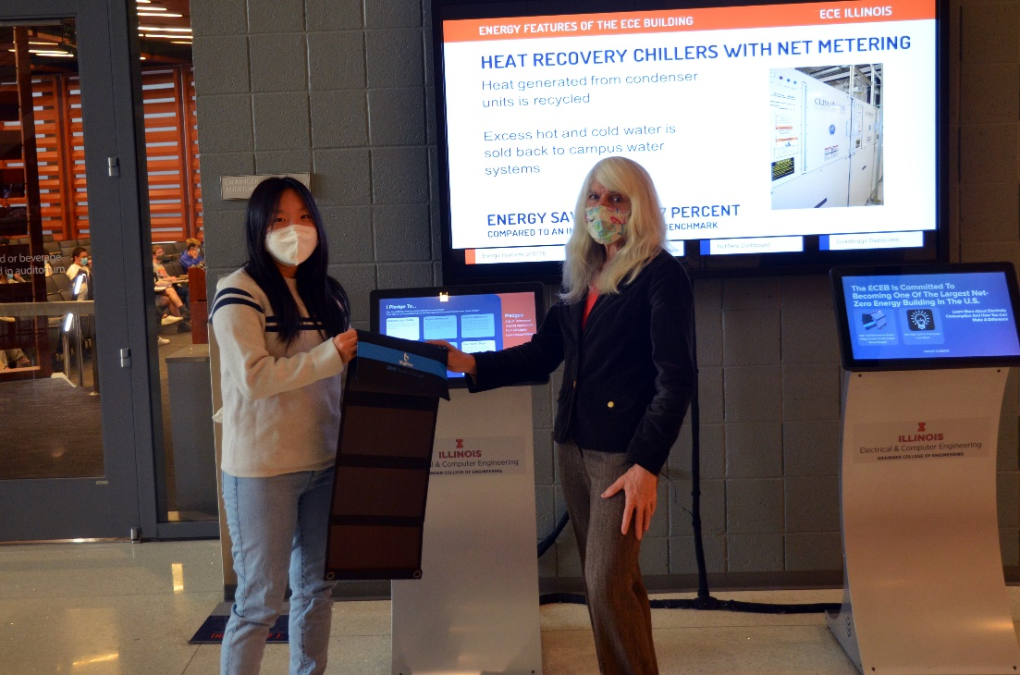

Elaine is a Computer Science major who had a class in the Grainger Auditorium (see background on left side of photo above) and stopped to interact with the energy kiosk. She chose to conserve heat and ac and turn off the lights when not in use. She also said she would unplug appliances when not in use (see photo below for choices).

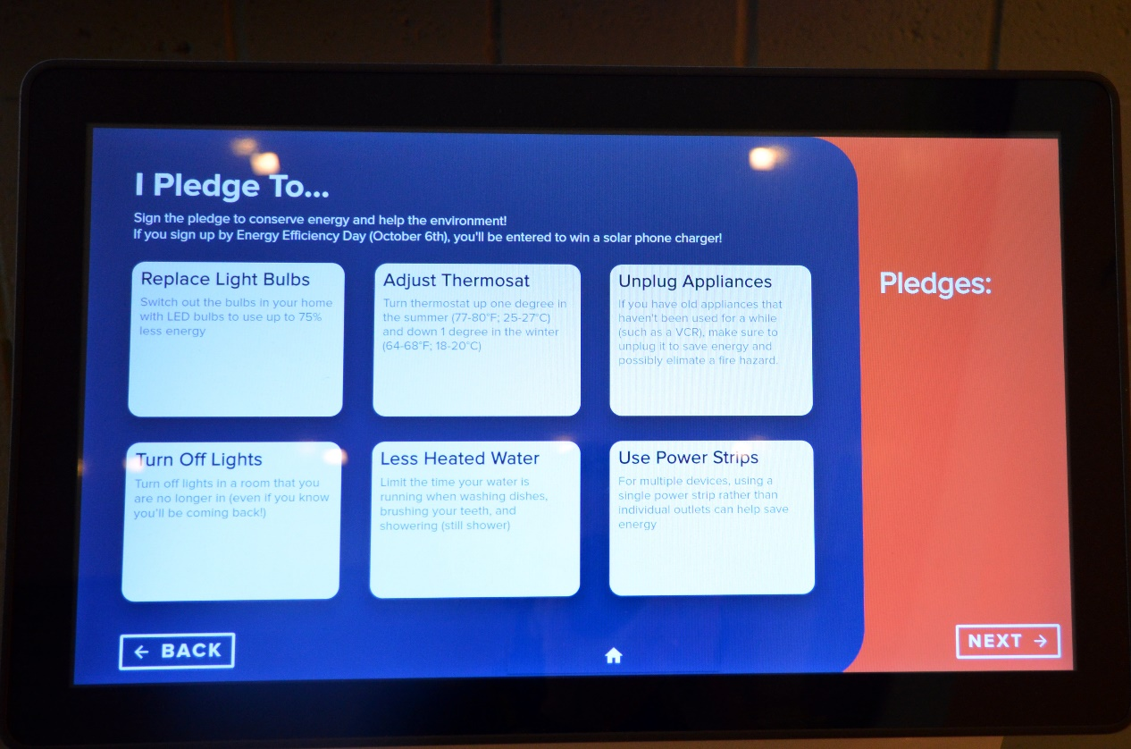

Elaine walks or takes the bus to save energy for transportation to classes. She has checked out the large screen display showing how much energy ECEB is using and producing. She thought perhaps in the future we could run a contest for conserving energy.