# *Thank you for your commitment to green initiatives at the University of Illinois. One of the final steps in completing the terms of the funding agreement for your project is the submission of a Final Report with key information about your project. You will also need to submit a detailed report of expenses (if you don't list it within this document) as well as supporting photos to showcase your project.*

# *Please be as accurate as possible in describing the project (including possible setbacks or challenges in meeting the initial goals of the project). Not fully meeting your project's goals will not disqualify you from making future funding requests as long as your reports are as complete and accurate as possible. If you have any questions, please contact the Student Sustainability Committee, at* [*sustainability-committee@illinois.edu*](mailto:sustainability-committee@illinois.edu)*.*

**Project Name:** Engineering Hall VAV Box Upgrades

**Date of Report Submission:** 1/21/2020

**Project Purpose:**

Upgrade variable air volume (VAV) boxes to Direct Digital Controls and room level occupancy sensors in Engineering Hall. These measures will allow for scheduling and programming the air flow to the areas served, which will reduce the energy consumption for heating, cooling, and electricity. Currently the space is utilizing pneumatically controlled devices, which were not able to be adjusted on a schedule, so they ran constantly at one specific set point. This results in a lack of ability to adjust to changing environmental conditions and results in less than optimal operating conditions. Making these scheduled systems for different settings will lower the unnecessary energy consumption in a building that gets a lot of use.

**Project Summary:**

Significant energy reductions were achieved as part of the re-commissioning process. Many items were attended to in the building, where other funding sources were also involved.

This project was completed over the span of 5 months, starting in July (2019) and ending in November (2019) The project originally was to convert one floor from pneumatic to DDC control using SSC funds. Facilities and Services provided additional funds and two floors, for a total of 54 boxes that were converted to DDC control with occupancy sensors. These upgrades, along with Facilities and Services recommissioning group going through the building, have resulted in approximately 50% utility reduction for FY18-FY19. These initiatives have greatly impacted the total energy expense for the building. These savings are observed in the monthly chart below, with January having the biggest saving YTD at $16,602.

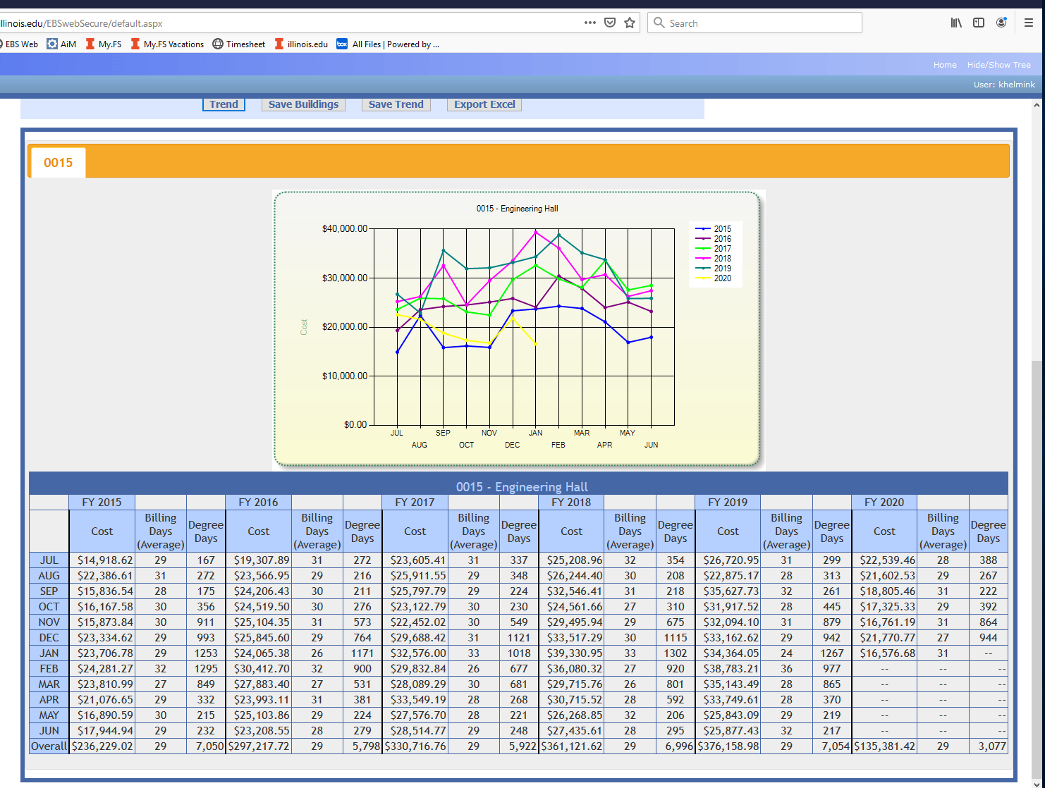

**Summary of Project Expenditures:**

The 1st and 4th floors were converted to DDC for a total cost of $129,388, with $57,214 in labor and $46,385 in material. The Recommissioning process had a total cost of $575,000. In total, $104,600 of SSC funding was spent on this project.

There is no way to calculate how much savings were achieved directly from converting the boxes to DDC alone since that work and the recommissioning process were performed simultaneously, but a simple payback calculation for the total initiative is just under 4 years. This is using the total utility expense for FY19 at $376,158 and assuming we continue to have a 50% decrease in utilities.

**Problems/Challenges Encountered**

There are always challenges when performing project work in a fully occupied building. There is significant amount of coordination with the occupants on getting access to office spaces, labs and classrooms.

This was one of the first buildings utilizing a different VAV controller that provided some additional outputs needed for room control. It was observed that these controllers had issues controlling at the lower air flows so minimums were required to prevent the control loop from hunting.

**Student Involvement and Outreach to Date:**

As the student lead/intern spearheading the proposal, I participated in the process and gained useful experience. The floors that were updated were primarily student use classrooms, lecture rooms, computer and lab space. The engineering students will also benefit from improved HVAC performance and experience a more comfortable work environment. These systems will be monitored through the energy control center resulting in less down time and improved response times for HVAC conditions.

**Marketing and Promotion Efforts to Date:**

College of Engineering leadership is well aware of this project.

**Additional Comments:**

This was a good project. We should be doing more of this type of work on campus.

In addition to the above fields, please provide a detailed accounting of how the funding was spent as well as pictures of the final project in an email to [sustainability-committee@illinois.edu](mailto:sustainability-committee@illinois.edu). Thank you again for your commitment to sustainability.