**Report on an SSC Project entitled**

**Pilot-Scale Implementation of Environment-Enhancing Energy (E2E) Paradigm for Food Waste to Biofuel and Biomaterial**

**By Yuanhui Zhang**, Professor, Agricultural and Biological Engineering

**Email Address:**  [yzhang1@illinois.edu](mailto:yzhang1@illinois.edu)

July 20, 2021

1. **PEOPLE:** I need an updated team list, adding new people and moving anyone who has moved on to “former.” Please provide names, departments, and whether they are Field/Lab Technicians, Postdocs, Ph.D. or M.S. students or undergrads (list departments, please). You are welcome to check what we have on the web (link/s above) and just send the pertinent info.

**Primary Project Team Members (Since project initiation in January 2019)**

|  |  |  |  |
| --- | --- | --- | --- |
| **Name** | **Department** | **Email** | **Status** |
|  |  |  |  |
| Aersi Aierzhati | Agri and Bio Engineering | aierzha2@illinois.edu | Former, PhD 2020 |
| NiKi Wu | Chemistry | nwu21@illinois.edu | Former, undergrad |
| Kang Xu | Agri and Bio Engineering | xukang2@illinois.edu | Former, undergrad |
| Michael Stablein | Agri and Bio Engineering | stablei1@illinois.edu | Current, PhD |
| Jamison Watson | Agri and Bio Engineering | Jtwatso2@illinois.edu | Current, PhD |
| Sabrina Summers | Agri and Bio Engineering | Ss131@illinois.edu | Current, PhD |
| Zixin Wang | Agri and Bio Engineering | Jtwatso2@illinois.edu | Current, PhD |
| Lane Weber | Agri and Bio Engineering | Lanew2@illinois.edu | Current, undergrad |
| Matthew Zhang | Mech Sci Engineering | mgzhang2@illinois.edu | Current, undergrad |
| Siyu Yang | NRES | Sy227@illinois.edu | Current, undergrad |

1. **PROPOSALS/NEW FUNDING:** Any sort of funding update would be welcome, whether received, or just new proposals (and amounts) whether they went through iSEE, as requested, or your home department. *Please the month the proposal was submitted, the amount, whether the proposal was funded (and when), rejected, or remains pending. We hope to build you your own webpage on our site once you receive an external grant for the project!*

The SSC project has played a key role in leveraging the PI to obtain the following external funding:

| **Principal Investigator (PI), Co-PI** | **Funding Agency** | **Brief Title** | **Funding Year(s)** | **Total Funding** | **Funding Specific to Zhang** |
| --- | --- | --- | --- | --- | --- |
| Competitive External Funding | | | | | |
| Ren, Zhang | DOE/BETO | Synergistic Thermo-Microbial-Electrochemical (T-MEC) Approach for Drop-In Fuel Production from Wet Waste | 2020-23 | $1,809,732* | $802,778* |
| Schideman, Zhang | ERDC | Renewable Energy Harvesting from Harmful Algal Blooms (REHAB) | 2020-21 | $428,932 | $195,372 |
| Cai, Zhang, Davidson | NSF | An Integrated Technology-Environment-Economic Modeling Platform for FEW Systems in Arid Regions | 2018-22 | $500,000 | $332,078 |
| **Pending** | | | | | |
| Lundquist, Zhang, Schmidt, Crowe, billing | DOE/BETO | Clean water, sustainable aviation fuel and renewable diesel production from wastewater | 2021-2025 | $4,000,000* | $1,982,800* |
| Zhang, Schideman | ERDC | Improvements in Harmful Algal Bloom Biomass Pretreatment, Hydrothermal Conversion and Upgradation to Finished Biofuel Products | 2021-23 | $747,000 | $501,110 |

*Not including matching fund, only the fund granted by DOE.

1. **PROGRESS**: Any new discoveries/patents/inventions, new directions taken, or just the work accomplished in the past year toward your goals, etc.

During this project, we have continued the HTL reactor development. We have collaborated with an industry partner and developed a mobile continuous HTL reactor (**Fig. 1**). This reactor has a capacity of processing one ton of wet waste per day and producing 100 liters of biocrude oil per day. This capacity of producing HTL biocrude oil and PHW allows us to perform the downstream research on upscaled techniques for biocrude oil upgradation and PHW valorization.

We have demonstrated that the energy we could recover from biocrude oil can be significantly higher than the HTL process energy. We have recently investigated the engine performance of HTL biodiesel blends, demonstrating the promise of the waste-to-fuel approach. The resulting biodiesel blend met the ASTM diesel standard and was tested in combustion engines (Lee et al., 2020).

**Fig. 1** A mobile hydrothermal liquefaction reactor at UIUC with capacity of treating one-ton wet waste per day

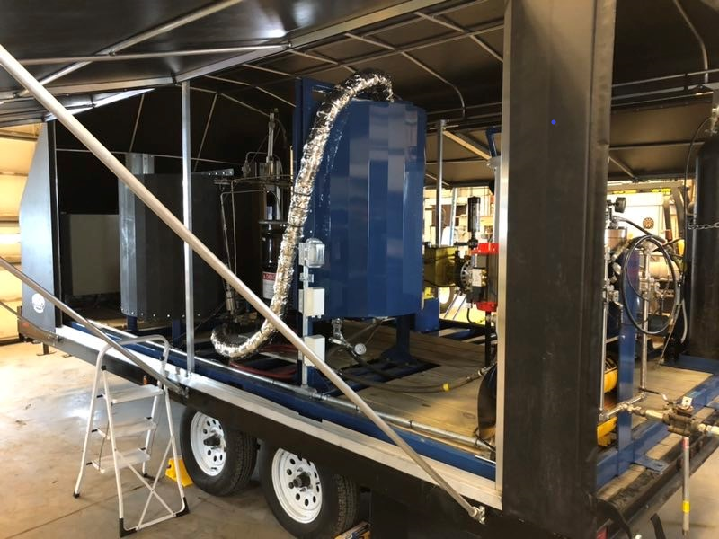

Based on the diesel blend work, we started to explore kerosene (jet fuel) production from HTL biocrude oil, and recent tests have demonstrated that upgrading HTL biocrude oil to kerosene (bio-kerosene) is highly feasible. We fractionated HTL biocrude via distillation into 14 distinct oil fractions and then characterized each fraction in terms of their elemental content, energy content, and physiochemical properties. The light fraction (groups 1-6) had a much higher O:C ratio than that of the heavy fraction (groups 7-14), but the heavy fraction had a lower H:C than the light fraction **(Fig. 2)**. Thus, important upgrading pathways include deoxygenation and decarboxylation techniques for the light fraction (groups 1-6) and hydrocracking and hydrotreating for the heavy fraction (groups 7-14). The results from the characterization data led us to appropriate upgrading strategies (Chen et al., 2018). The higher heating values of the heavy fraction reached ~50 MJ/kg, which is slightly higher than typical petroleum-based diesel and kerosene fuels (light blue-cluster in **Fig. 2**). Previous studies have shown that approximately 0.05g H2/g biocrude oil was needed to successfully hydrotreat biocrude oil, and the residual organics in PHW is a potential source of this hydrogen. All in all, these results indicate that hydrotreating and hydrocracking are promising upgradation techniques that could lead to high-quality, high-purity drop-in biofuel products, and H2 production from the electrochemical conversion of PHW would be an advantageous part of the whole waste-to-fuel strategy (Cherad et al., 2016).

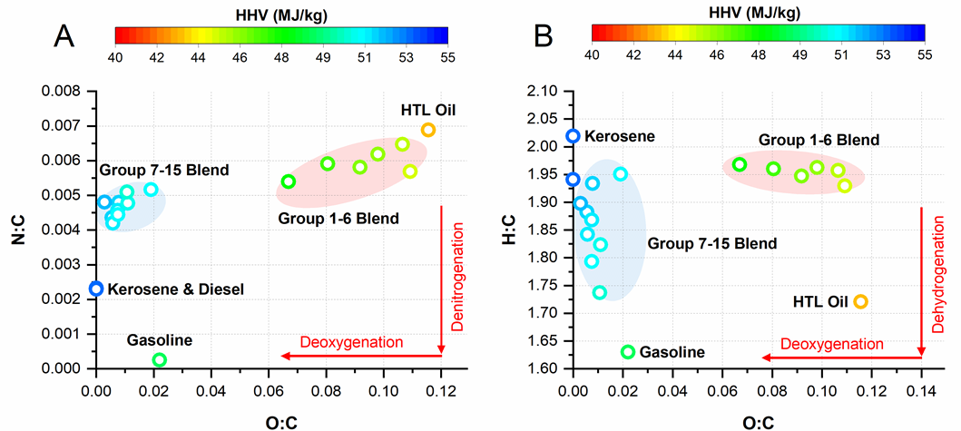

**Fig. 2** Van Krevelen diagram of biocrude oil fraction and base fuels.

While the HTL-extracted majority part of energy (70%) and carbon in the algal biomass and channeled into biocrude stream, the post-HTL wastewater (PHW) has high concentration of toxic compounds, nutrients (N and P) and organics that would exert a deleterious chemical oxygen demand (COD) if released to surface waters. Thus, the PHW must be treated before it can be discharged to the environment. We are investigating several promising approaches for treating and recovering valuable resources in the PHW such as carbonaceous organics and nutrients. Such approaches include nanofiltration concentration of PHW organics, electrochemical treatment cells to convert nitrogen-containing heteroaromatics compounds into hydrogen, nitrite and/or ammonium, and recycling the PHW back to HTL reactor to improve the energy and carbon recovery efficiency. The concentrated organics from PHW can also be recycled back to the HTL reactor to enhance the overall conversion efficiency and reduce the wastewater treatment load.

In summary, our E2-Energy approach has shown promising result in producing renewable biofuels, and at the same time protect the environment by recover carbon and nutrients and reuse the wastewater. This SSC project has enabled our team to expend our research program and becomes more competitive in obtaining external grants.

1. **PUBLICATIONS/PRESENTATIONS**: Anything published in a scholarly journal? Any presentations at an event?

Watson, Jamison, Buchun Si, Zixin Wang, Tengfei Wang, Amanda Valentine, Yuanhui Zhang. 2021. Towards transportation fuel production from food waste: Potential of biocrude oil distillates for gasoline, diesel, and jet fuel. Fuel: <https://doi.org/10.1016/j.fuel.2021.121028>.

Wang, Zixin, Jamison Watson, Tengfei Wang, Shuqi Yi, Buchun Si, Yuanhui Zhang. 2021. Enhancing energy recovery via two stage co-fermentation of hydrothermal liquefaction aqueous phase and crude glycerol. Renew. Sustain. Energy Review. Su<https://doi.org/10.1016/j.enconman.2021.113855>

Aierzhati, Aersi, Jamison Watson, Buchun Si, Michael Stablein, Tengfei Wang, Yuanhui Zhang. 2021. Development of a mobile, pilot scale hydrothermal liquefaction reactor: food waste conversion product analysis and techno-economic assessment. Energy Conversion and Management: X: <https://doi.org/10.1016/j.ecmx.2021.100076>

Watson, Jamison, Megan Swoboda, Aersi Aierzhati, Tengfei Wang, Buchun Si and Yuanhui Zhang. 2021. Biocrude Oil from Algal Bloom Microalgae: A Novel Integration of Biological and Thermochemical Techniques. Environ. Science and Technology: <https://pubs.acs.org/doi/10.1021/acs.est.0c05924>

Stablein, Michael, Aersi Aierzhati, Jamison Watson, Buchun Si, Yuanhui Zhang. 2020. Characterization and Bioremediation Potential of Byproducts from Hydrothermal Liquefaction of Food Wastes. Bioresource Technology Report: <https://doi.org/10.1016/j.biteb.2020.100555>

Lee, Timothy Haw Yu; Ziming Yang; Yuanhui Zhang; Wan-Ting Chen. 2020. Investigation of Combustion and Spray of Biowaste Based Fuel and Diesel Blends. Fuel: <https://doi.org/10.1016/j.fuel.2020.117382>.

Watson, Jamison, Tengfei Wang, Buchun Si, Wan-Ting Chen, Aersi Aierzhati, Yuanhui Zhang. 2020. Valorization of hydrothermal liquefaction aqueous phase: pathways towards commercial viability. Progress of Energy and Combustion Sciences: <https://doi.org/10.1016/j.pecs.2019.100819>

Carpio, Rowena, Yuanhui Zhang, Chih-Ting Kuo, Wan-Ting Chen, Lance Schideman, Rizalinda de Leon. 2019. Characterization and thermal decomposition of demineralized wastewater algae biomass. Algal Research: <https://doi.org/10.1016/j.algal.2018.101399>.

Jesse, S.D.; Zhang, Y.; Margenot, A.J.; Davidson, P.C. Hydroponic Lettuce Production Using Treated Post-Hydrothermal Liquefaction Wastewater (PHW). Sustainability 2019, 11, 3605. <https://doi.org/10.3390/su11133605>

Aierzhati A., M. Stablein, N. Wu, C. Kuo, B. Si, Xu Kang, Y. Zhang, 2019. Experimental and model enhancement of food waste hydrothermal liquefaction with combined effects of biochemical composition and reaction conditions, Bioresource Technology 284:139–147

Li, Meng, Buchun Si, Yuanhui Zhang, J. Watson, A. Aierzhati, 2019. Reduce recalcitrance of cornstalk using post-hydrothermal liquefaction wastewater pretreatment, Bioresource Technology 279:57-66.

Si, Buchun Si, Jamison Watson, Aersi Aierzhati, Libin Yang, Zhidan Liu, Yuanhui Zhang. 2019. Biohythane production of post-hydrothermal liquefaction wastewater: A comparison of two-stage fermentation and catalytic hydrothermal gasification. Bioresources Technology. 274:335-342.

Watson J, Lu J, Souza R, Zhang Y, Liu Z. 2019. Effects of the Extraction Solvents in Hydrothermal Liquefaction Processes: Biocrude Oil Quality and Energy Conversion Efficiency. *Energy.* 167: 189-197.

Si, B, Yang L, Zhou X, Watson J, Tommaso G, Chen WT, Liao Q, Duan N, Liu Z, Zhang Y. 2019. Anaerobic Conversion of Hydrothermal Liquefaction Aqueous Phase: Fate of Organics and Intensification with Granule Activated Carbon/Ozone Pretreatment. *Green chemistry*. 21:1305-1318.

1. **PHOTOS/VIDEOS**: If you have any new pix from the past year of work, I would LOVE to have them to refresh our webpages and have something visual for the report!

Our team has been requested by National Science Foundation to produce a video to demonstrate and promote the Environment-Enhancing Energy paradigm. Based on our work funded by SSC on food waste, our team has produced a video clip hosted by the Agricultural and Biological Engineering Department YouTube site: <https://www.youtube.com/watch?v=okQ4VgoDTPQ>