iSEE ANNUAL UPDATES
Environment-Enhancing FEWS Project

FUNDING, PROPOSALS
- The U.S. Department of Energy’s Bioenergy Technologies Office (BETO) over four years for a project titled “Clean water, sustainable aviation fuel and renewable diesel production from wastewater” (2021-2025, Total $4 million; $1.983 million for Zhang).
- The U.S. Department of Energy Bioenergy Technologies Office (DOE/BETO) funded project “Synergistic Thermo-Microbial-Electrochemical (T-MEC) Approach for Drop-In Fuel Production from Wet Waste” (2020-2023, $1.8 million; $802 K for Zhang).
- The U.S. Army Corps of Engineer Research and Development Center (ERDC) funded project “Renewable Energy Harvesting from Harmful Algal Blooms (REHAB)” (2020-2023, $1,172,000).
- The National Science Foundation Division of Chemical, Bioengineering, Environmental and Transport Systems (NSF/CBET) funded project “An Integrated Technology-Environment-Economic Modeling Platform for FEW Systems in Arid Regions” (2018-2022, $500,000).
- The UIUC Student Sustainability Committee (SCC) funded project “Pilot-Scale Implementation of Environment-Enhancing Energy (E2E) Paradigm for Food Waste to Biofuel and Biomaterial” (2019-2022, $150,000).

PROGRESS
We have continued the pilot HTL development and have successfully run the pilot HTL with three different feedstock, algae, salad dressing waste, and the Harvest Market food waste. About 75 liters of each feedstock were run and the gross yield of the food waste biocrude was 68.35 wt%, prior to moisture removal. To further separate the biocrude from HTL wastewater (PHW), dewatering was performed and the final biocrude yield was 43.63% wt%.

Catalytic upgrading of the HTL biocrude oil is in progress. One dozen heterogeneous catalysts for hydrodeoxygenation are screened. The team The team’s objective is to produce sustainable aviation fuel (SAF) from the biowaste including food waste, algal biomass and sludge. The team is investigating several approaches for recovery the valuable resources in the PHW such as carbonaceous organics and nutrients. For example, electrochemical cells were used to convert nitrogen containing heteroaromatics compounds into hydrogen, nitrite, and ammonium. Researchers in the group are also screening an array of targeted algal species that could efficiently uptake the nutrient in PHW.

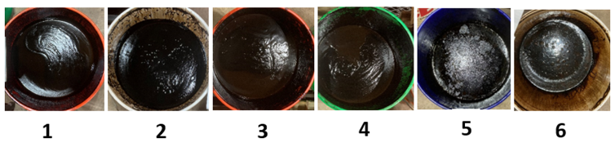
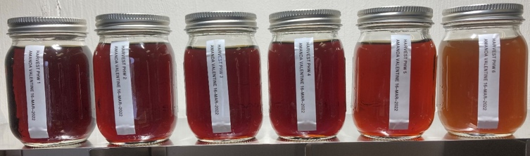
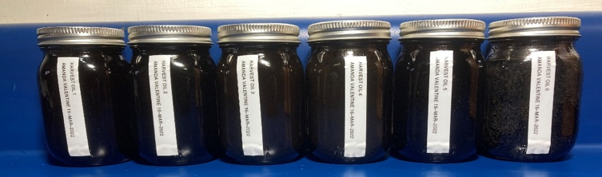
Raw products from HTL (top), PHW samples (middle) and biocrude samples (bottom).

PEOPLE
Faculty and Collaborators
- PI Yuanhui Zhang, Professor of Agricultural & Biological Engineering (ABE)
His departmental page >>>
- Paul Davidson, Associate Professor of ABE
His departmental page >>>
- Ximing Cai, Professor of Civil & Environmental Engineering (CEE)
His departmental page >>>
- Lance Schideman, Research Scientist, ISTC

Team members:
- Sabrina Summers, Ph.D. Candidate, ABE
Read more about Sabrina and her work >>>
- Rachael Dalke, Ph.D. Candidate, ABE
- Tiago Costa, Ph.D. Candidate, ABE
- Zixin Wang, Ph.D. Candidate, ABE
- Camila Bogarin, M.S. Candidate, ABE
- Siyu Yang, Undergraduate, Natural Resources & Environmental Sciences
- Lane Weber, Undergraduate, ABE
- Luiz Araujo, Undergraduate, ABE
- Amanda Valentine, Research Specialist, ABE
- Harshal Kawale, Postdoctoral research associate, ABE

Former Team members
- Jamison Watson, Ph.D. Candidate, ABE
- Michael Stablein, Ph.D. Candidate, ABE
- Aiersi Aierzhati, Ph.D. Candidate, ABE
- Trevor Bultinck, Undergraduate, ABE
- Claire Hanrahan, Undergraduate, ABE
- Lane Weber, Undergraduate, ABE
- Matthew Zhang, Undergraduate, Mechanical Sciences & Engineering
- Avishek Biswas, Undergraduate, Chemistry
- Niki Wu, Undergraduate, Chemistry
- Kang Xu, Undergraduate, ABE

PUBLICATIONS
(Selected publications since 2021)
- Summers, Sabrina, Siyu Yang, Jamison Watson, Yuanhui Zhang. 2022. Diesel blends produced via emulsification of hydrothermal liquefaction biocrude from food waste. Fuel: https://doi.org/10.1016/j.fuel.2022.124817
- Li, Ruirui, Dianlei Liu, Yuanhui Zhang, Giovana Tommaso, Buchun Si, Zhidan Liu, Na Duan. 2022. Enhanced anaerobic digestion of post-hydrothermal liquefaction wastewater: Bio-methane production, carbon distribution and microbial metabolism. Science of The Total Environment. DOI: https://doi.org/10.1016/j.scitotenv.2022.155659.
- Wang, Zixin, Cheng Zhang, Jamison Watson, Brajendra Sharma, Buchun Si, Yuanhui Zhang. 2022. Adsorption or direct interspecies electron transfer? A comprehensive investigation of the role of biochar in anaerobic digestion of hydrothermal liquefaction aqueous phase. Chemical Engineering Journal: https://doi.org/10.1016/j.cej.2022.135078
- Li, Hugang, Maojiong Cao, Yuanhui Zhang, Zhidan Liu. 2021. Hydrothermal liquefaction accelerates the toxicity and solubility of arsenic in biowaste. Journal of Hazardous Materials. DOI: https://doi.org/10.1016/j.jhazmat.2021.126341
- Yang, Ziming, Timothy H Lee, Yikai Li, Wan-Ting Chen, Yuanhui Zhang. 2021. Spray and combustion characteristics of pure hydrothermal liquefaction biofuel and mixture blends with diesel. Fuel. DOI: https://doi.org/10.1016/j.fuel.2021.120498
- Li, Hugang, Maojiong Cao, Jamison Watson, Yuanhui Zhang, Zhidan Liu. 2021. In Situ hydrochar regulates Cu fate and speciation: Insights into transformation mechanism. Journal of Hazardous Materials. DOI: https://doi.org/10.1016/j.jhazmat.2020.124616
- Wang, Zixin, Jamison Watson, Tengfei Wang, Shuqi Yi, Buchun Si, Yuanhui Zhang. 2021. Enhancing energy recovery via two stage co-fermentation of hydrothermal liquefaction aqueous phase and crude glycerol. Energy Conversion and Management. DOI: https://doi.org/10.1016/j.enconman.2021.113855
- Stablein, Michael, Douglas H. Baracho, Jamison T. Watson, Jaqueline C. Silva, Yuanhui Zhang, Ana T. Lombardi. 2021. Inhibition of Photosynthetic Performance and Mixotrophic Microalgal Growth in Post Hydrothermal Liquefaction Wastewater (PHW). Algal Research: https://doi.org/10.1016/j.algal.2021.102548.
- Yang, Libin, Qisi Su, Buchun Si, Yalei Zhang, Yuanhui Zhang, Hong Yang, Xuefei Zhou. 2021. Enhancing bioenergy production with carbon capture of microalgae by ultraviolet spectrum conversion via graphene oxide quantum dots. Chemical Engineering Journal 429 (2022) 132230. https://doi.org/10.1016/j.cej.2021.132230.
- Watson, Jamison, Buchun Si, Zixin Wang, Tengfei Wang, Amanda Valentine, Yuanhui Zhang. 2021. Towards transportation fuel production from food waste: Potential of biocrude oil distillates for gasoline, diesel, and jet fuel. Fuel: https://doi.org/10.1016/j.fuel.2021.121028.
- Costa, Tiago, Neslihan Akdeniz, Richard S. Gates, James Lowe, Yuanhui Zhang. 2021. Testing the plastic-wrapped composting system to dispose of swine mortalities during an animal disease outbreak. J. of Environmental Quality, https://doi.org/10.1002/jeq2.20235
- Dias M.E., G.H.D. Oliveira, P.T.Couto, K.J.Dussánb, M.Zaiat, R.Ribeiro, M.J.Stablein, J.T.Watson, Y.Zhang, G.Tommaso. 2021. Anaerobic digestion of hydrothermal liquefaction wastewater from spent coffee grounds. Biomass and Bioenegy 148: 106030. https://doi.org/10.1016/j.biombioe.2021.106030
- Wang, Zixin, Jamison Watson, Tengfei Wang, Shuqi Yi, Buchun Si, Yuanhui Zhang. 2021. Enhancing energy recovery via two stage co-fermentation of hydrothermal liquefaction aqueous phase and crude glycerol. Renew. Sustain. Energy Review. https://doi.org/10.1016/j.enconman.2021.113855
- Carpio, Rowena, Yuanhui Zhang, Chih-Ting Kuo, Wan-Ting Chen, Lance Schideman, Rizalinda de Leon. 2021. Effects of reaction temperature and reaction time on the hydrothermal liquefaction of demineralized wastewater algal biomass. Bioresource Technology Report: https://doi.org/10.1016/j.biteb.2021.100679
- Aierzhati, Aersi, Jamison Watson, Buchun Si, Michael Stablein, Tengfei Wang, Yuanhui Zhang. 2021. Development of a mobile, pilot scale hydrothermal liquefaction reactor: food waste conversion product analysis and techno-economic assessment. Energy Conversion and Management: X: https://doi.org/10.1016/j.ecmx.2021.100076
- Watson, Jamison, Megan Swoboda, Aersi Aierzhati, Tengfei Wang, Buchun Si, Yuanhui Zhang. 2021. Biocrude Oil from Algal Bloom Microalgae: A Novel Integration of Biological and Thermochemical Techniques. Environ. Science and Technology: https://pubs.acs.org/doi/10.1021/acs.est.0c05924
PHOTOS
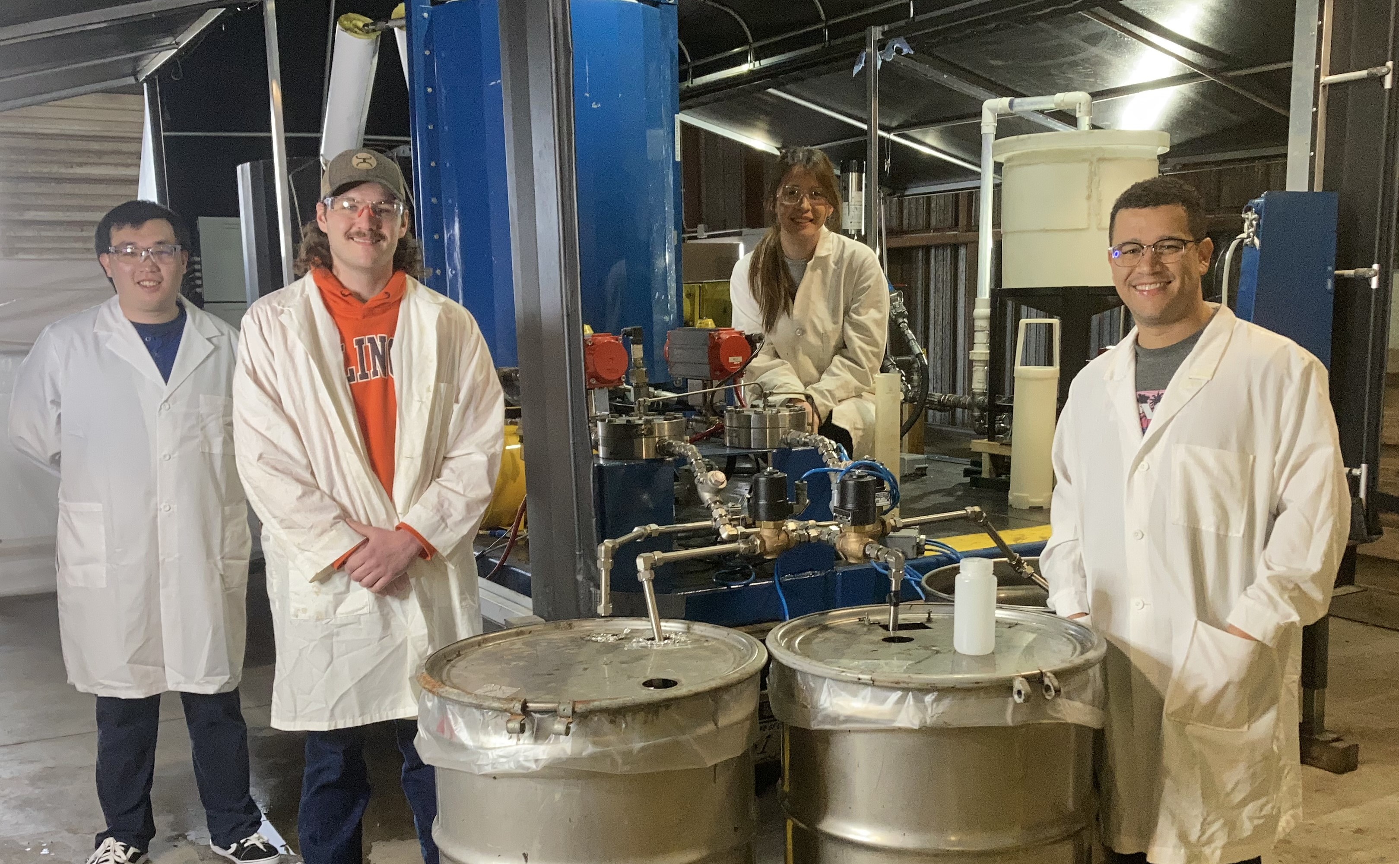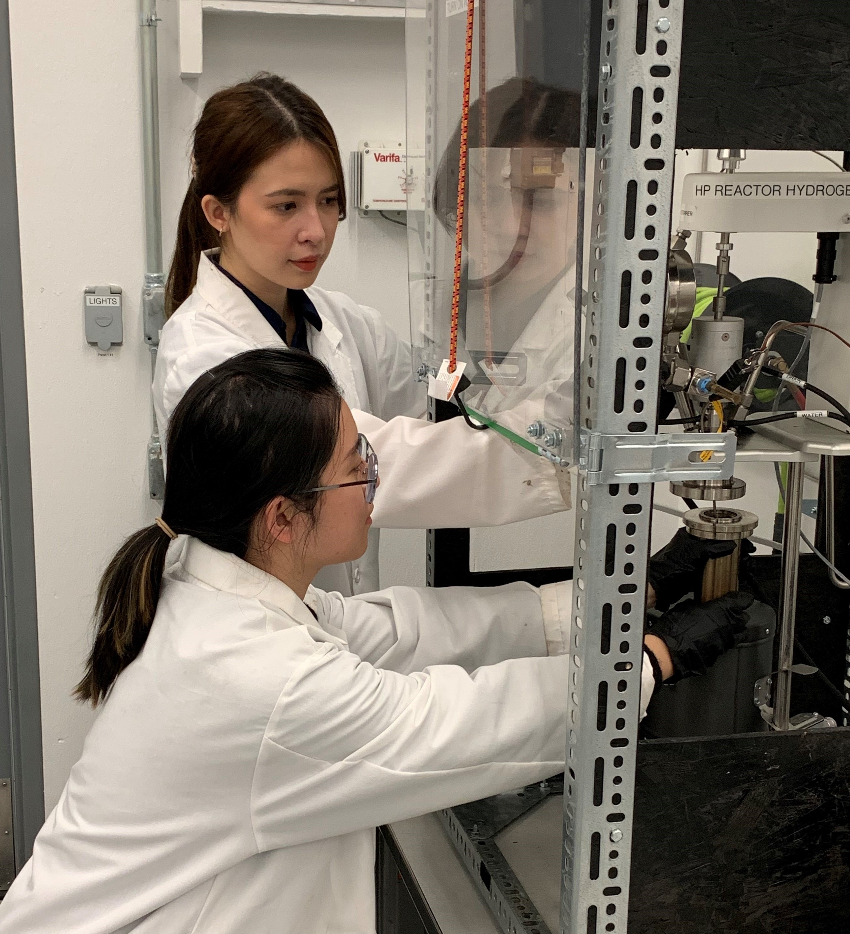
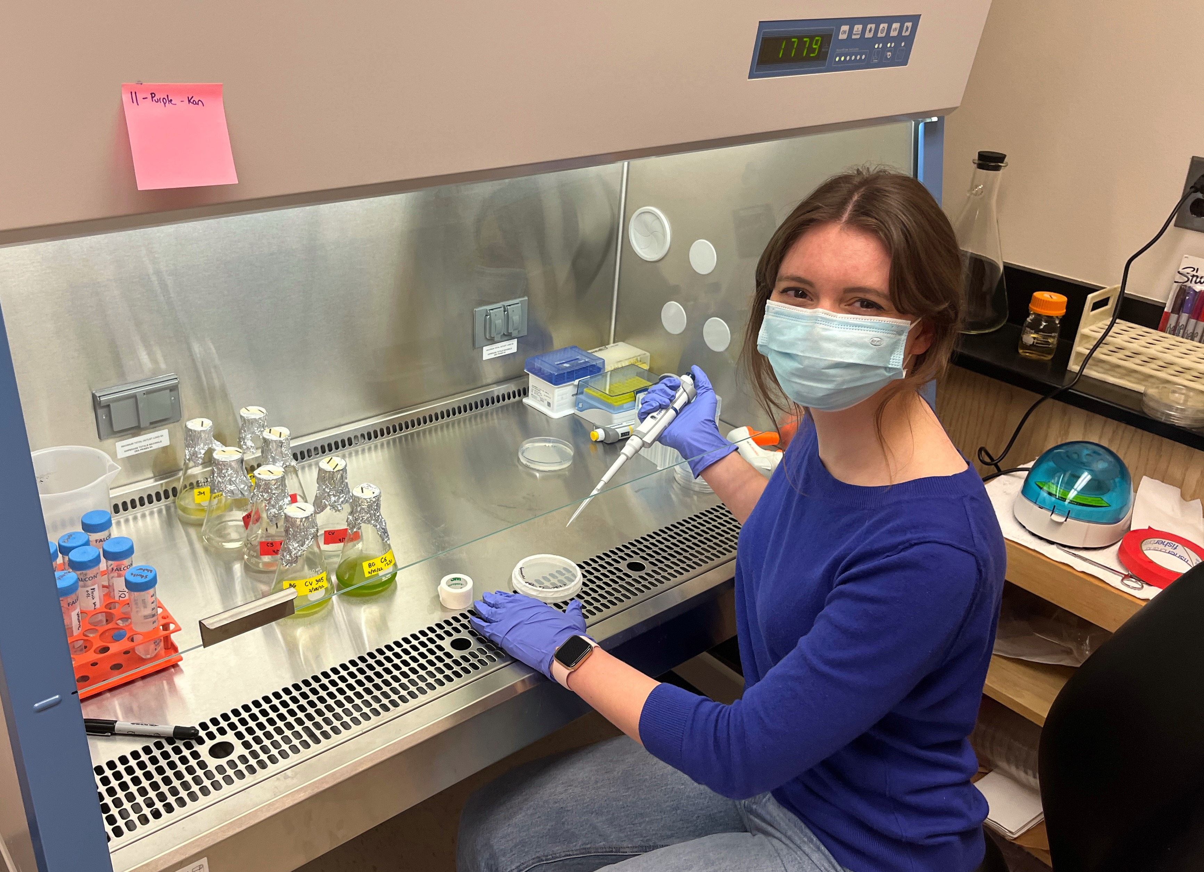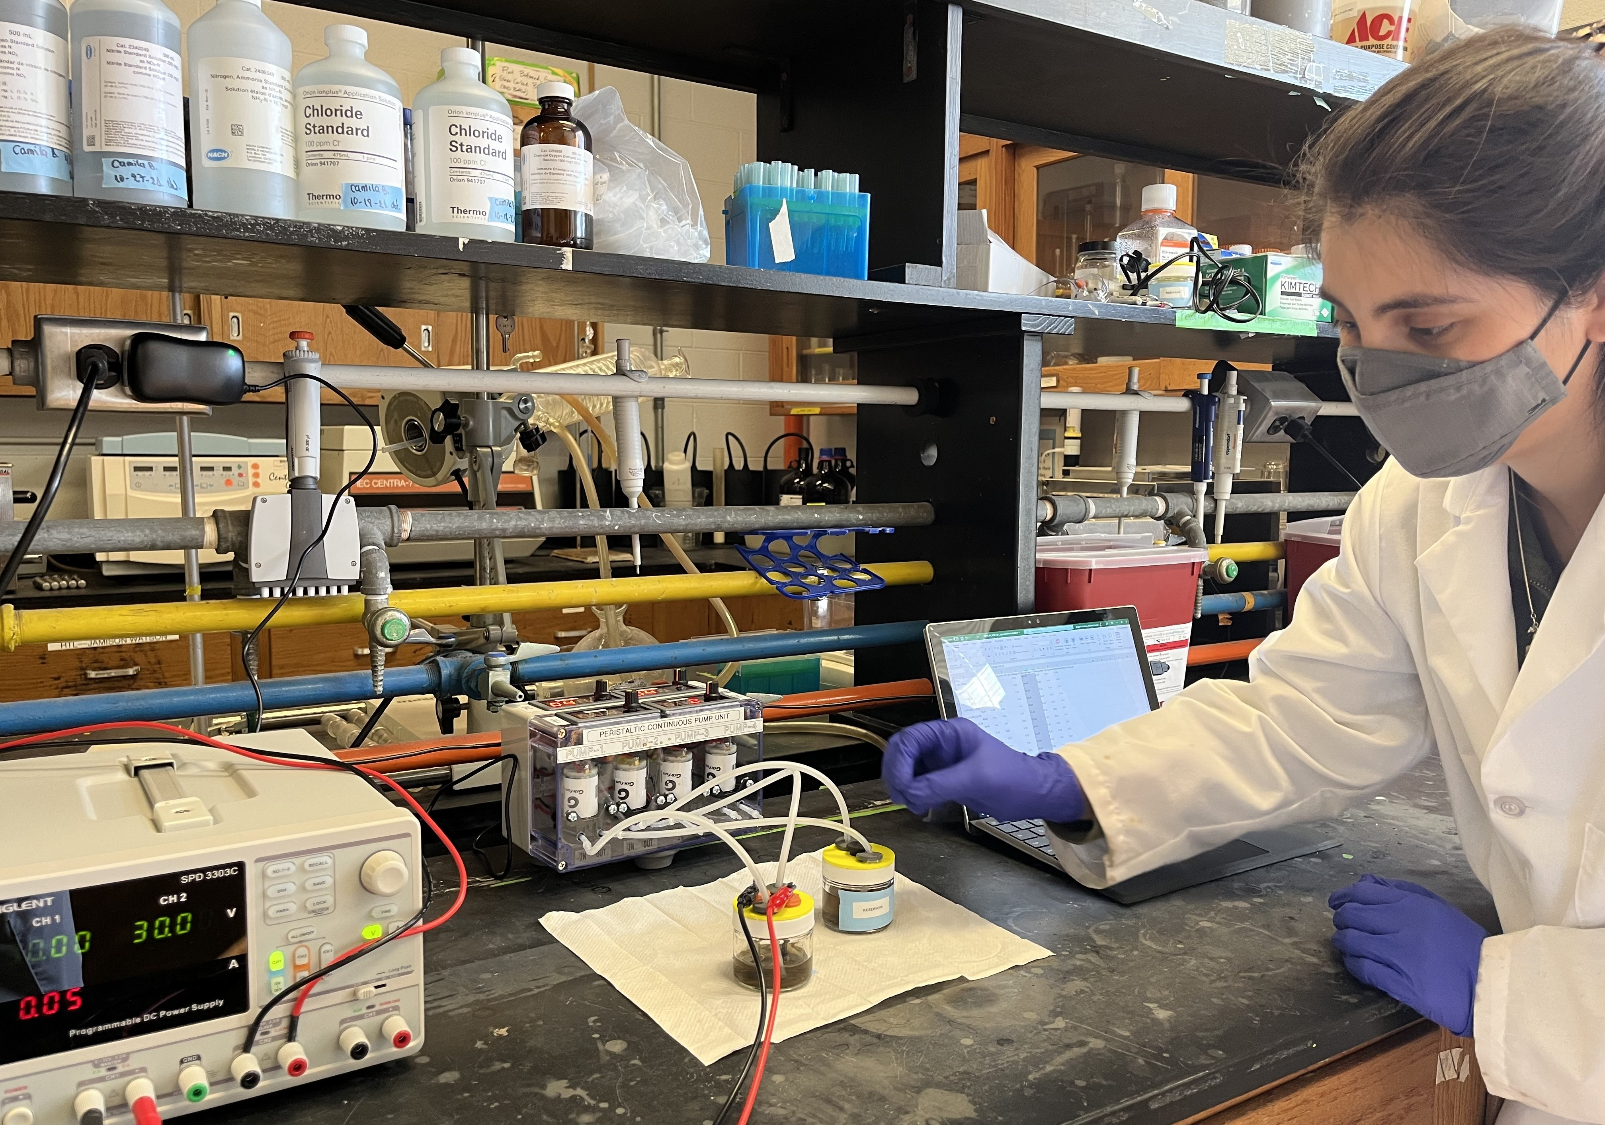
Graduate students working on waste-to-energy and nutrient recovery, from top-left clockwise: The HTL reactor crew; upgrading HTL biocrude oil; electrolyzing PHW for nutrient recovery; screening algae species for PHW utilization.

