**Funding Award and Acceptance Letter**

April 15, 2018

Project: Student-led census of the Trelease Woods Forest Dynamics Plot

Dear Mx. Dalling:

On behalf of the University of Illinois at Urbana-Champaign Student Sustainability Committee (SSC), I would like to thank you for considering the funds raised by the Sustainable Campus Environment Fee to implement a project that improves the sustainability of our campus. SSC is pleased to inform you that we are recommending to the Institute for Sustainability, Energy, and Environment (iSEE) that your project **receives $69,467 in grant funding**.

In order to remain eligible for this award, you must agree to the following conditions:

1. A final report of all work completed should be provided to the SSC Program Coordinator by May 31, 2020.
2. Project status updates and detailed account statements must be provided at the end of each semester, in the method requested, until the project is completed.
3. The CFOP provided for this award shall strictly be used for the money awarded in this proposal.
4. No SSC funding shall be used for transportation, including gas and car rentals.
5. Any substantial modifications to project scope, budget, or timeline must first be approved by SSC. These requests must be submitted in a formal letter to the Chair and Program Coordinator.
6. All projects will be expected to follow campus policies and procedures as well as any applicable State and Federal laws.
7. A willingness to be an active member of the SSC community, such as mentoring student applicants, while your project is active.
8. SSC reserves the right to revoke funding if the project does not comply with the terms and conditions outlined in this letter.
9. No SSC funding will go towards car rentals, transportation, or gasoline spending.
10. Any press releases or educational/promotional materials involving the project should acknowledge SSC funding.
11. Any signage involving the project or events surrounding this project should include SSC’s logo and/or a statement of which fee funded the project. Projects must coordinate with SSC to ensure promotion appropriately highlights the SSC’s contributions to the project.

If you agree to the terms and conditions for the funding, please sign on the designated line at the bottom of this letter. If you have any questions regarding these requirements please contact the Chair, Nick Heyek, at [nheyek2@illinois.edu](mailto:nheyek2@illinois.edu) or the SSC Coordinator, Cathy Liebowitz, at [cwl1517@illinois.edu](mailto:cwl1517@illinois.edu). You will be notified when the Institute for Sustainability, Energy, and Environment and Vice Chancellor for Student Affairs officially approves this project. Again, thank you for your interest in improving the sustainability of the University of Illinois at Urbana-Champaign. We look forward to working with you in the future.

**SSC Signatories**                                                 **Awardee Signatory**

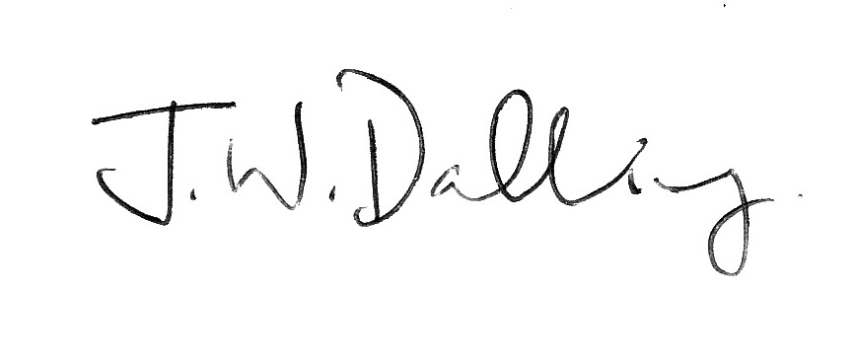

_________________________________                  _________________________________

Nick Heyek, Chair                                                   James Dalling

Student Sustainability Committee                                           Applicant

__________________________________ **iSEE Signatory**

Olivia Yu, Treasurer

Student Sustainability Committee                                     _________________________________ Dr. Evan DeLucia, Director

Institute for Sustainability, Energy & Environment

**Student Affairs Signatory**

_________________________________

Dr. Danita Brown Young

Division of Student Affairs

**Project Information**

**Project:** Student-led census of the Trelease Woods Forest Dynamics Plot

**Funding Source:** Sustainable Campus Environment Fee

**Funding Amount:** $69,467

**Receiving Campus Unit:** School of Integrative Biology

**Unit Financial Contact:** Penny Broga

**E-mail:** broga@illinois.edu

**Project Description:**

This project will complete the first census of Trelease woods, a university-managed natural area, using the standard Forest-Geo protocol in 2018-2019. When finished, Trelease will become entered into the international plot network. This project will require over 2,500 hours of undergraduate student labor and will be overseen by a graduate student. Undergraduate students will learn how to survey trees and will have access to an international dataset. They will explore forest management as well as carbon sequestration. Similarly, professors can use Trelease as a hands-on learning environment in UIUC classes. Conducting the tree census will also support the university’s goals of tracking its carbon storage. The allocated funding will go towards census supplies and student labor.

This proposal directly funds:

1. Student labor
2. Census supplies