*Please submit this completed application, the supplemental budget spreadsheet, and any relevant supporting documentation by the deadline indicated in your Step 1 notification letter to* [*Sustainability-Committee@Illinois.edu*](mailto:Sustainability-Committee@Illinois.edu)*.The Working Group Chairs will be in contact with you regarding any questions about the application. If you have any questions about the application process, please contact the SSC Program Advisor, Micah Kenfield, at* [*kenfield@illinois.edu*](mailto:kenfield@illinois.edu)

# General Information

**Project Name:** “Roly Poly” Bicycle Registration and RFID Tracking Program

**Total Amount Requested from SSC:** $25,207

**Project Topic Area(s):** ☐Energy ☐Education ☐Food & Waste

☐Land ☐Water ☒Transportation

# Contact Information

### Project Lead

Applicant Name: Lily Wilcock

Unit/Department: Facilities and Services

Email Address: [lwilco2@illinois.edu](mailto:lwilco2@illinois.edu) and [sjw2@illinois.edu](mailto:sjw2@illinois.edu)

Phone Number: 217-244-6865

### Financial Contact *(Must be Full-time University of Illinois Staff Member)*

Contact Name: Mike Alsip

Unit/Department: Facilities and Services

Email Address: alsip@illinois.edu

Phone Number: 1 (217) 244-4049

Organization Code: 311

### Facilities Management Contact *(If Applicable)*

Contact Name: Lily Wilcock

Email Address: lwilco2@illinois.edu

**Primary Project Team**

|  |  |  |
| --- | --- | --- |
| **Name** | **Department** | **Email** |
| Sarah Conroy | Student and Roly Poly Team | sconroy2@illinois.edu |
| Mardy Hillengas | Student and Roly Poly Team | mhille3@illinois.edu |
| Karolina Urban | Student and Roly Poly Team | urban6@illinois.edu |
| Samantha Walter | Student and Roly Poly Team | sjw2@illinois.edu |

# Project Description

**Please provide a brief background of the project, the goals, and the desired outcomes:**

The goal of this initiative is to track how frequently individuals ride their bikes on the University of Illinois campus using radio frequency identification (RFID). When students and faculty of the University register their bikes, they will each receive a tag for their bike with a personal ID number. With the data collected about their individual biking habits, students and faculty will be able to track how often they bike and earn rewards through an online interface and incentive system. The interface will show the number of times biked, the rewards an individual can earn, and offer the ability to submit reports since bikers often see needed improvements before planners and engineers. The incentive program will encourage more individuals to bike and develop healthier behaviors. Furthermore, data will be compiled to analyze the areas of campus that need the most attention based on the locations that are used most frequently.

**How will the project improve the sustainability of the Illinois campus and how will the project go above and beyond campus standards?**

This project will encourage more people to bike around campus, which will enable campus to achieve sustainable transportation goals outlined in the Illinois Climate Action Plan (iCAP). Currently, the University of Illinois Urbana-Champaign campus is a Bronze Bike Friendly University, as ranked by the League of American Bicyclists. With the addition of this program, as well as the improvements that can be implemented through the information gathered, we will be closer to achieving Silver, and Gold, status, as stated in the 2015 iCAP. These improvements would not only enrich the campus cycling experience, but also bring the University closer to its sustainability goals.

Cyclists in the community use the roads on a day to day basis, and therefore see the need for certain infrastructure improvements before planners and engineers do. We hope to be able to improve infrastructure on campus with the information that cyclists report to the program. Some sensors might be busier than other sensors, thus providing information on better traffic conditions for cyclists. This will help the campus transportation planners prioritize implementation of Complete Streets for cyclists and increase bicycle friendliness for future road projects.

Besides its sustainability and positive impact on the environment, cycling is a healthy activity. Many staff and faculty are sedentary for long hours of the day, and transportation by bike adds physical activity that is sorely needed. Americans have long been proud of the positive health effects of sports like cycling. We see Roly Poly and the incentives attached to bicycle commuting as a positive way to change unhealthy behaviors in and out of the workplace.

**Where will the project be located? Will special permissions be required to enact the project on this site? If so, please explain and submit any relevant letters of support with the application.**

Light posts around campus on Champaign, Urbana, and UIUC streets will need to have sensors installed about eight feet off the ground. The responsible jurisdiction for any light post will need to give permission to install the sensors, and the Active Transportation Coordinator for UIUC will obtain the formal permission before installations begin. Throughout the installation process, the Active Transportation Coordinator will have communications with the surrounding cities about the project. Two coordination meetings will be scheduled: one coordination meeting for the introduction of the initiative, and one stakeholder meeting to discuss progress, map light posts, and solidify timelines.

**Other than the project team, who will have a stake in the project? Please list other individuals, groups, or departments affiliated directly or indirectly by the project. This includes any entity providing funding (immediate, future, ongoing, matching, in-kind, etc.) and any entities that will be benefitting from this project. Please attach letters of commitment or support at the end of the application.**

Campus and community groups that will be interested include: iSEE, F&S, Transportation SWATeam, BikeFACE (RSO), Wellness Center, Campus Recreation (who has always participated in Bike to Work Week), SSC, Champaign County Bikes, the Urbana Bicycle and Pedestrian Advisory Commission, and the city public works staff members.

**Please indicate how this project will involve or impact students. What role will students play in the project?**

Students on UIUC campus use bicycle infrastructure every day. Students are also the most frequent users because they rely on bicycles more than any other group on campus. Encouraging and rewarding students, staff, and faculty with incentives will increase the numbers of cyclists on campus and reduce the number of cars, making streets safer. If that is not convincing enough, the 10 largest cities in the United States have seen huge increases in traffic safety and cycling engagement since the improvement of biking infrastructure. UIUC needs better bike paths and more cyclists, not just for sustainability goals, but for student safety.

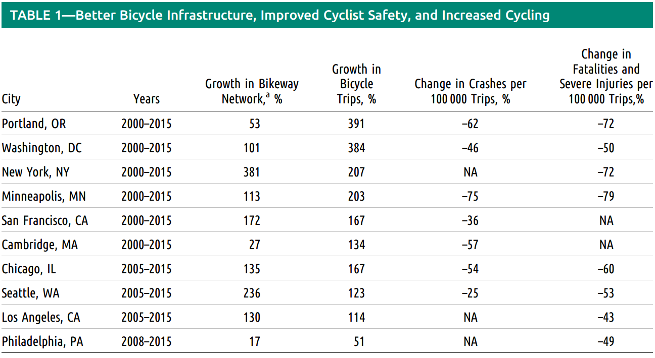

<http://ajph.aphapublications.org/doi/pdf/10.2105/AJPH.2016.303507>

This summer the Active Transportation Coordinator worked with Joe Bradley, who teaches the projects section of the IEFX summer student program for incoming freshmen. The idea of tracking cyclist movements through innovative technology was picked up by a student team, named Roly Poly. The team comprised of four students: all female engineers. Women are underrepresented in Engineering, and this team is showing a level of leadership that, male or female, shows exceptionalism. When the summer program was complete, the Roly Poly team continued to dedicate time on a weekly basis toward seeing this idea become a reality. Morgan Johnston believes that their energy and commitment is exactly what the SSC seeks to support for student engagement in making deep systemic changes to the sustainability of campus.

# Financial Information

*In addition to the questions below, please submit the supplemental budget spreadsheet available on the Student Sustainability Committee website. Submission of both documents by the submission deadline is required for consideration of your project.*

**Have you applied for funding from SSC before? If so, for what project?**

No, this team has not applied for funding before. Active Transportation Coordinator, Lily Wilcock, helps with several SSC funded projects across campus, such as the iBike bike sharing program. This is the first time Roly Poly team and ATC have applied for funding.

**If this project is implemented, will there be any ongoing funding required? What is the strategy for supporting the project in order to cover replacement, operation, or renewal costs?**

No renewal costs will be necessary as the software for the project are in house. The software will be developed by the Roly Poly team, and they intend to maintain the software while they remain on campus. The only anticipated long-term cost is the maintenance and repair of sensors. The Roly Poly team will strive to make the sensors as long-lasting and durable as the budget allows. The F&S Transportation Demand Management (TDM) department will be the “owner” of the sensors and will take responsibility for the long-term maintenance.

**Please note that SSC provides funding on a case by case basis annually and should not be considered as an ongoing source of funding.**

If needed, please also address this in the supplemental budget spreadsheet in the relevant section.

**Please include any other sources of funding that have been obtained or applied for. Please attach any relevant letters of support as needed in a separate document.**

Another source of funding is the student fee, Bicycle Infrastructure and Programming Fee. We have asked for funding to promote and publicize this new program with Bike Fee funds.

# Environmental, Economic, and Awareness Impacts

*In addition to the below questions, please indicate specific measurable impacts as applicable on the supplemental budget spreadsheet.*

**Which aspects of sustainability does your project address, and how? Does the project fit within any of the iCAP goals? If so, how does the project go beyond the university status quo standards and policies.**

The RFID bike tracking system will encourage more students and faculty alike to ride their bikes on campus through an incentive program, which will decrease car travel and therefore decrease CO2 emissions for campus. A goal of the 2015 iCAP is to implement the 2014 Campus Bicycle Plan. According to this plan, University of Illinois at Urbana-Champaign is a bronze-level bike friendly campus, and one of the goals is to be promoted to a silver-level, which can be accomplished by incentivizing bike use on campus. Another goal of the Campus Bicycle Plan is to prioritize funding for improvements of bicycle infrastructure. By tracking which locations are used the most by cyclists, the campus transportation planners can prioritize areas with the greatest cyclist traffic to improve the bicycle infrastructure.

**How will the environmental impacts of your project be measured in the short and long term? What specific monitoring and evaluation processes will you be using to track outcomes and progress?**

Currently, TDM sends volunteers out to paths to manually collect traffic data with clipboards. This process is inefficient, costly, and can introduce human error. This project will also track the usage of registered bikes on campus, allowing the effectiveness of the incentive program to be monitored both in the short and long term.

**What is the plan for publicizing the project on campus? In addition to SSC, where will information about this project be reported?**

A website similar to the current bicycle registration site (go.illinois.edu/MyBike) will be created to register bikes, order RFID tags, and track incentives. We will publicize this website with a booth on the main quad on weekdays and Quad Day at the beginning of the school year, as well as using volunteers stationed near bike racks throughout the year. F&S, with support of the Bike Fee, will create promotional materials and spread awareness of RFID bicycle registration at various tabling events.

**What are your specific, measurable outreach goals? How will these be measured?**

Our primary goal is to track bicycle movement on campus, for the purposes described above. We would also like to increase the number of bicycles registered on campus, which will be accomplished by comparing the number of bicycles registered in previous years and the number of bicycles after we implement the program. In FY16, there were approximately 200 bikes registered, and we would like to increase this by 200% for a total of 600 bikes registered per year.

We would also like to increase the usage of bicycles on campus, which will be accomplished in the long term by analyzing the data received through our process. We will also track participation in bicycling events, such as Bike to Work Week, and send out surveys to faculty, staff, and students asking about biking habits.

**Do you have any additional comments or relevant information to aid in evaluation of this application?**

Concerns have been raised about security of using RFID technology to track individuals. We would like to address this concern by stating that our technology will use ultra-high frequency tags and readers, which will be mounted high above the ground. Passports and credit cards use a completely different frequency and, in fact, a different technology to transfer information. They use near-field communication, which requires the reader to be within a few centimeters from the RFID tag, so these Roly Poly sensors will not be able to read that personal information.

Most security issues with RFID tags came early on in the development of these technologies; since then, security on these projects has vastly increased. In addition to this, contactless credit card payments haven’t ever really caught on. The Federal Reserve Board found in 2012, the latest year data has been made available, that there were only 43 million contactless card payments, in contrast to the billions made by non-RFID cards. Since 2012, many credit cards have also moved to EMV cards, which use a computer chip and not an RFID tag, so it is likely that these credit cards have further declined in prevalence. Passports now have a thin layer of metal inserted in the jacket that prevents readers from reading from far away, as well as a pin number that must be entered into the reader before any information can be gleaned.

Furthermore, there will be no information physically stored on the RFID tag; only a tag number. This tag number will be entered into a database, where biker’s information will be kept. In order to access any information, the anti-biking scumbag would have to hack into the database. Even so, none of the information we will collect is protected under FERPA; most of it is common knowledge.

A second concern was raised about using RFID technology over a phone app. While a GPS based app is certainly good at tracking people and transmitting data, we chose to use RFID tags because we were concerned about the number of people who would, or could, use an app. Anyone who bikes can use a tag; however, not everyone who bikes has a smartphone. It also takes effort to turn on your phone and open an app. People would certainly forget, give up on the app, or delete it to make space on their phone. Putting a tag on a bike would be far more mindless; it requires one thought and one action. It is easier to convince people to put a tag on their bike than to download and continually use an app. With a tag, even if people forget that the tag is on their bike, we will still be able to get information about where they traveled on campus.