*Please submit this completed application, the supplemental budget spreadsheet, and any relevant supporting documentation by the deadline indicated in your Step 1 notification letter to* [*Sustainability-Committee@Illinois.edu*](mailto:Sustainability-Committee@Illinois.edu)*.The Working Group Chairs will be in contact with you regarding any questions about the application. If you have any questions about the application process, please contact the SSC Program Advisor, Micah Kenfield, at* [*kenfield@illinois.edu*](mailto:kenfield@illinois.edu)

# General Information

**Project Name:** A Campus Circular Economy – From Farm to Table & Desk

**Total Amount Requested from SSC:** $65, 695

**Project Topic Area(s):** Energy Education Food & Waste

Land Water Transportation

# Contact Information

### Project Lead

Applicant Name: Eric Benson

Unit/Department: Art + Design/Graphic Design

Email Address: ebenson@illinois.edu

Phone Number: 512-538-4211

### Financial Contact *(Must be Full-time University of Illinois Staff Member)*

Contact Name: Sheryl Netherton

Unit/Department: Art + Design

Email Address: netherto@illinois.edu

Phone Number: 217-244-4249

Organization Code: 526000

### Facilities Management Contact *(If Applicable)*

Contact Name: David Akins

Email Address: akins@illinois.edu

**Primary Project Team**

|  |  |  |
| --- | --- | --- |
| **Name** | **Department** | **Email** |
| Matt Turino | Crop Sciences | turino@illinois.edu |
| Name | Department/Organization | Email Address |
| Name | Department/Organization | Email Address |
| Name | Department/Organization | Email Address |

# Project Description

**Please provide a brief background of the project, the goals, and the desired outcomes:**

The Student Sustainable Farm (SSF), has been growing sustainably produced vegetables for the U of I campus community since 2009.  Zack Grant and Professor Bruce Brahnam, with the support of the Student Sustainability Committee, founded the farm to be grow fresh produce for the dining services on campus as well as to create a learning laboratory space for sustainable agriculture on the U of I campus.  Student workers, volunteers, and visitors have come to the farm to learn about small scale, diversified agriculture systems.  The power of the farm stems from the fact that it has not only been a space for people to learn about growing food, but through collaborations with Architecture, Engineering, and last but not least Fresh Press (Art and Design), the farm has been a hands on multifaceted learning space for students who are interested in various  aspects of sustainability and health. Farms are inherently multidisciplinary entities, making them ideal spaces for  students to experience many elements of hands-on work.

Fresh Press (FP) began officially in 2012 at the University of Illinois through a gracious 2011 grant from the SSC. The award from SSC provided us papermaking and farm equipment (to speed up the process) and also student labor – an integral part to a sustainable economy (fair wages for all).  Eric Benson and Steve Kostell in collaboration with Zack Grant (formerly of the Sustainable Student Farm – SSF) conceived of the idea of closing the loop on farming waste on campus by using corn stover, soybean stalks, prairie grasses, and other vegetable/grass-based agricultural waste fibers to make into paper for student and campus use. Agricultural residue is a more sustainable source for paper products than tree fiber.In a recent [lifecycle study](http://stepforwardpaper.com/wp-content/uploads/2014/10/SFP-life-cycle-study-final-141009.pdf) by Step Forward Paper, wheat straw residue paper was shown to have less than half of the negative impact on the environment in comparison to 100% virgin tree fiber paper

This collaboration between SSF and FP is one we are still eagerly pushing forward with now a new team and university partners. We feel we are both at a tipping point where both the SSF and FP can provide greater services to improve the health and sustainability of campus. We believe we are at an important point in our history as evidence by our local TV media ([WCIA3](https://www.youtube.com/watch?v=hQdMfuwyn3I), [WILL](https://www.youtube.com/watch?v=Bpro_13xGsQ&feature=youtu.be), WCID15, and campus [press](https://www.youtube.com/watch?v=Bpro_13xGsQ&feature=youtu.be)) have all found our project interesting and worthy of promotion to the public/campus.. Furthermore, the Willie Nelson-founded Farm Aid charity invited Fresh Press  to make sustainable paper at their 30th anniversary celebration in Chicago. Our collaboration is growing in awareness, but there are some economic challenges to climb ahead. To scale that peak, we are asking for more funding as described in the next section.

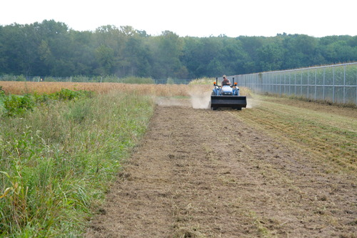

*Preparing the land for planting on the Sustainable Student Farm*

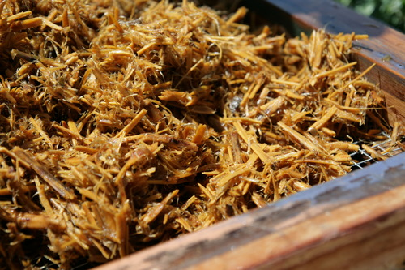

*Cooked agri-fiber waste from the farm*

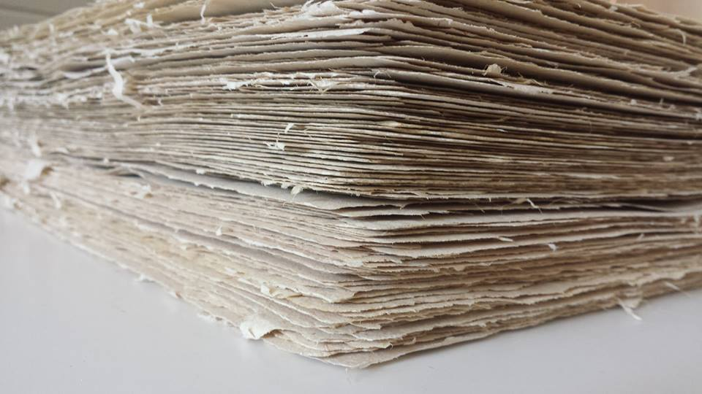

*Prairie grass paper made for Art + Design students for their foundation drawing course Fall 2015*

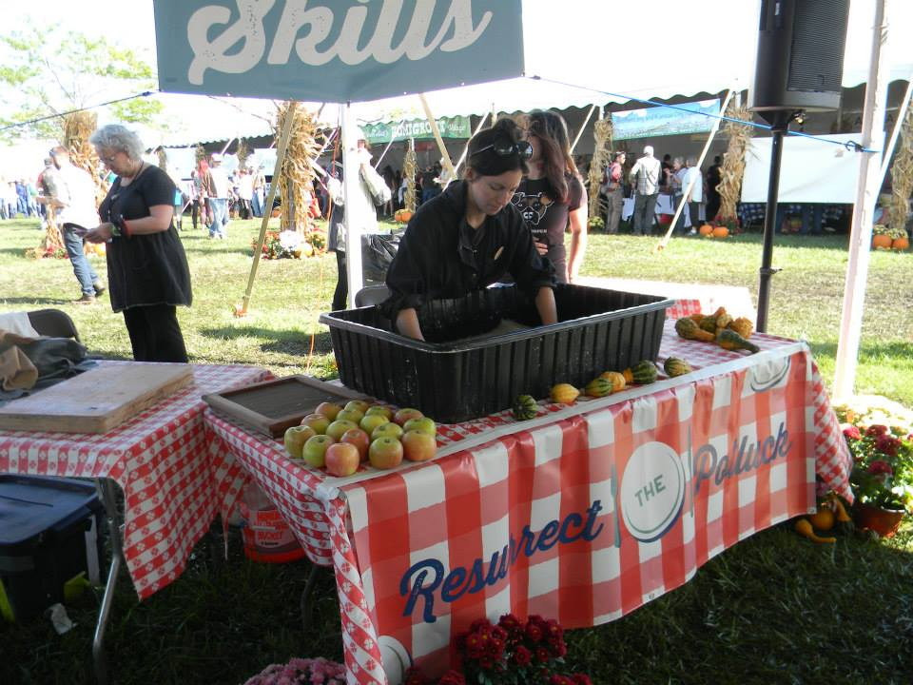

*Fresh Press workshop at Farm Aid 2015, Chicago, IL (Megan Diddie, Painting MFA – Fresh Press Research Assistant, 2013-2015)*

**How will the project improve the sustainability of the Illinois campus and how will the project go above and beyond campus standards?**

This project will not only contribute to sustainability on the Illinois campus, but also create a new standard. By continuing to use responsible and organic agricultural practices that promote soil and human health combined with re-using waste for paper production, SSF and FP together will create a sustainable circular economy on campus where students and faculty are not only consumers but producers. Students on campus will be able to purchase the produce and paper they can also be paid to help grow, harvest, and manufacture through our circular economy model. In every step of the way, the food and paper are more sustainable than their larger commercial counterparts and since they are on campus, have a much smaller carbon footprint. Also embedded in every action is conversation and awareness about sustainability. The print/digital material we plan to produce through our student labor and coordinator positions for SSF and FP, will explain and visually demonstrate the sustainability of the endeavor and food/product choices the students and faculty are making with their dollars.

**Where will the project be located? Will special permissions be required to enact the project on this site? If so, please explain and submit any relevant letters of support with the application.**

The project will live in two spaces with outreach throughout campus. First, the Sustainable Student Farm (Crop Sciences) will be still the location for farm and fiber production, while secondly, Fresh Press (South Studio 3 – Art + Design) will be the site for paper production and exploration. No special permissions will be required to continue the existing and new work that will occur on these two campus sites.

**Other than the project team, who will have a stake in the project? Please list other individuals, groups, or departments affiliated directly or indirectly by the project. This includes any entity providing funding (immediate, future, ongoing, matching, in-kind, etc.) and any entities that will be benefitting from this project. Please attach letters of commitment or support at the end of the application.**

* The College of Fine and Applied Arts
* School of Art + Design
* Department of Crop Sciences
* University Housing, Dining Management

**Please indicate how this project will involve or impact students. What role will students play in the project?**

Students will be and always have been an integral force in our collaborative efforts at SSF and FP. In the past, students have either volunteered, were Research Assistants, or were paid hourly for their contributions to the initiatives. With our request for funds in this grant proposal, we are asking for funds to continue to pay for student labor on the SSF and a new paid CSA student coordinator/liaison role to:

* Spread awareness about the work of SSF and Fresh Press on campus
* Implement workshops, events, and other educational programming for the student population
* Encourage student involvement in new, incubator project ideas between SSF and Fresh Press
* Make the products of Fresh Press available to students (i.e. providing paper for Department of Art and Design classes)
* Make the products of SSF available to students (i.e. encourage dining halls to source from the farm)
* Expand campus markets for paper and produce to reach more students
* Create opportunities for hands-on learning in food or paper production
* Plan and coordinate the implementation of an SSF CSA
* Create educational materials; collect recipes and information on SSF and FP products.
* Write newsletters for CSA members.

With the conviction that truly lasting sustainable practices must involve people, education and the labor of human hands, this coordinator position would be instrumental to building connections with students and RSO’s and engaging them directly in the work of Fresh Press and the Sustainable Student Farm.  When people engage directly in the production of material goods, they inherently become invested and knowledgeable about the practices that have an impact on their lives. Cottage industries and small-scale production are an essential part of sustainable initiatives of the future and students that have such experiences during their college years will be more likely to champion these efforts post-college. In this case of a partnership between Fresh Press and SSF, students will see how the sustainable practices of one initiative are connected to, depend upon and relate to the sustainable practices of another initiative.

While a seed can be planted by integrating the work of Fresh Press and the Sustainable Student Farm through student engagement, future prospects are vast and still unknown. Beyond paper and produce, our campus community can invest in people and projects to produce other goods that have use value. The coordinator will work to uncover new possibilities and support other students in doing so.

# Financial Information

*In addition to the below questions, please submit the supplemental budget spreadsheet available on the Student Sustainability Committee website. Submission of both documents by the submission deadline is required for consideration of your project.*

**Have you applied for funding from SSC before? If so, for what project?**

* Benson, Eric, Kostell, Steve, “Agri-fiber Paper Lab,” Student Sustainability Committee, University of Illinois, 2011, $22,500.
* Benson, Eric, Kostell, Steve, “Dotting the I’s and Crossing the Ts of Sustainability: Moving Toward a Greener Agri-Fiber Paper Lab on an Off-Grid Sustainable Farm,” Student Sustainability Committee, University of Illinois, 2012, $68,416.
* Benson, Eric, Kostell, Steve, “Farm and Fiber,” Student Sustainability Committee, University of Illinois, 2014, $79,620.

**If this project is implemented, will there be any ongoing funding required? What is the strategy for supporting the project in order to cover replacement, operation, or renewal costs?**One of the goals of this project is financial sustainability. Both the SSF and Fresh Press feel that with the funds from this grant, we both will have a much stronger chance of achieving the third component of the triple bottom line – financial stability. Through the production and consumption of produce and paper on campus created and purchased by students, we believe that we can create a sustainable circular economy on campus. The production of the produce and paper requires paid labor to create revenue from its sales through the dining halls, CSA, Quad market, and commissions. This revenue will go back to pay our student works, purchase supplies, and invest back into the activities for further growth. To achieve expansion at Fresh Press, a second dry box is needed. With only one, we are limited in daily production. Currently we could probably make fifty sheets a day, however with the CSA and more awareness, we calculated we would need one extra drybox to increase production to meet demand and increase our chances at financial sustainability.

Outside of this specific financial aspect of our collaboration, both the SSF and Fresh Press will continue to seek external funding from donors, foundations, and other organizations that align with our individual and collective missions.

**Please include any other sources of funding that have been obtained or applied for. Please attach any relevant letters of support as needed in a separate document.**

Not applicable.

# Environmental, Economic, and Awareness Impacts

*In addition to the below questions, please indicate specific measurable impacts as applicable on the supplemental budget spreadsheet.*

**Which aspects of sustainability does your project address, and how? Does the project fit within any of the iCAP goals? If so, how does the project go beyond the university status quo standards and policies.**

This project addresses environmental and economic sustainability issues related to agricultural practices, sourcing, and waste reduction. SSF uses organic practices that promote soil and human health. The waste products from the farm are then sourced to produce a new product (paper), adding value to an element of agricultural practice that was previously not financially productive. Using these agricultural waste products in paper production are the foundation of a circular economy. Hamid Mughal, Director of global manufacturing at Rolls Royce, calls the circular economy model as “...a social and economic necessity…” We agree and feel our collaboration will aid in not only creating more awareness about sustainability on campus, but actually start a small-scale circular economy that has the ability to grow beyond produce and paper to other areas of student and faculty life.

Social sustainability is addressed through access to healthy, regional food via our CSA program, the SSF farm market, and provisions to dining halls. The CSA program, in particular, will extend the reach of the existing market beyond the central quad area.

iCAP describes sustainability goals related to purchasing and waste reduction, which this project directly addresses. For example, waste is diverted from landfills through FP’s purchasing of SSF wastes. Additionally, SSF uses rainwater to inoculate seeds for cover crops and legumes, reducing the use of potable water. This actually increases the productivity of SSF because chlorinated water kills the bacteria necessary for nitrogen-fixation.

This is just one of the examples whereby sustainable practices in agricultural support and buttress each other. The SSF has been committed to sustainable agricultural practices, and funding these positions will only contribute to this commitment. Fresh Press also uses rainwater in their fiber production, and can expand beyond this to all areas of the process with an additional UV filter.

This project also reaches iCAP’s goals related to sustainable agricultural practices, through the use of cover crops and the absence of fertilizers. Sustainable agricultural practices entail the use of nitrogen-fixing cover crops, which further contribute to carbon sequestration.

iCAP’s standards for Outreach are a major part of this initiative. By increasing student participation in SFF and Fresh Press, this position would promote awareness of agrarian community on campus and in the community. The CSA and coordinator position would bring the work of papermaking and food-production into closer proximity with students, faculty and staff.

**How will the environmental impacts of your project be measured in the near and long term? What specific monitoring and evaluation processes will you be using to track outcomes and progress?**

At FP, the use of the additional UV water filter will allow us to measure our decrease in municipal water usage, as we can better filter rainwater and reuse water from the processes.

The goal of waste diversion will be measurable through products created by FP from SSF wastes. This is, in turn, measured by sales and output of paper.

The general activity and involvement of students at SFF and FP are measures of the success of both organizations. Establishing CSA sales for students and faculty will be added to sales from the Market on the Quad, to measure success of reaching demand. This, in turn, promotes better access to healthy food on and around campus.

Increased paper sales will cut into unsustainable wood-fiber use.

Qualitative measures of success will include the number of activities, tours,  and events at FP and SSF that increase awareness of sustainable agriculture and paper.

**What is the plan for publicizing the project on campus? In addition to SSC, where will information about this project be reported?**

Projects will be largely publicized on the websites and social media sites of SSF and FP. In addition to that, flyers and other promotional material about CSA, market, farm, and SSF will be printed on FP paper and distributed throughout campus. The new coordinator position will be the guiding force behind these marketing initiatives.

SSF will also continue to publicize and outreach to dining halls, specifically LAR, in order to increase product use in dorms.

We are consistently contacted by local and University media. We hope to continue to use our coordinator to create educational programming for workshops and tours which will involve students, that will be featured in local and university news outlets.

**What are your specific, measurable outreach goals? How will these be measured?**

In regards to outreach/awareness

* Amount of students attending events/workshops
* Sales of paper
* Sales of CSA
* Sales at market
* Students emailing/contacting us to get involved/learn more

Environmental impacts:

* Waste reduction on farm to FP
* Water usage at FP switching to rainwater

**Do you have any additional comments or relevant information to aid in evaluation of this application?**

We both have existed for a while (2009, 2012) and continually strive to improve to reach better sustainability goals in our work and consequently on campus. Throughout our history, we demonstrate a proven track record of success, showing our commitment to supporting change at UIUC that will benefit the student body and our environs. We want to be a successful model for other universities to follow. By overcoming barriers between organizations, we hope to show that better work is possible and sustainable through collaboration.