# *Thank you for your commitment to green initiatives at the University of Illinois. One of the ongoing requirements listed in the terms of the funding agreement for your project is the submission of semesterly reports with key information about your project. In addition to this form, please provide additional financial documentation and/or progress photos if available.*

# *Please be as accurate as possible in describing the project (including possible setbacks or challenges in meeting the initial goals of the project). Not fully meeting your project's goals will not disqualify you from making future funding requests as long as your reports are as complete and accurate as possible. If you have any questions, please contact the Student Sustainability Committee, at* [*sustainability-committee@illinois.edu*](mailto:sustainability-committee@illinois.edu)*.*

**Project Name:** A Campus Circular Economy – From Farm to Table & Desk

**Date of Report Submission:** 8/8/2017

**Project Purpose:**

This project will not only contribute to sustainability on the Illinois campus, but also create a new standard. By continuing to use responsible and organic agricultural practices that promote soil and human health combined with re-using waste for paper production, SSF and FP together will create a sustainable circular economy on campus where students and faculty are not only consumers but producers. Students on campus will be able to purchase the produce and paper they can also be paid to help grow, harvest, and manufacture through our circular economy model. In every step of the way, the food and paper are more sustainable than their larger commercial counterparts and since they are on campus, have a much smaller carbon footprint. Also embedded in every action is conversation and awareness about sustainability. The print/digital material we plan to produce through our student labor and coordinator positions for SSF and FP, will explain and visually demonstrate the sustainability of the endeavor and food/product choices the students and faculty are making with their dollars.

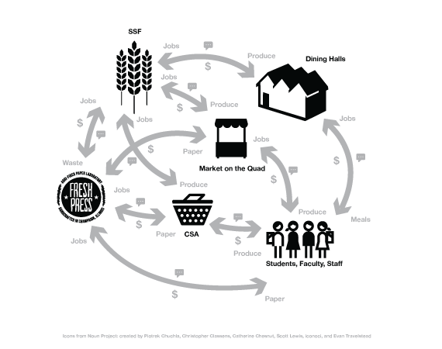

**Detailed Accounting of Expenditures to Date:**

|  |  |
| --- | --- |
| Labor Spent: $12,991.20 | Labor Awarded: $28,000 |
| Equipment Purchased: $6,834.39 | Equipment $ Awarded: $8,895 |
| Advertising Spent: $216 | Advertising Awarded: $800 |

**Project Progress to Date:**

We have completed two somewhat CSA semester shares (Fall 2016 and Spring 2017). These two CSA shares were promoted via our social media accounts on [Twitter](http://www.twitter.com/freshpresspaper), [Facebook](http://www.facebook.com/freshpresspaper), and [Instagram](http://www.instagram.com/fiberbyfreshpress). Furthermore we created [Fiber by Fresh Press](http://www.fiberbyfreshpress.com) website to drive awareness and online sales. We conducted a campus survey in the summer of 2016 to determine our student, faculty, and staff interests in our paper CSA and found that individual sheets of paper, paper packs, notepads, postcards, art prints, and 3D pulp were the most advantageous objects to explore with our student-based team. Our first CSA in fall 2016 focused on the individual sheets, paper packs, and notepads producing 28 total shares. In that semester, the notepads nearly sold out, while the paper packs and sheets performed fairly well. Our total sales online were $539 and we did some in-person sales totaling $99.50.

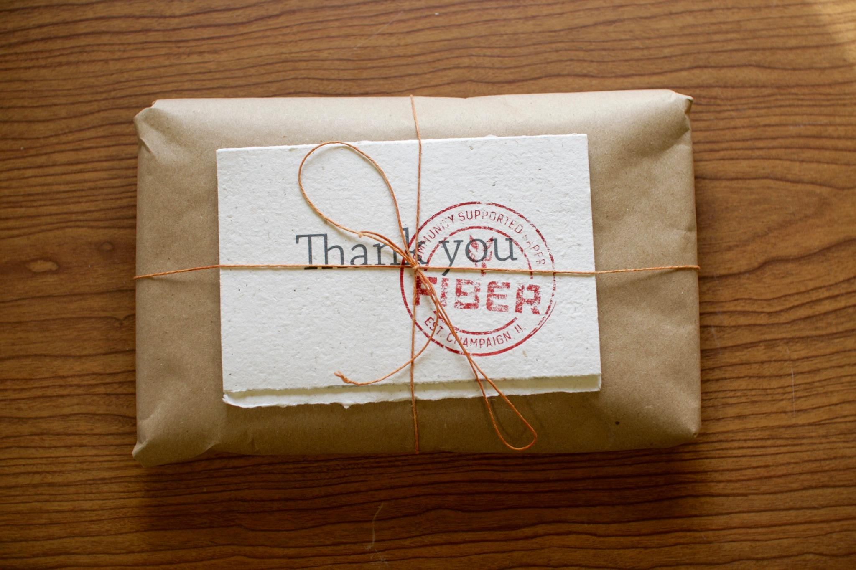

Our spring 2017 CSA was rethought by the students to focus more on the University of Illinois and the students in general. We better embraced our mantra of “Made by Students. Funded by Students,” by recycling old student artwork from the School of A+D into new speckle-tone recycled cotton sheets and printed new student artwork on them to create small and large prints. We offered these prints in recycled canvas folios of five postcards and five 9x12” larger prints. (We also sold these individually in-person and online). Our sales totaled $431 mainly on in-person sales.

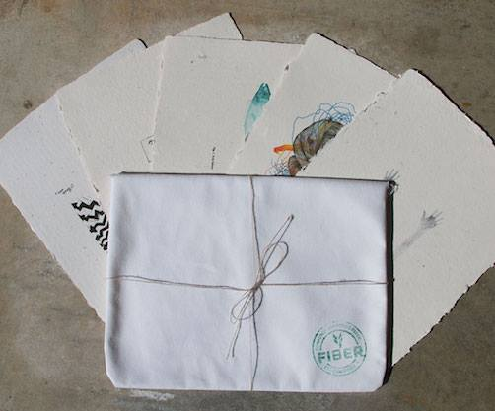

The lower sales have A LOT to do with technology issues with selling online. We have run into a number of issues with online sales (starting in January of 2017) in regards to adding sales tax to the cumbersome UIUC Webtools software, which does not operate like a normal online shopping cart. This has definitely hurt our ability to make this project more successful. We have instead focused on in-person sales (as the year progressed) at the Sustainable Student Farm Market on the Quad. This is an issue we have, at this time, no solution to fix due to current University of Illinois regulations.

We have learned quite a lot from this foray into entrepreneurship, and have rethought each semester CSA prior to launching the next. For the summer of 2017, we are focusing on preparing the shares for fall 2017. We have focused on a newly redesigned paper pack and individual sheets. We have received some unexpected outreach and sales to the community this summer. We have been approached by a number of locally owned businesses asking to stock our paper and participated in a three-hour Maker’s Fair at Urbana August First Fridays. We sold around $300 of our shares during that evening and connected with more people from campus and the community. The locally owned businesses have offered to purchase our shares wholesale and sell to their customers. We have worked with University of Illinois legal to write up a wholesale agreement that fulfills both the needs of the businesses and University of Illinois.

This summer we have also put together our 3D open-source printer and have begun some experiments to see if we can create an agri-fiber filament to print corn, soy, prairie grass, rye, etc. 3D objects. We have reached out to [Sun Buckets](https://www.sunbuckets.com) on campus to get our solar oven (to move entirely away from fossil fuels in our project) and are awaiting a reply for purchase.

Finally, we were lucky enough to have our shares featured in the [Pulp as Portal](http://centerforbookarts.org/event/pulp-as-portal/) traveling exhibit, which started in New York City and moved to Salina, KS in 2016 and 2017. The shares were seen by [The Peace Paper Project](http://www.peacepaperproject.org) and consequently placed in the permanent handmade paper archives at Yale University.

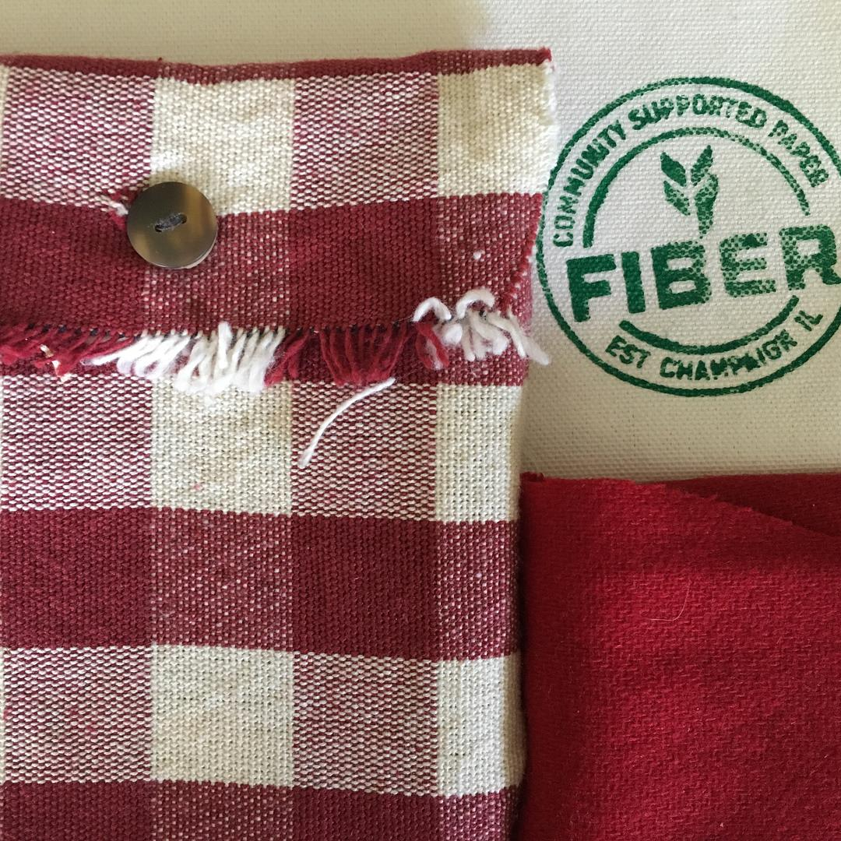

**Student Involvement and Outreach to Date:**

Students are the linchpins for the project success. They have been the force behind our creative output, marketing, and momentum. Everything thus far was funded and created by students.

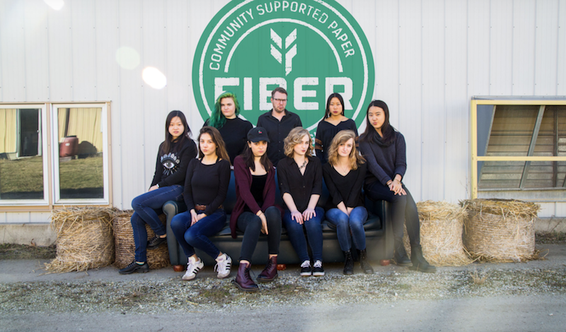

**Marketing and Promotion Efforts to Date:**

We have purchased a web domain [Fiber by Fresh Press](http://www.fiberbyfreshpress.com) and through our social media accounts. We also have received a good amount of “word of mouth” support as it has led us to working with the First Fridays Urbana and potentially being stocked in some locally owned businesses. Some of the “word of mouth” has come from our feature on local [WCIA CBS](http://www.illinoishomepage.net/ciliving/fresh-press-using-agricultural-products-to-make-paper/639914108).

**Additional Comments:**

We feel we have started to gain more traction on campus and in the community despite some technological setbacks. We feel we can make this project economically sustainable with a bit more effort this term and some help from the SSC in terms of promotion and support.